SREE NARAYANA COLLEGE, SIVAGIRI, VARKALA,
THE DEPARTMENT OF HISTORY
CIVIL SERVICE CLUB
in Association with
IQAC

Essay Writing Competition – “Nuclear Weapons and Global Peace: Lessons from Hiroshima and Nagasaki”
BROCHURE
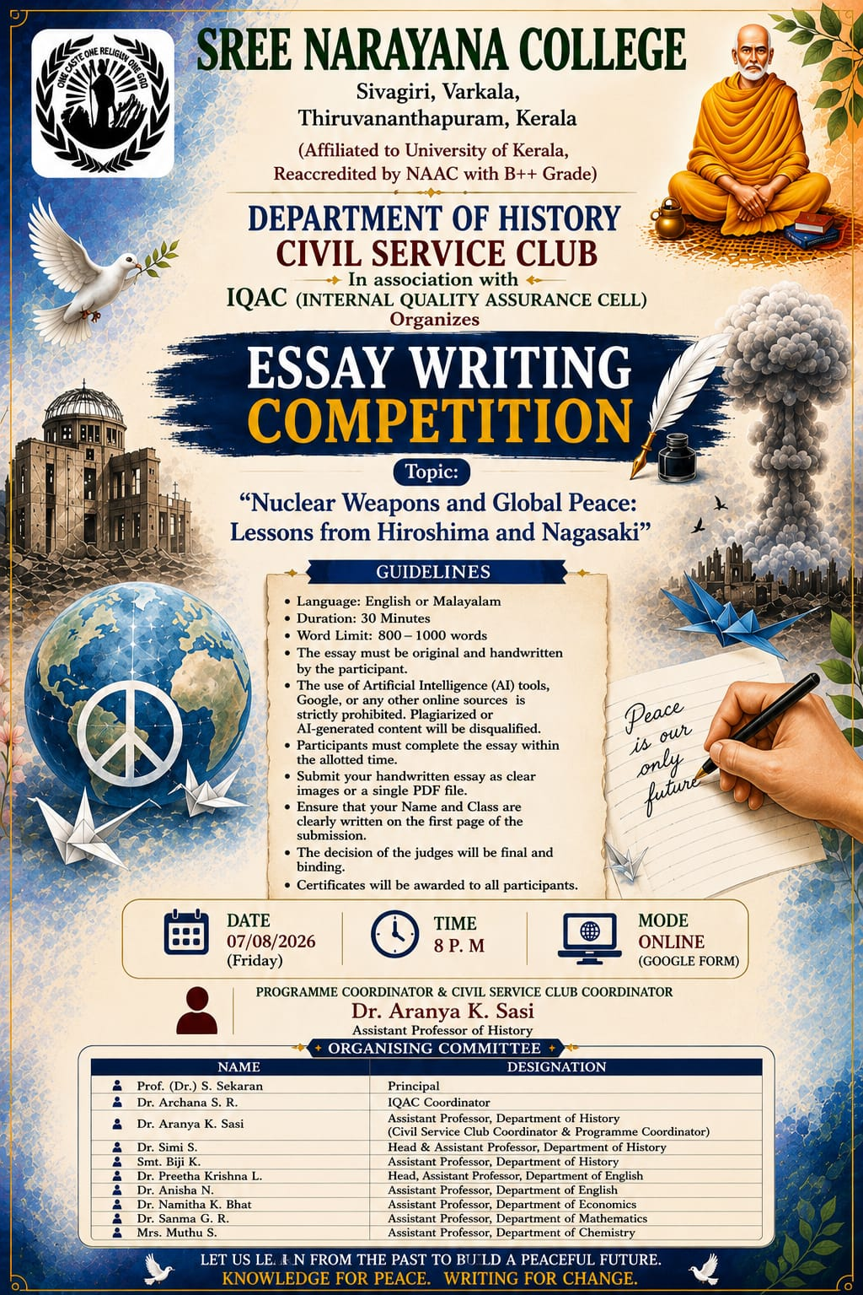

ATTENDANCE
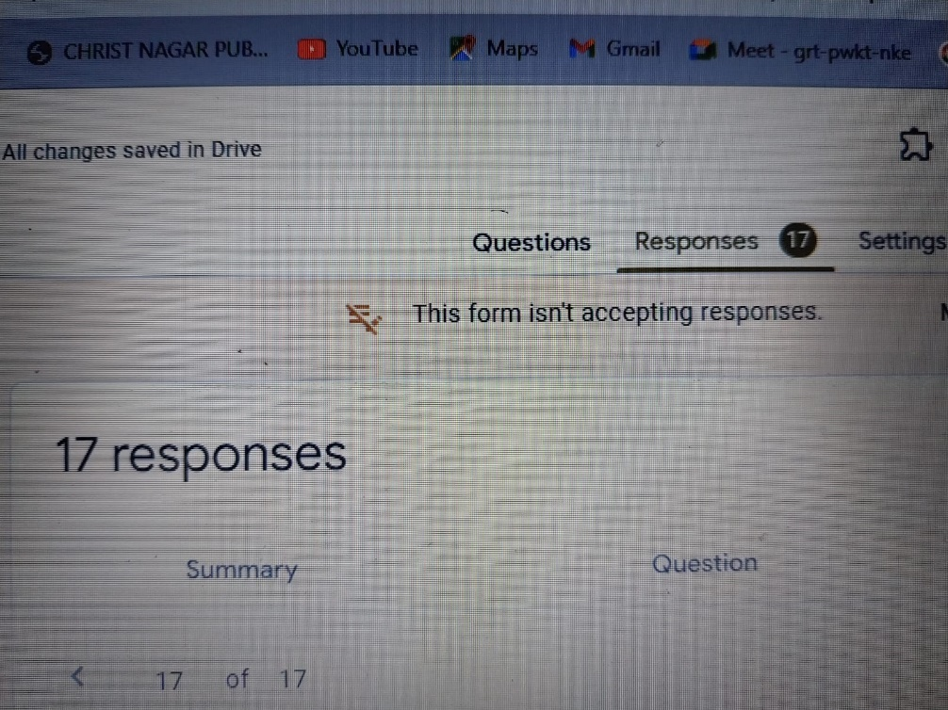

RESULT
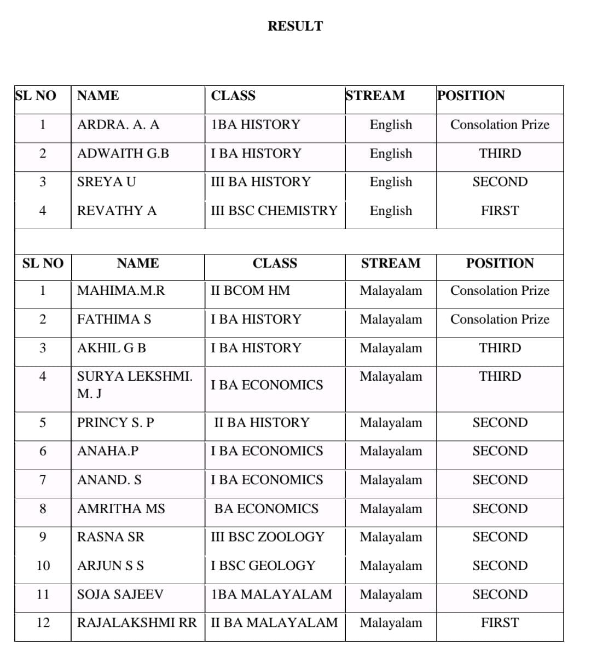

REPORT

Essay Writing Competition – “Nuclear Weapons and Global Peace: Lessons from Hiroshima and Nagasaki”
The Department of History and Civil Service Club of Sree Narayana College, Sivagiri, Varkala, in association with the Internal Quality Assurance Cell (IQAC), organized an Online Essay Writing Competition on the topic “Nuclear Weapons and Global Peace: Lessons from Hiroshima and Nagasaki” on 7 August 2026 (Friday) at 8:00 p.m. The competition was conducted through Google Forms as part of the Freedom & Heritage Month initiative.
The programme was organized with the objective of encouraging students to critically reflect on the historical consequences of the atomic bombings of Hiroshima and Nagasaki and to examine their wider implications for nuclear warfare, international peace, disarmament and global security.

Objectives of the Competition
The competition aimed to:
- Develop students’ historical understanding of Hiroshima and Nagasaki.
- Encourage critical reflection on the consequences of nuclear weapons and warfare.
- Promote awareness of the importance of global peace and disarmament.
- Encourage students to connect historical experiences with contemporary global concerns.
- Develop students’ essay-writing, analytical and argumentative skills.
- Provide an academic platform for students to express their views on peace and nuclear security.

Competition Guidelines
Participants were permitted to write the essay in English or Malayalam. The allotted time was 30 minutes, with a prescribed word limit of 800–1000 words.
The competition specifically emphasized originality and independent writing. Participants were required to submit their original handwritten essays, and the use of Artificial Intelligence tools, Google, or other online sources was strictly prohibited. Plagiarized or AI-generated content was to result in disqualification. Participants were instructed to complete the essay within the allotted time and submit it as clear images or as a single PDF file.
The guidelines also required participants to clearly mention their name and class on the first page of the submission. The competition therefore placed emphasis not only on knowledge but also on original thinking, independent expression and disciplined writing within a limited time.

Participation
The online Google Form recorded 17 responses, indicating active student participation in the competition. Students participated in both English and Malayalam, representing different programmes and academic disciplines.
The participation reflected the interdisciplinary nature of the initiative, with students from History, Economics, Chemistry, Commerce, Zoology and Geology, among others, taking part.

Results
The published results recognized students in the First, Second and Third positions, along with Consolation Prizes, separately for the English and Malayalam streams.

English Stream
Position | Student | Class
First | Revathy A | III BSc Chemistry
Second | Sreya U | III BA History
Third | Adwaith G. B | I BA History
Consolation Prize | Ardra A. A | I BA History

Malayalam Stream
Position | Student | Class
First | Rajalakshmi RR | II BA Malayalam
Second | Princy S. P | II BA History
Second | Anaha P | I BA Economics
Second | Anand S | I BA Economics
Second | Amritha MS | BA Economics
Second | Rasna SR | III BSc Zoology
Second | Arjun S S | I BSc Geology
Second | Soja Sajeev | I BA Malayalam
Third | Akhil G B | I BA History
Third | Surya Lekshmi M. J | I BA Economics
Consolation Prize | Mahima M. R | II BCom HM
Consolation Prize | Fathima S | I BA History
The results demonstrate participation and achievement across a wide range of disciplines, with students from both the humanities and science/commerce streams securing positions.

Academic Significance
The competition provided students with an opportunity to engage critically with one of the most important issues in modern world history. The topic encouraged them to move beyond the factual study of Hiroshima and Nagasaki and consider the broader questions of human suffering, nuclear deterrence, peace, disarmament and the responsibility of nations in preventing future conflicts.
The requirement of handwritten and independently produced essays further encouraged students to develop their own arguments and articulate their perspectives without dependence on digital or AI-generated content. This contributed to strengthening creative thinking, historical interpretation, writing skills and independent academic expression.
The programme also reinforced the central message of the Freedom & Heritage Month initiative: that remembering the tragedies of the past is essential for building a peaceful future.

Organising Committee
The competition was conducted under the guidance and support of:
- Prof. (Dr.) S. Sekaran – Principal
- Dr. Archana S. R. – IQAC Coordinator
- Dr. Aranya K. Sasi – Assistant Professor, Department of History; Civil Service Club Coordinator & Programme Coordinator
- Dr. Simi S. – Head & Assistant Professor, Department of History
- Smt. Biji K. – Assistant Professor, Department of History
- Dr. Preetha Krishna L. – Head, Assistant Professor, Department of English
- Dr. Anisha N. – Assistant Professor, Department of English
- Dr. Namitha K. Bhat – Assistant Professor, Department of Economics
- Dr. Sanma G. R. – Assistant Professor, Department of Mathematics
- Mrs. Muthu S. – Assistant Professor, Department of Chemistry
The Essay Writing Competition on “Nuclear Weapons and Global Peace: Lessons from Hiroshima and Nagasaki” successfully provided students with a meaningful platform to explore the historical legacy of nuclear warfare and its implications for global peace. With 17 responses, the programme encouraged interdisciplinary participation and independent academic expression.
The initiative effectively combined historical awareness, critical thinking, writing skills and peace education, reinforcing the message that learning from Hiroshima and Nagasaki is essential for promoting a culture of peace and preventing future nuclear conflict.

