SREE NARAYANA COLLEGE, SIVAGIRI, VARKALA,
THE DEPARTMENT OF HISTORY
CIVIL SERVICE CLUB
in Association with
IQAC

From World War to World Peace: Hiroshima & Nagasaki Day Quiz 2026

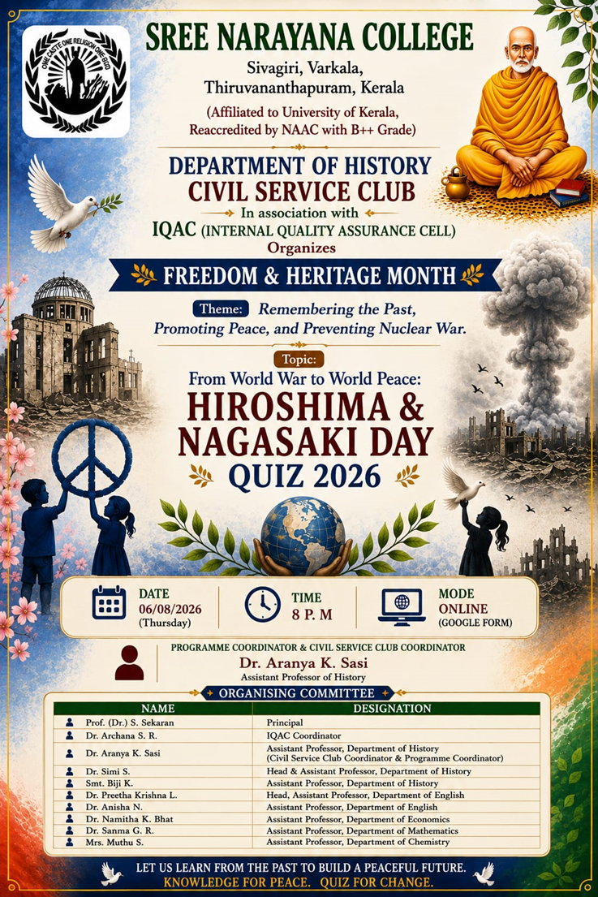

Attendance

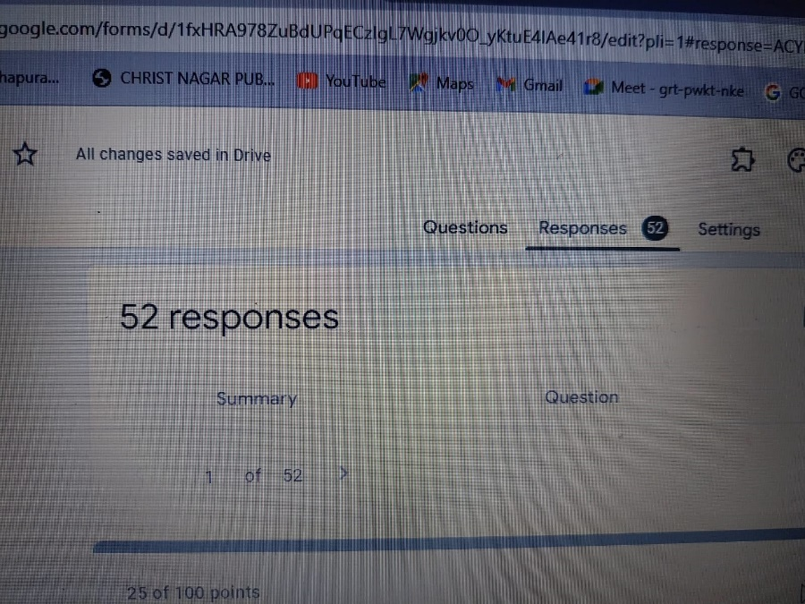
Result
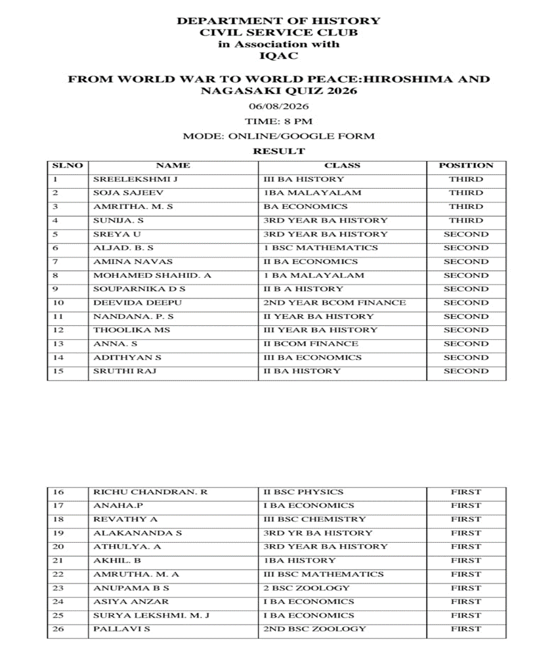
Report

From World War to World Peace: Hiroshima & Nagasaki Day Quiz 2026
The Department of History and Civil Service Club of Sree Narayana College, Sivagiri, Varkala, in association with the Internal Quality Assurance Cell (IQAC), organized an online quiz titled “From World War to World Peace: Hiroshima & Nagasaki Day Quiz 2026” on 6 August 2026 at 8:00 p.m. through Google Forms.
The quiz was conducted as part of the Freedom & Heritage Month initiative, based on the theme “Remembering the Past, Promoting Peace, and Preventing Nuclear War.” The programme was organized to commemorate Hiroshima and Nagasaki Day and to encourage students to reflect on the historical consequences of nuclear warfare and the importance of peace.

Objectives of the Quiz
The quiz aimed to:
- Create awareness about the Hiroshima and Nagasaki bombings and their historical significance.
- Encourage students to understand the wider context of World War II.
- Promote awareness of the humanitarian consequences of nuclear weapons.
- Highlight the importance of peace, disarmament and international cooperation.
- Encourage students to learn from history and develop a commitment towards preventing future conflicts.
- Provide an engaging platform for students to test and expand their knowledge of modern world history.

Participation and Conduct
The quiz was conducted entirely online through Google Forms, making it accessible to students across different departments and programmes. The response sheet recorded 52 participants/responses, demonstrating significant student interest in the programme.
The quiz covered historical and general awareness aspects related to World War II, Hiroshima and Nagasaki, nuclear weapons, global peace, international relations and the historical consequences of warfare. The online format enabled students to participate conveniently while encouraging independent learning and engagement with the subject.

Results
The quiz results recognized participants in First, Second and Third positions. The published result sheet listed 26 prize/position holders across the three categories.
Third Position
- Sreelakshmi J – III BA History
- Soja Sajeev – I BA Malayalam
- Amritha M. S. – BA Economics
- Sunija S. – III Year BA History
Second Position
5. Sreya U – III Year BA History
6. Aljad. B. S – I BSc Mathematics
7. Amina Navas – II BA Economics
8. Mohamed Shahid. A – I BA Malayalam
9. Souparnika D S – II BA History
10. Deevida Deepu – II Year BCom Finance
11. Nandana P. S – II Year BA History
12. Thoolika MS – III Year BA History
13. Anna. S – II BCom Finance
14. Adithyan S – III BA Economics
15. Sruthi Raj – II BA History
First Position
16. Richu Chandran. R – II BSc Physics
17. Anaha. P – I BA Economics
18. Revathy A – III BSc Chemistry
19. Alakananda S – III Year BA History
20. Athulya. A – III Year BA History
21. Akhil. B – I BA History
22. Amrutha. M. A – III BSc Mathematics
23. Anupama B S – II BSc Zoology
24. Asiya Anzar – I BA Economics
25. Surya Lekshmi. M. J – I BA Economics
26. Pallavi S – II BSc Zoology
The diversity of participants from History, Economics, Malayalam, Mathematics, Physics, Chemistry, Zoology and Commerce reflected the interdisciplinary appeal of the programme.

Significance of the Programme
The quiz provided an effective academic platform for students to engage with one of the most significant and tragic episodes of modern world history. By connecting the historical memory of Hiroshima and Nagasaki with the contemporary concerns of nuclear proliferation, peace and global security, the programme encouraged students to look beyond memorising historical facts and reflect on their wider implications.
The initiative also reinforced the message that historical knowledge can contribute to building a culture of peace. Remembering the consequences of nuclear warfare serves as an important reminder of the need for dialogue, diplomacy, humanitarian values and responsible international cooperation.
The programme was coordinated by Dr. Aranya K. Sasi, Assistant Professor of History and Civil Service Club Coordinator & Programme Coordinator, with the support of the organizing committee.

Organising Committee
- Prof. (Dr.) S. Sekaran – Principal
- Dr. Archana S. R. – IQAC Coordinator
- Dr. Aranya K. Sasi – Assistant Professor, Department of History; Civil Service Club Coordinator & Programme Coordinator
- Dr. Simi S. – Head & Assistant Professor, Department of History
- Smt. Biji K. K. – Assistant Professor, Department of History
- Dr. Preetha Krishna L. – Head, Assistant Professor, Department of English
- Dr. Anisha N. – Assistant Professor, Department of English
- Dr. Namitha K. Bhat – Assistant Professor, Department of Economics
- Dr. Sanma G. R. – Assistant Professor, Department of Mathematics
- Mrs. Muthu S. – Assistant Professor, Department of Chemistry
The “From World War to World Peace: Hiroshima & Nagasaki Day Quiz 2026” successfully combined historical learning with peace education. With 52 responses and participants from multiple disciplines, the programme demonstrated strong student engagement and contributed to creating awareness about the devastating consequences of nuclear warfare. The initiative effectively conveyed the message of remembering the past, promoting peace, and preventing nuclear war.

