SREE NARAYANA COLLEGE, SIVAGIRI, VARKALA,
THE DEPARTMENT OF HISTORY
IQAC

Meet, Mingle & Make Memories – An Interactive Welcome Gathering for First Year History Students

BROCHURE
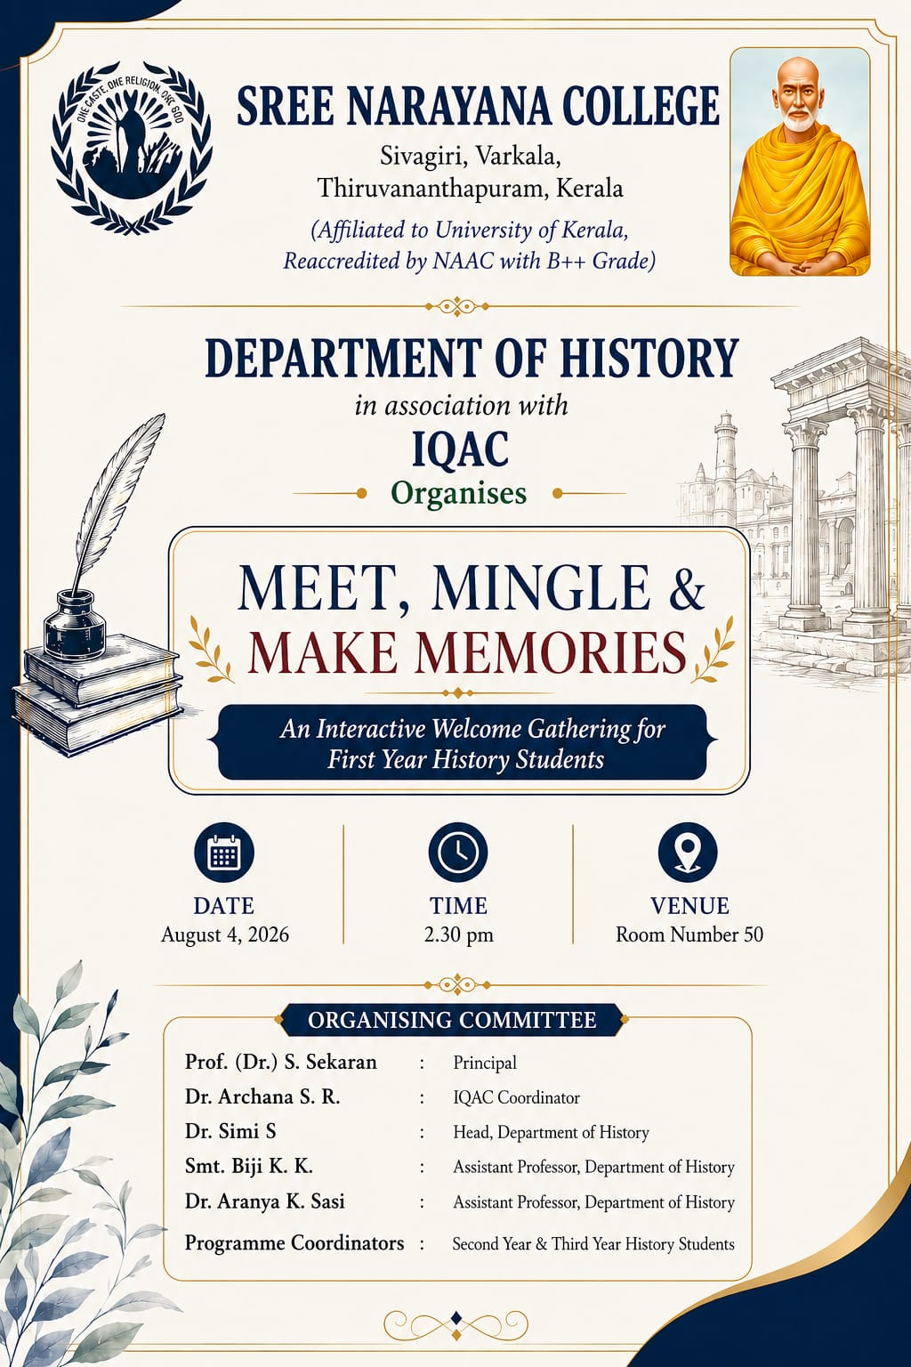

Photos

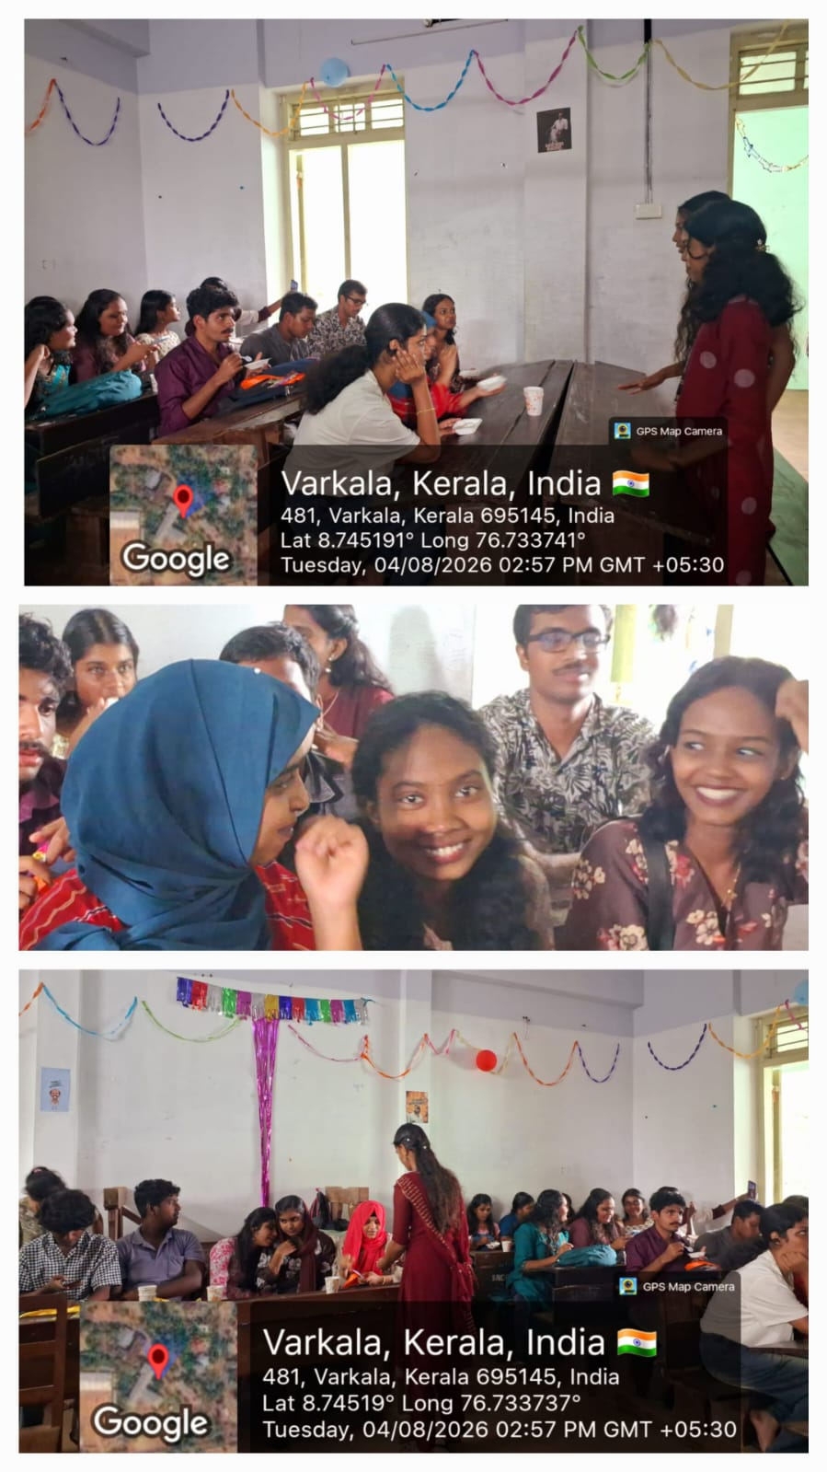

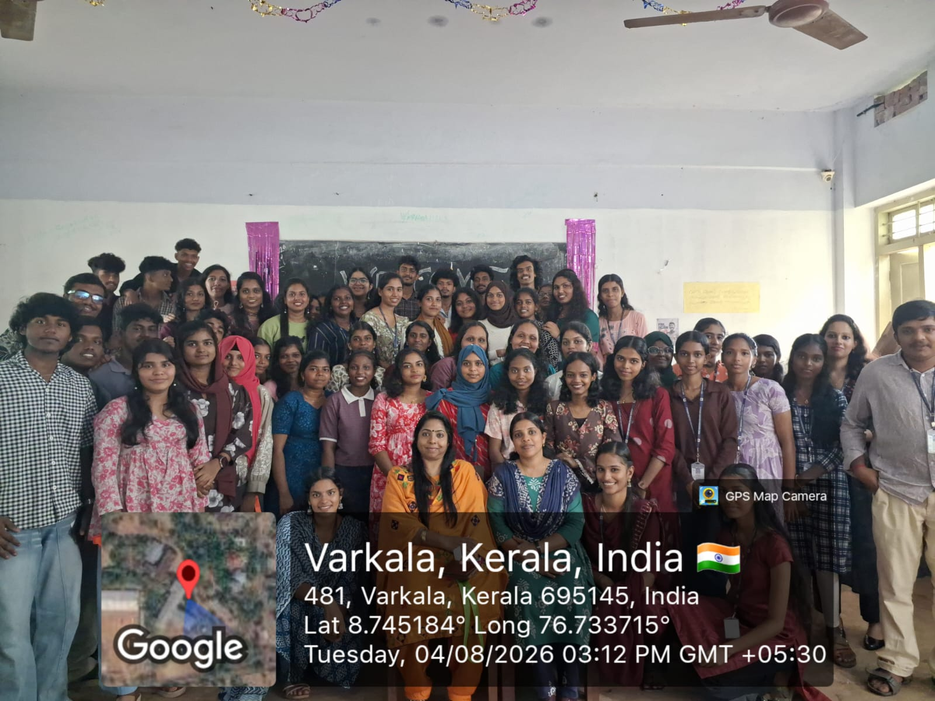

REPORT

Meet, Mingle & Make Memories – An Interactive Welcome Gathering for First Year History Students
The Department of History, Sree Narayana College, Sivagiri, Varkala, in association with the Internal Quality Assurance Cell (IQAC), organized “Meet, Mingle & Make Memories”, an interactive welcome gathering for the First Year History Students, on 4 August 2026 at 2:30 p.m. in Room No. 50.
The programme was organized with the objective of warmly welcoming the newly admitted students to the Department of History and helping them become familiar with the academic environment, faculty members, and senior students. The gathering provided a friendly and informal platform for students to interact, communicate, and build new relationships within the department.
The programme emphasized the importance of student interaction, peer bonding, teamwork, and a sense of belonging during the initial phase of undergraduate education. Through informal interactions and engaging activities, first-year students were encouraged to introduce themselves, share their interests, and interact with their seniors. The programme helped create a welcoming atmosphere and reduced the initial hesitation often experienced by new students entering a new academic environment.
The interaction between first-year students and senior students was particularly significant. Senior students had the opportunity to share their experiences of academic life, departmental activities, and campus experiences, thereby helping newcomers gain a better understanding of student life in the Department of History.
The programme also encouraged students to view the department as a supportive academic community where they could actively participate in curricular and co-curricular activities. The gathering promoted values such as friendship, cooperation, mutual respect, communication, and collective learning.
The programme was conducted under the guidance of Prof. (Dr.) S. Sekaran, Principal, and Dr. Archana S. R., IQAC Coordinator. Dr. Simi S., Head of the Department of History, Smt. Biji K. K., Assistant Professor, Department of History, and Dr. Aranya K. Sasi, Assistant Professor, Department of History, were part of the organizing committee. The programme was coordinated with the support of the Second Year and Third Year History Students.
The event successfully created a warm and inclusive beginning for the first-year students and strengthened interaction between different batches. “Meet, Mingle & Make Memories” thus served as a meaningful departmental initiative for fostering student engagement, building interpersonal relationships, and creating a positive and supportive academic environment.
Top of Form

