SREE NARAYANA COLLEGE, SIVAGIRI, VARKALA,
THE DEPARTMENT OF HISTORY
IQAC
BROCHURE

Threads of Friendship – A Friendship Day Special Interactive Session

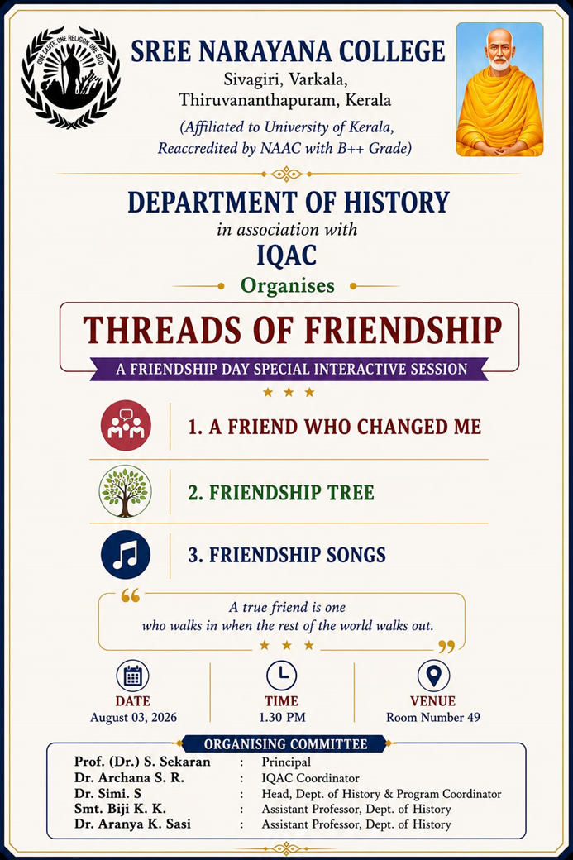
PHOTOS
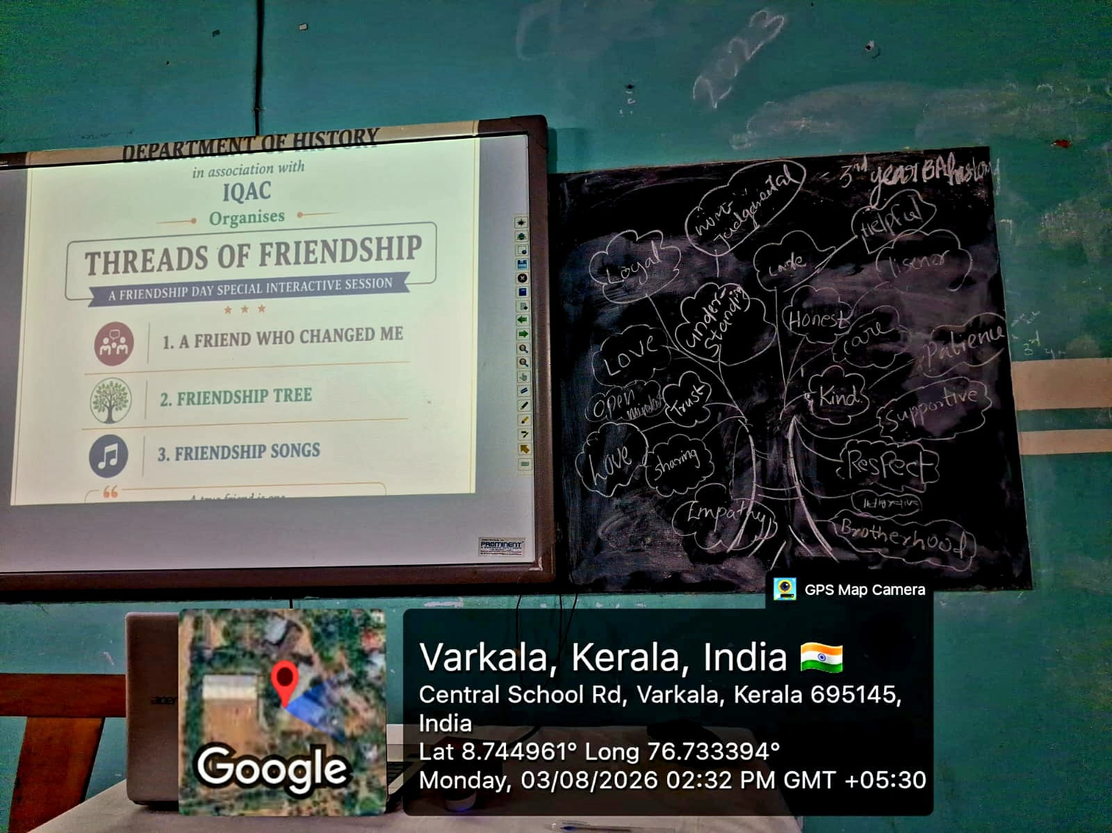

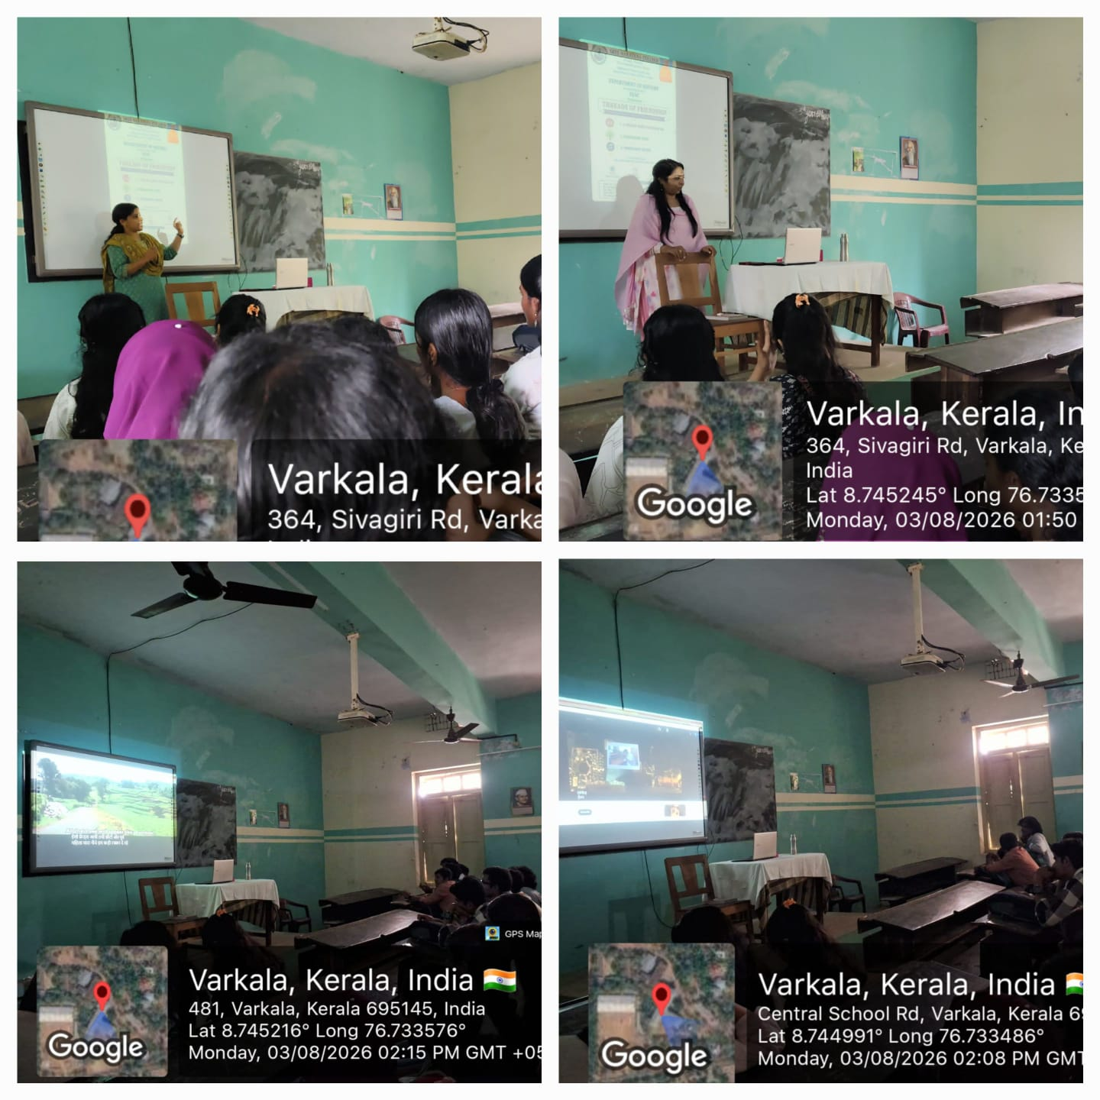
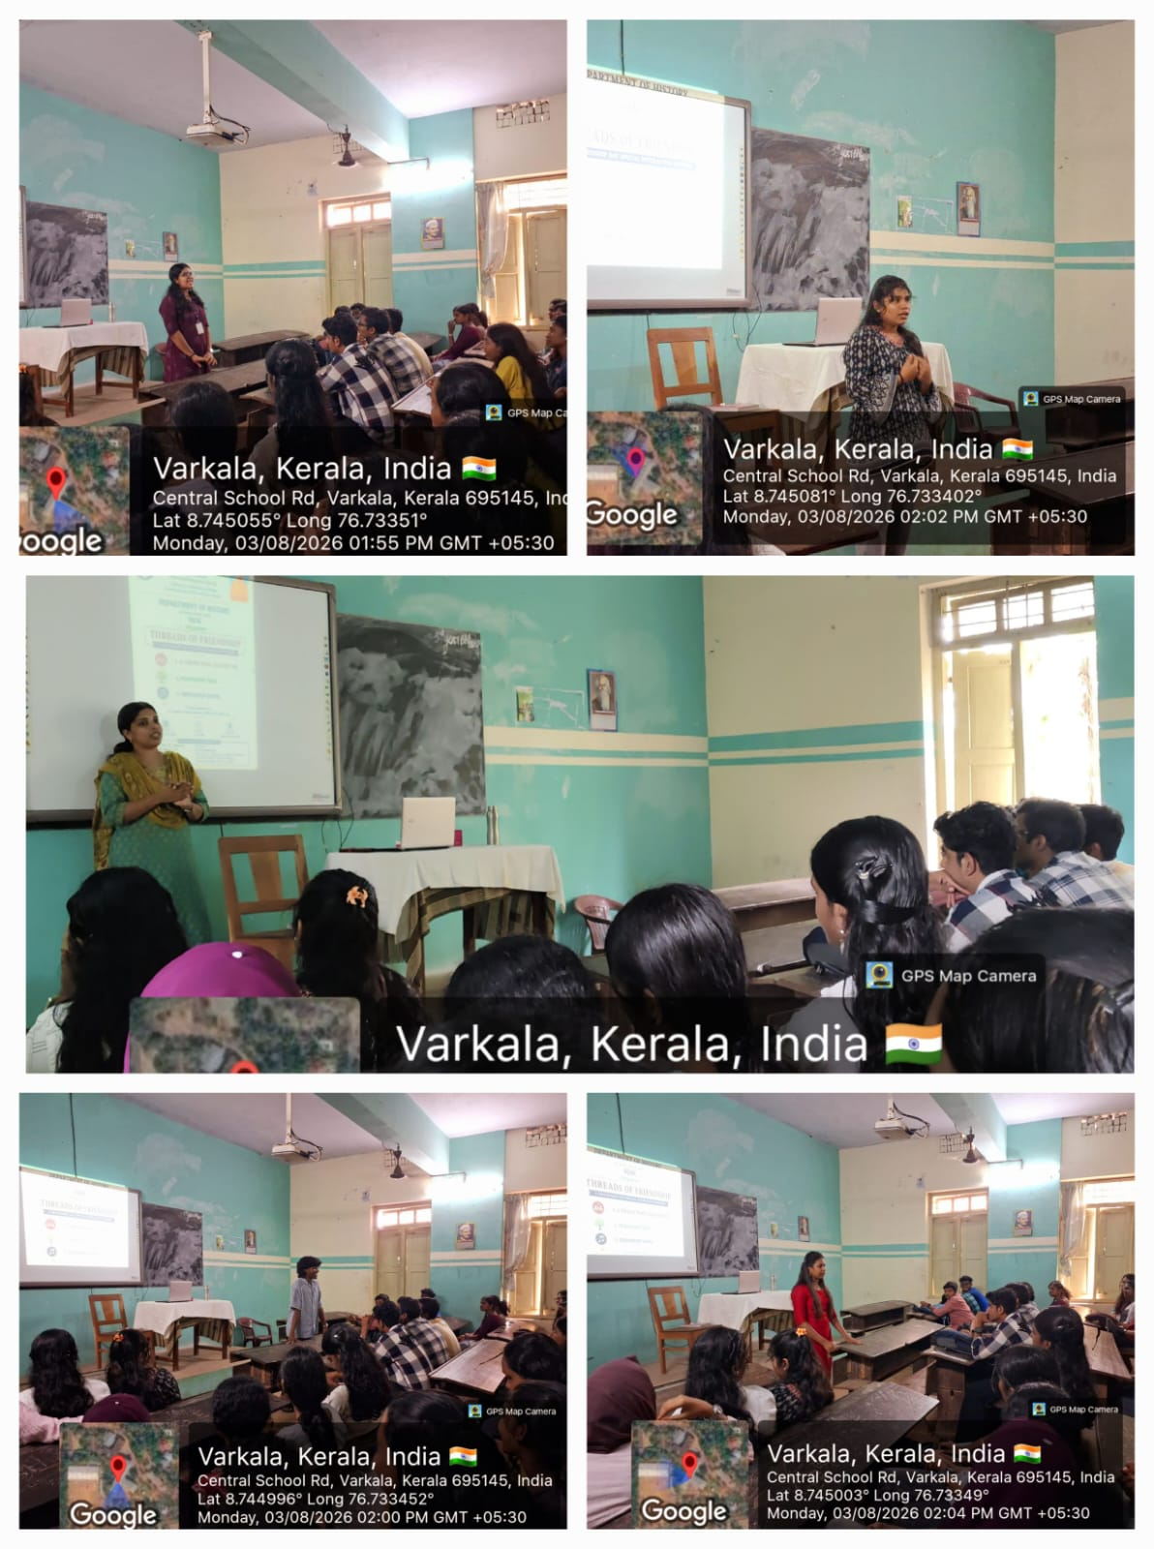

REPORT

Threads of Friendship – A Friendship Day Special Interactive Session
The Department of History, Sree Narayana College, Sivagiri, Varkala, in association with the Internal Quality Assurance Cell (IQAC), organized “Threads of Friendship – A Friendship Day Special Interactive Session” on 3 August 2026 at 1:30 p.m. The programme was conducted at Room No. 49 as a special initiative to celebrate the values of friendship, companionship, mutual support, and meaningful interpersonal relationships among students.
The programme was designed as an interactive and participatory session, providing students with an opportunity to reflect upon the importance of friendship in their personal and academic lives. Rather than following a conventional lecture format, the session incorporated creative and engaging activities that encouraged students to share their experiences, memories, emotions, and perspectives on friendship.

Objectives of the Programme
The session aimed to:
- Highlight the importance of friendship and meaningful relationships in student life.
- Encourage students to appreciate the friends who have positively influenced their lives.
- Provide a platform for self-expression and sharing of personal experiences.
- Strengthen interpersonal relationships and a sense of belonging among students.
- Promote values such as trust, empathy, cooperation, understanding, and mutual support.
- Create a positive and inclusive atmosphere within the academic community.

Major Activities
The interactive session consisted of three major activities:
1. A Friend Who Changed Me
The first activity encouraged students to reflect on a friend who had made a meaningful difference in their lives. Students were invited to share experiences about how friendship had influenced their personality, confidence, outlook, decisions, or personal growth. The activity provided an opportunity for students to recognise and express gratitude towards people who had positively influenced them.
2. Friendship Tree
The Friendship Tree was designed as a creative and collaborative activity. Students contributed their thoughts, messages, memories, and values associated with friendship. The activity symbolically represented friendship as a growing tree, with relationships strengthened through care, trust, understanding, and mutual support. It also encouraged collective participation and interaction among students.
3. Friendship Songs
The session concluded with Friendship Songs, creating a lively and enjoyable atmosphere. Students participated through music and shared songs associated with friendship and companionship. The activity added an element of celebration while reinforcing the emotional and social significance of friendship.
The programme was inspired by the message:
“A true friend is one who walks in when the rest of the world walks out.”
This message reflected the central theme of the programme—that genuine friendship is founded on support, loyalty, understanding, and companionship during both challenging and joyful moments.

Academic and Social Significance
The programme extended beyond the conventional academic environment and provided students with a space for emotional expression, social interaction, and creative participation. Such activities contribute to creating a healthy campus environment by encouraging students to communicate openly and develop stronger interpersonal relationships.
The interactive format also helped students recognise the importance of positive friendships in developing confidence, emotional resilience, cooperation, empathy, and a sense of community. The programme thus complemented the academic objectives of the Department of History by promoting the broader development of students as socially responsible and emotionally aware individuals.

Organising Committee
The programme was organized under the guidance of:
- Prof. (Dr.) S. Sekaran – Principal
- Dr. Archana S. R. – IQAC Coordinator
- Dr. Simi S. – Head, Department of History & Programme Coordinator
- Smt. Biji K. K. – Assistant Professor, Department of History
- Dr. Aranya K. Sasi – Assistant Professor, Department of History
The active involvement of the organizing committee contributed to the smooth and successful conduct of the programme.
“Threads of Friendship” was a meaningful and engaging Friendship Day initiative that brought students together through reflection, creativity, music, and interaction. The programme successfully created a warm and positive environment where students could celebrate friendship and acknowledge the important role of meaningful relationships in their lives. It served as a valuable initiative for strengthening student engagement, fostering a sense of belonging, and promoting a supportive campus community.
Top of Form

