SREE NARAYANA COLLEGE, SIVAGIRI, VARKALA,
THE DEPARTMENT OF HISTORY

History and Beyond: A Multidisciplinary Bridge Course for FYUGP History Students (2026)
Commerce Session
Brochure
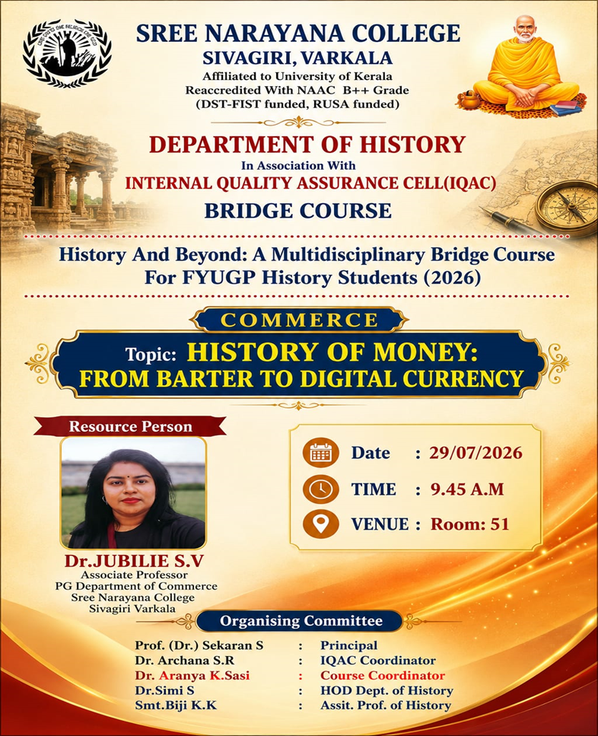

Photos
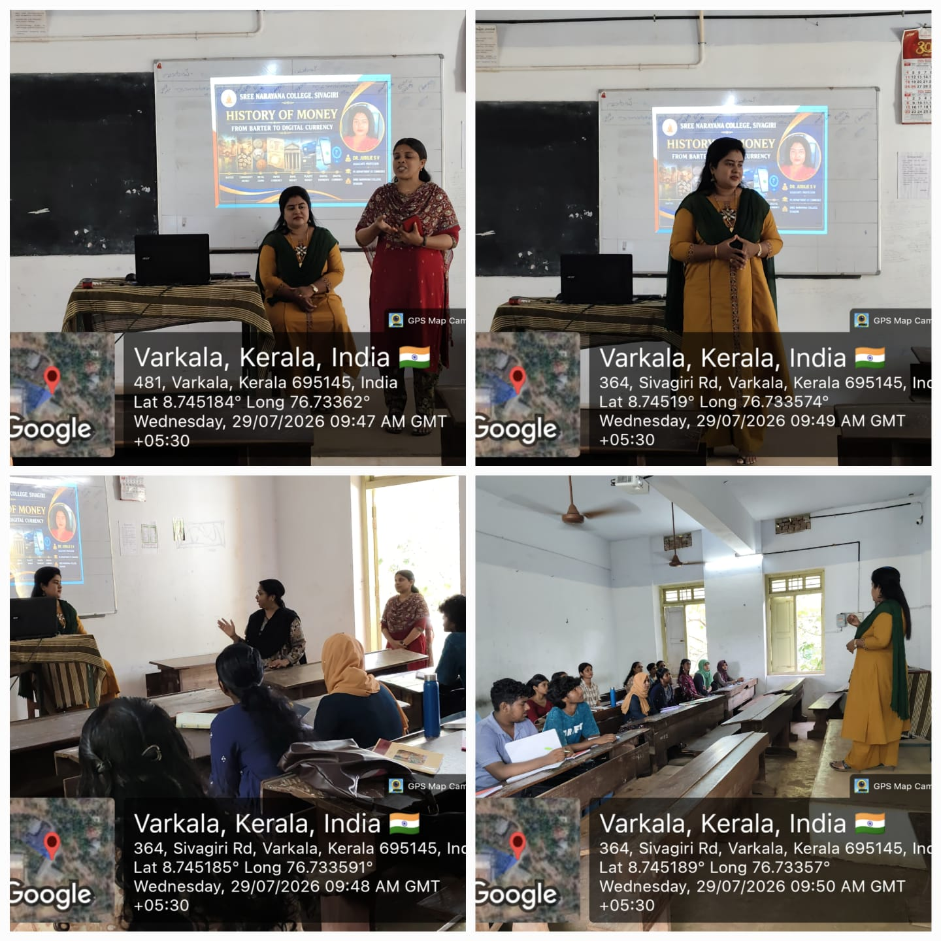

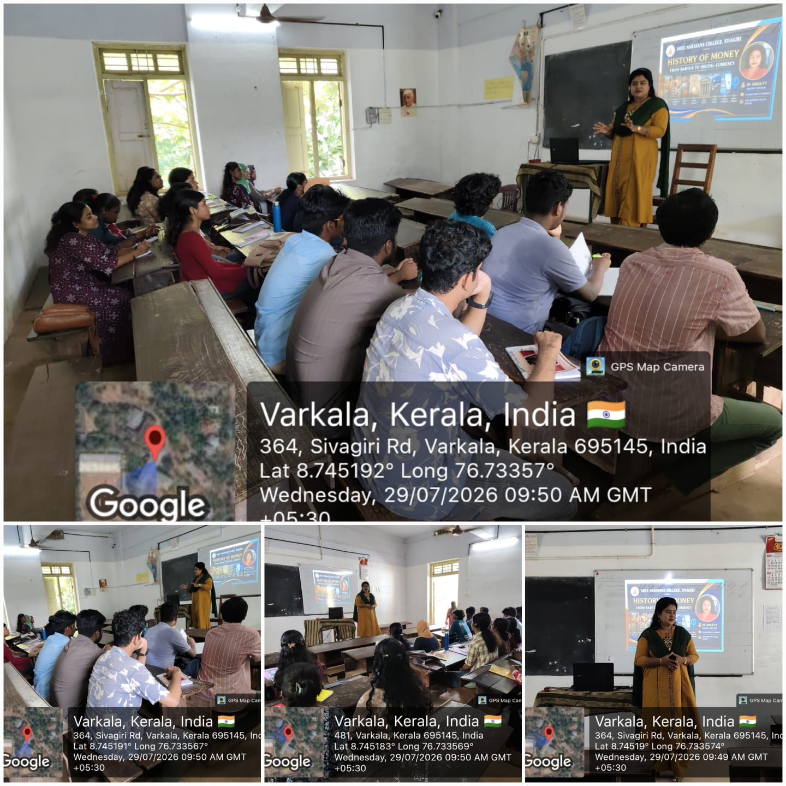

REPORT

History and Beyond: A Multidisciplinary Bridge Course for FYUGP History Students (2026)
The Department of History, Sree Narayana College, Sivagiri, Varkala, in association with the Internal Quality Assurance Cell (IQAC), organized a session of the multidisciplinary bridge course “History and Beyond: A Multidisciplinary Bridge Course for FYUGP History Students (2026)” on 29 July 2026 at 9:45 a.m. in Room No. 51.
The session was conducted under the Commerce component of the bridge course, with the topic “History of Money: From Barter to Digital Currency.” The session aimed to familiarise students with the historical evolution of money and its transformation from traditional systems of exchange to modern digital forms of currency. The topic also helped students understand the connections between history, commerce, economics and contemporary technological developments.
The session was handled by Dr. Jubilie S. V., Associate Professor, PG Department of Commerce, Sree Narayana College, Sivagiri, Varkala, who served as the resource person. She provided students with an informative overview of the development of money, beginning with the barter system and progressing through various forms of currency to the emergence of digital currency.
The programme was organised under the leadership of Prof. (Dr.) Sekaran S., Principal, and Dr. Archana S. R., IQAC Coordinator. Dr. Aranya K. Sasi, Course Coordinator, coordinated the programme with the support of Dr. Simi S., HOD, Department of History, and Smt. Biji K. K., Assistant Professor of History.
The session was academically enriching and provided FYUGP History students with an interdisciplinary perspective on the relationship between historical developments and contemporary economic systems. The programme successfully contributed to the objectives of the bridge course by broadening students’ understanding beyond the conventional boundaries of History.

