SREE NARAYANA COLLEGE, SIVAGIRI, VARKALA,
THE DEPARTMENT OF HISTORY
CIVIL SERVICE CLUB
in Association with
IQAC

Civil Services Orientation Programme: Opportunities, Syllabus and Preparation Strategy
Brochure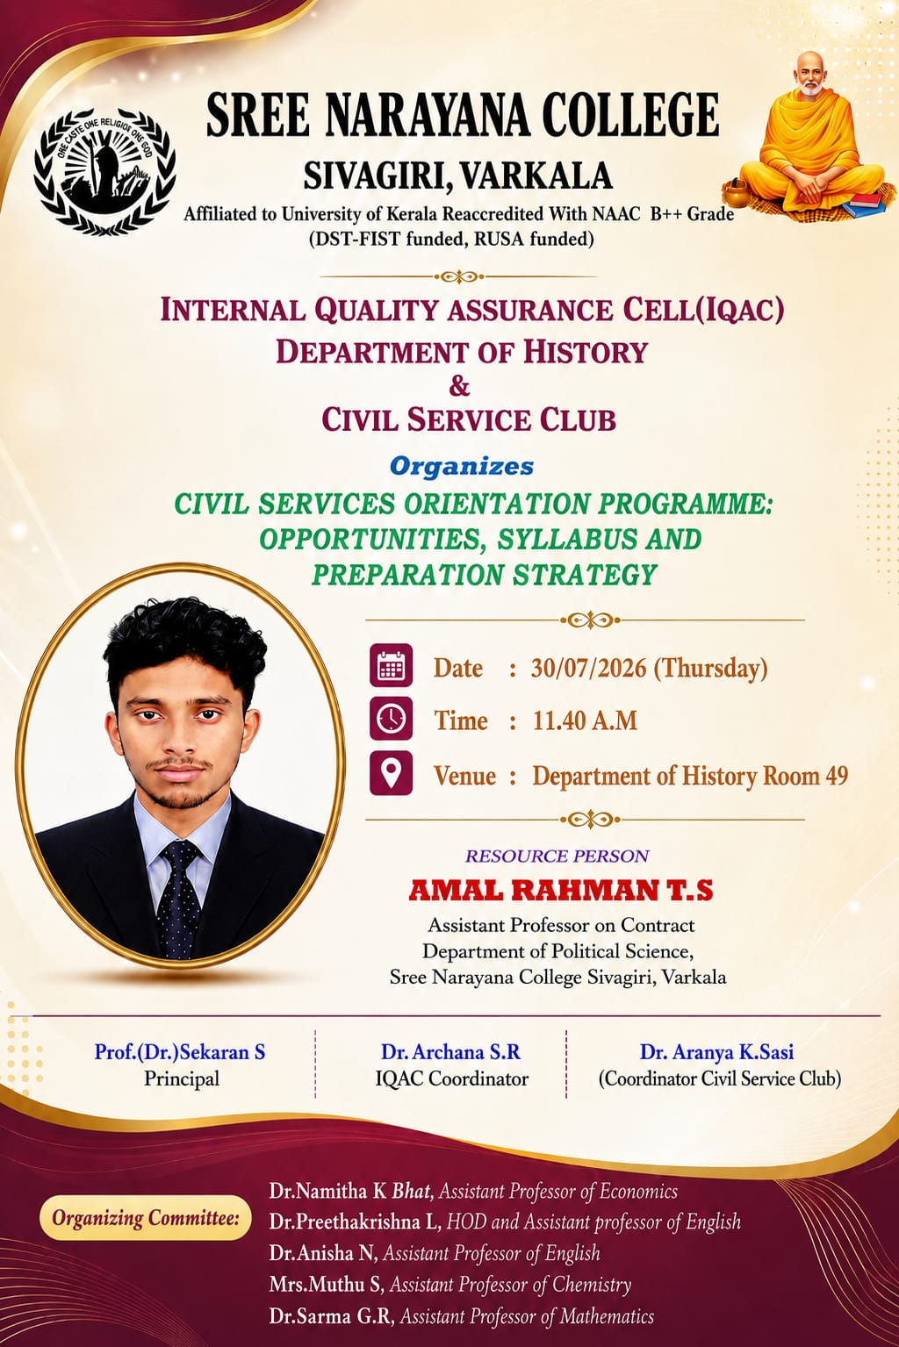
Photos
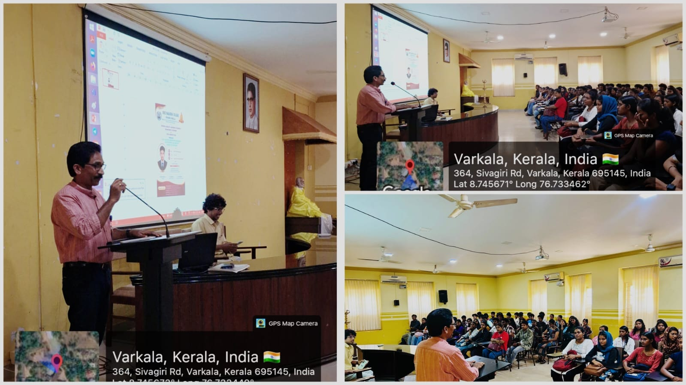
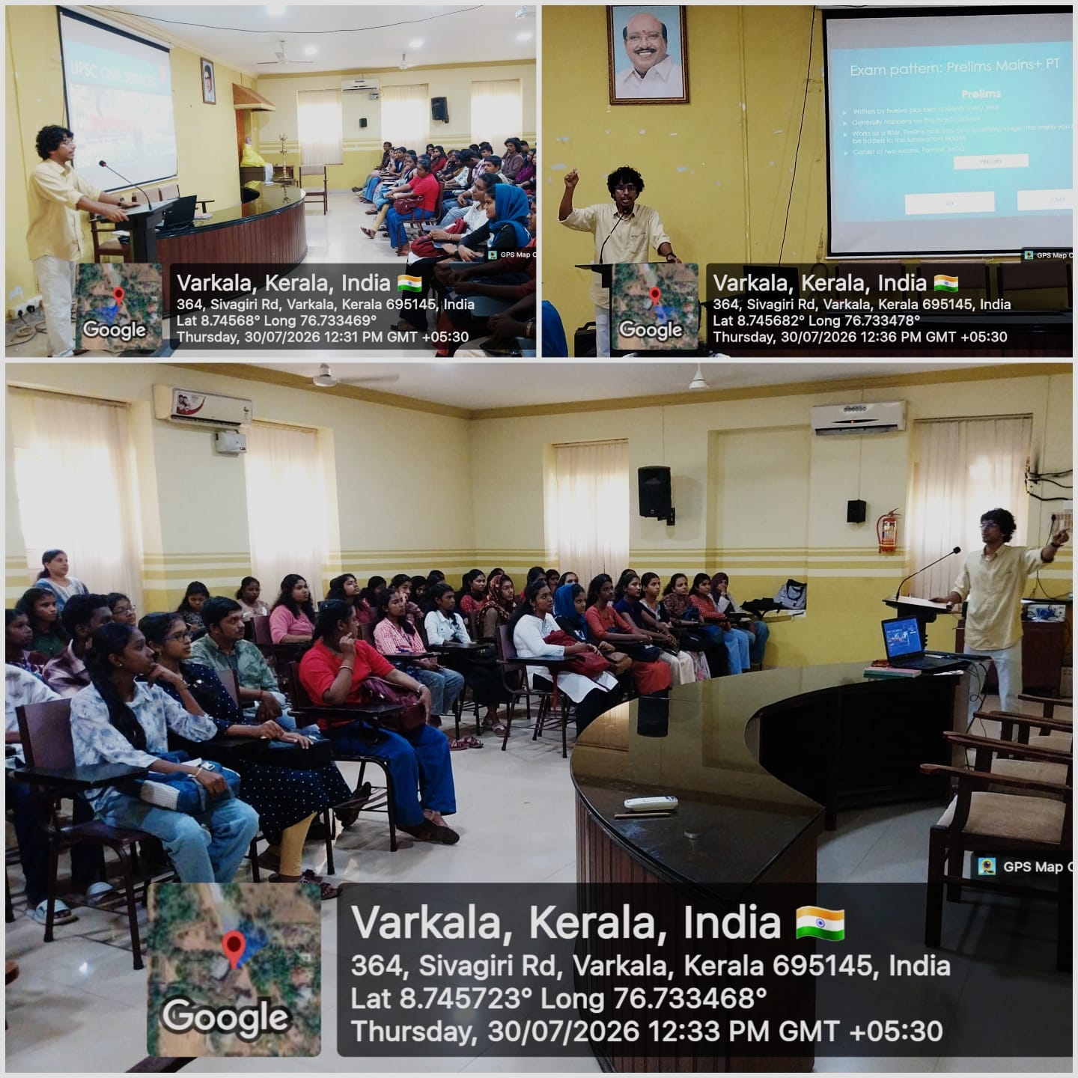
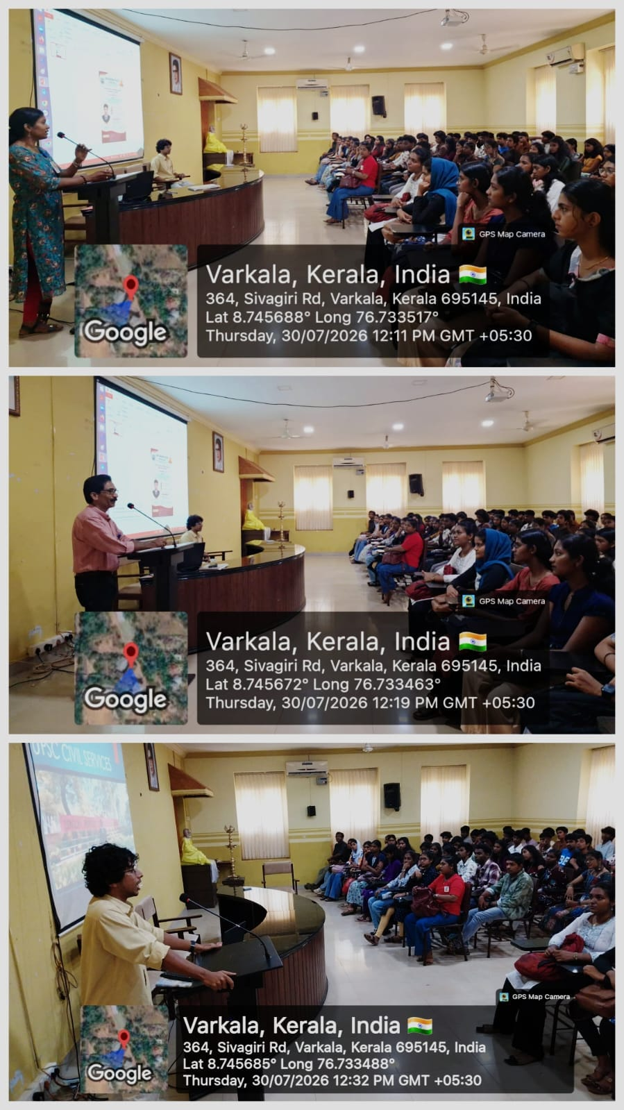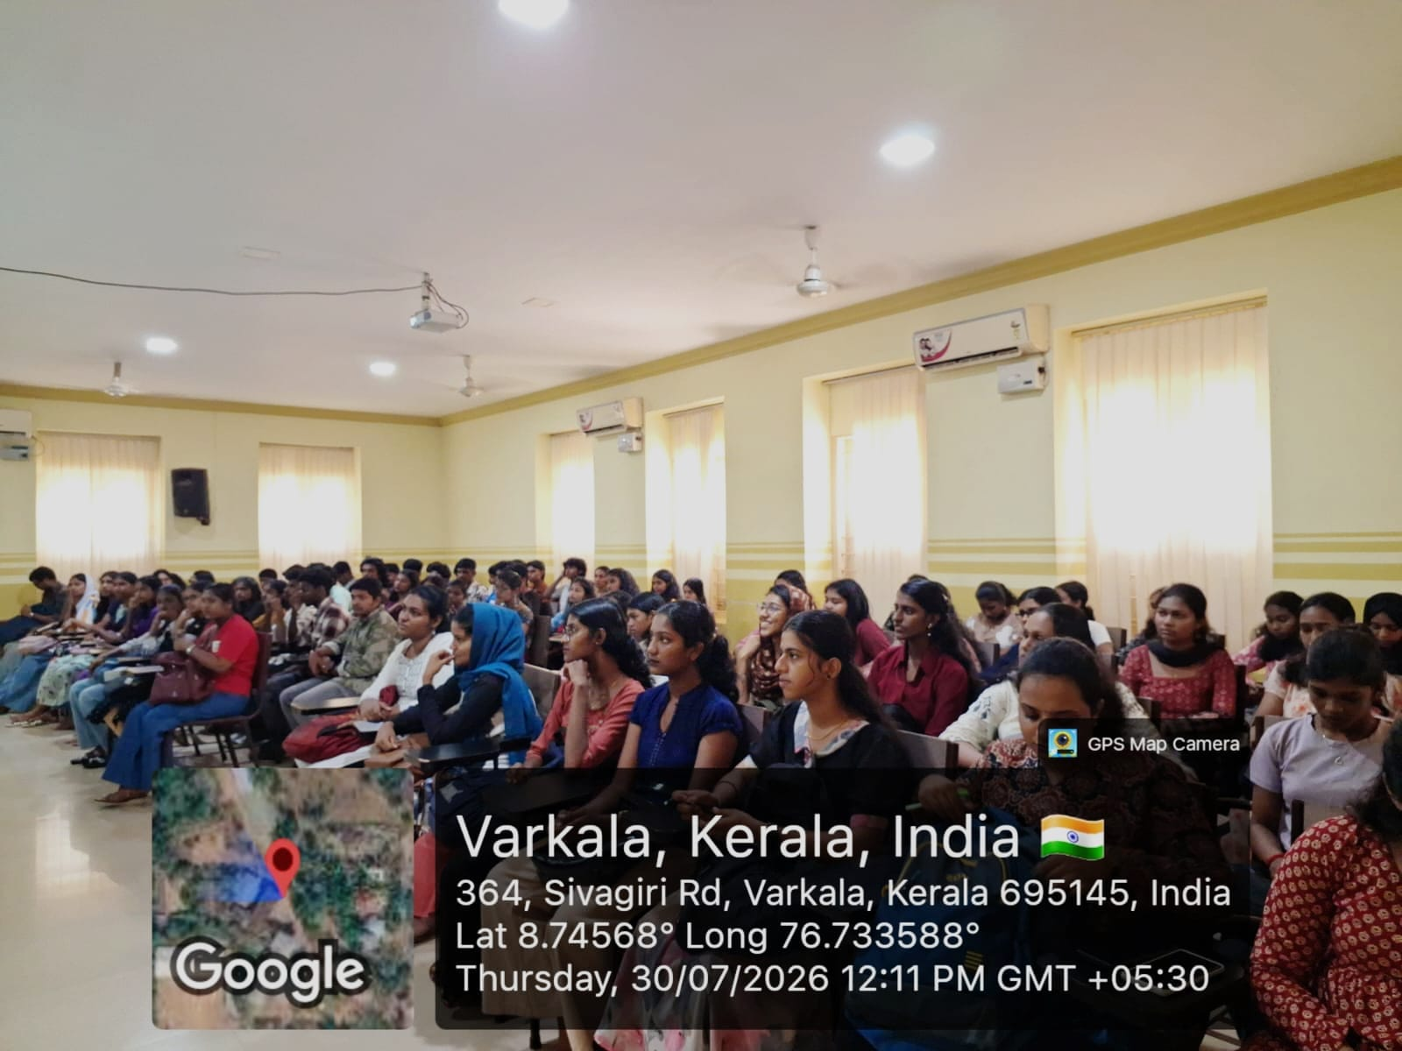

REPORT

Civil Services Orientation Programme: Opportunities, Syllabus and Preparation Strategy
The Internal Quality Assurance Cell (IQAC), Department of History, and Civil Service Club of Sree Narayana College, Sivagiri, Varkala, jointly organized a Civil Services Orientation Programme on the topic “Opportunities, Syllabus and Preparation Strategy” on 30 July 2026 (Thursday) at 11:40 a.m. The programme was held at Room 499(Changed to Conference Hall), Department of History.
The orientation programme was organized with the objective of creating awareness among students about the Civil Services Examination, career opportunities in the public services, examination pattern, syllabus, and effective preparation strategies. The programme sought to motivate students to consider Civil Services as a career option and to provide them with a clear understanding of the preparation process.
Mr. Amal Rahman T. S., Assistant Professor on Contract, Department of Political Science, Sree Narayana College, Sivagiri, Varkala, served as the Resource Person. He provided students with a comprehensive overview of the Civil Services Examination and discussed the various opportunities available through the examination. The session also focused on understanding the syllabus, planning preparation systematically, selecting appropriate study materials, developing a consistent study routine, and approaching the examination with confidence.
The programme was held under the guidance of Prof. (Dr.) Sekaran S., Principal, and Dr. Archana S. R., IQAC Coordinator. Dr. Aranya K. Sasi, Coordinator of the Civil Service Club, coordinated the programme and facilitated its successful conduct.
The organizing committee included Dr. Namitha K. Bhat, Assistant Professor of Economics; Dr. Preethakrishna L., HOD and Assistant Professor of English; Dr. Anisha N., Assistant Professor of English; Mrs. Muthu S., Assistant Professor of Chemistry; and Dr. Sarma G. R., Assistant Professor of Mathematics.
The programme provided students with valuable academic and career-oriented guidance and encouraged them to approach Civil Services preparation in a structured, informed, and goal-oriented manner. The orientation served as a meaningful initiative towards strengthening competitive examination awareness and fostering a culture of Civil Services preparation among students.

