SREE NARAYANA COLLEGE, SIVAGIRI, VARKALA,
THE DEPARTMENT OF HISTORY

National Flag Day Celebration 2026
BROCHURE

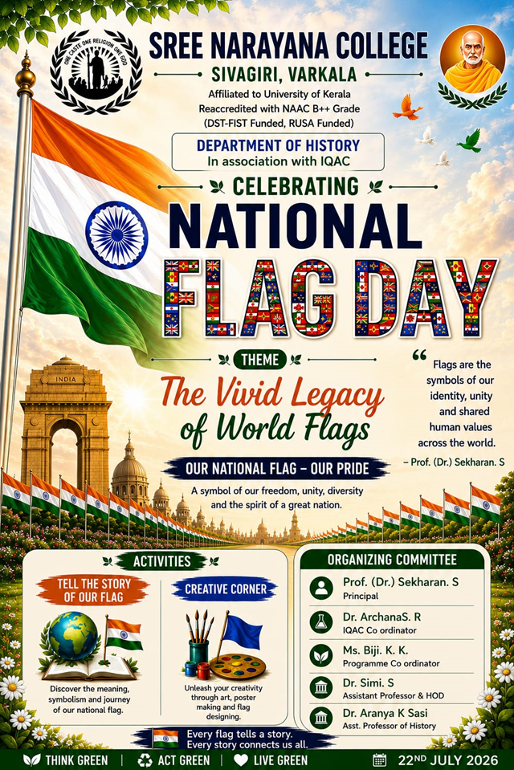

PHOTOS

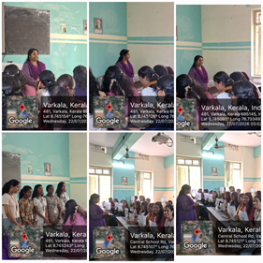
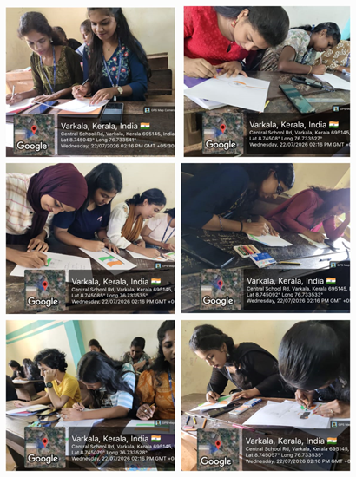
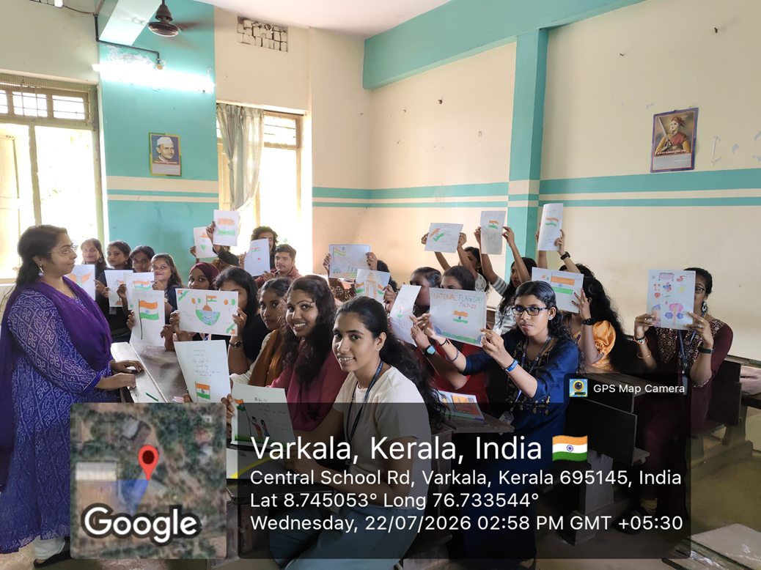
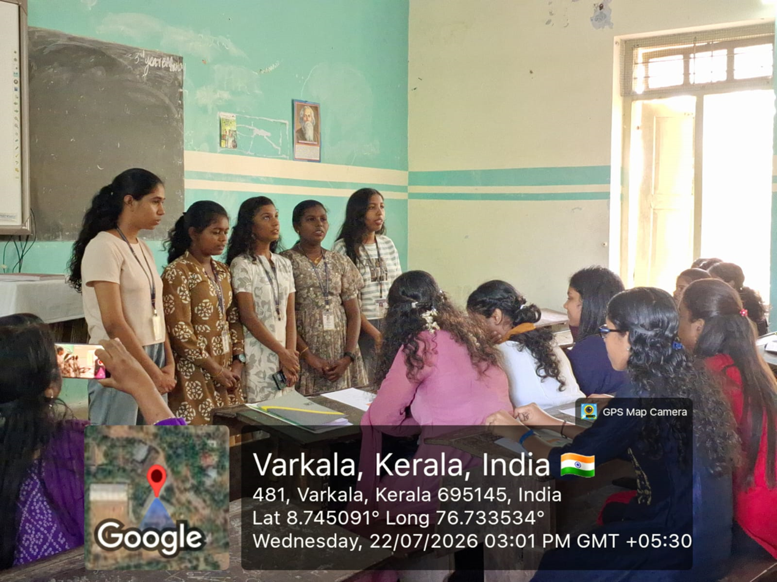

REPORT

National Flag Day Celebration 2026
The Department of History, in association with the Internal Quality Assurance Cell (IQAC), Sree Narayana College, Sivagiri, Varkala, celebrated National Flag Day on 22 July 2026 with the theme "The Vivid Legacy of World Flags – Our National Flag, Our Pride." The programme aimed to promote patriotism, national unity, and awareness of the historical significance and symbolism of the Indian National Flag while introducing students to the cultural and historical importance of flags across the world.
As part of the celebration, the Department organized two engaging activities: "Tell the Story of Our Flag" and "Creative Corner." The first activity encouraged students to explore and present the history, symbolism, and evolution of the Indian National Flag, highlighting its role in India's freedom struggle and nation-building. Through presentations and discussions, students reflected on the values of unity, diversity, and national identity represented by the Tricolour.
The Creative Corner activity provided students with an opportunity to express their patriotism through poster making, flag designing, and other creative artworks inspired by national and international flags. The activity fostered creativity while enhancing students' appreciation of flags as symbols of identity, culture, and shared human values.
The programme emphasized the importance of respecting the National Flag and understanding its historical and constitutional significance. Students actively participated in the activities, demonstrating enthusiasm and creativity while deepening their knowledge of national heritage and civic responsibility.
The programme was organized under the guidance of Prof. (Dr.) Sekaran S., Principal, with the support of Dr. Archana S. R., IQAC Coordinator. The programme was coordinated by Ms. Biji K. K., Programme Coordinator, with the organizing committee comprising Dr. Simi S., Head and Assistant Professor, Department of History, and Dr. Aranya K. Sasi, Assistant Professor, Department of History.
The celebration concluded successfully with enthusiastic student participation, reinforcing the message that the National Flag is a powerful symbol of freedom, unity, and democratic values, inspiring every citizen to uphold the ideals of the nation.

