SREE NARAYANA COLLEGE, SIVAGIRI, VARKALA,
THE DEPARTMENT OF HISTORY

Hands-on Botany: Laboratory and Museum Experience – An Educational Visit by the Department of History Students

BROCHURE
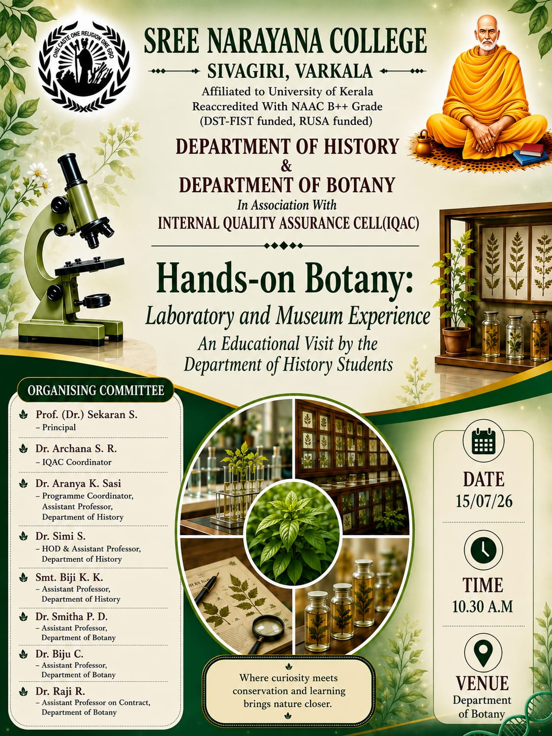

PHOTOS
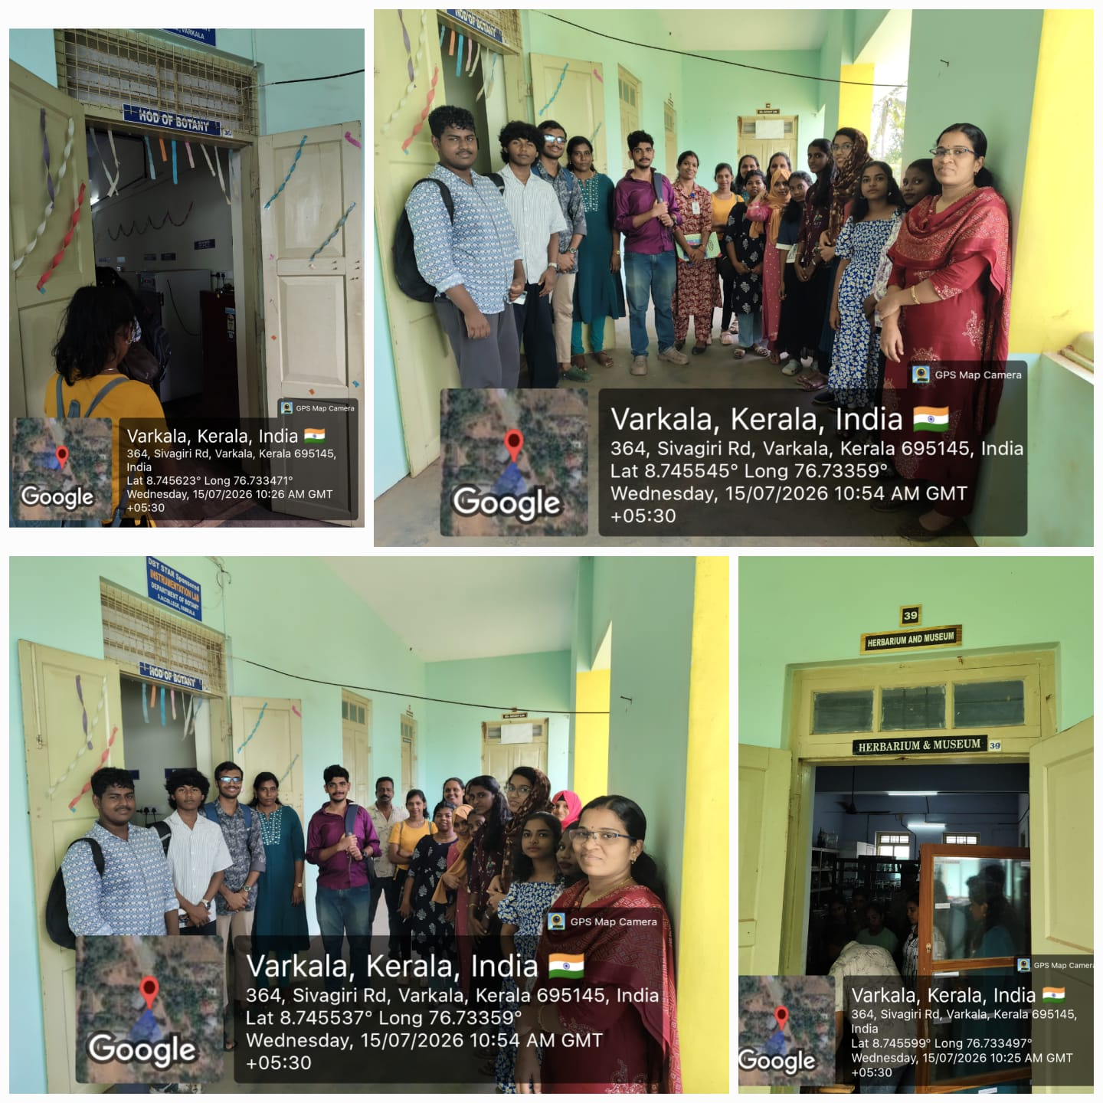
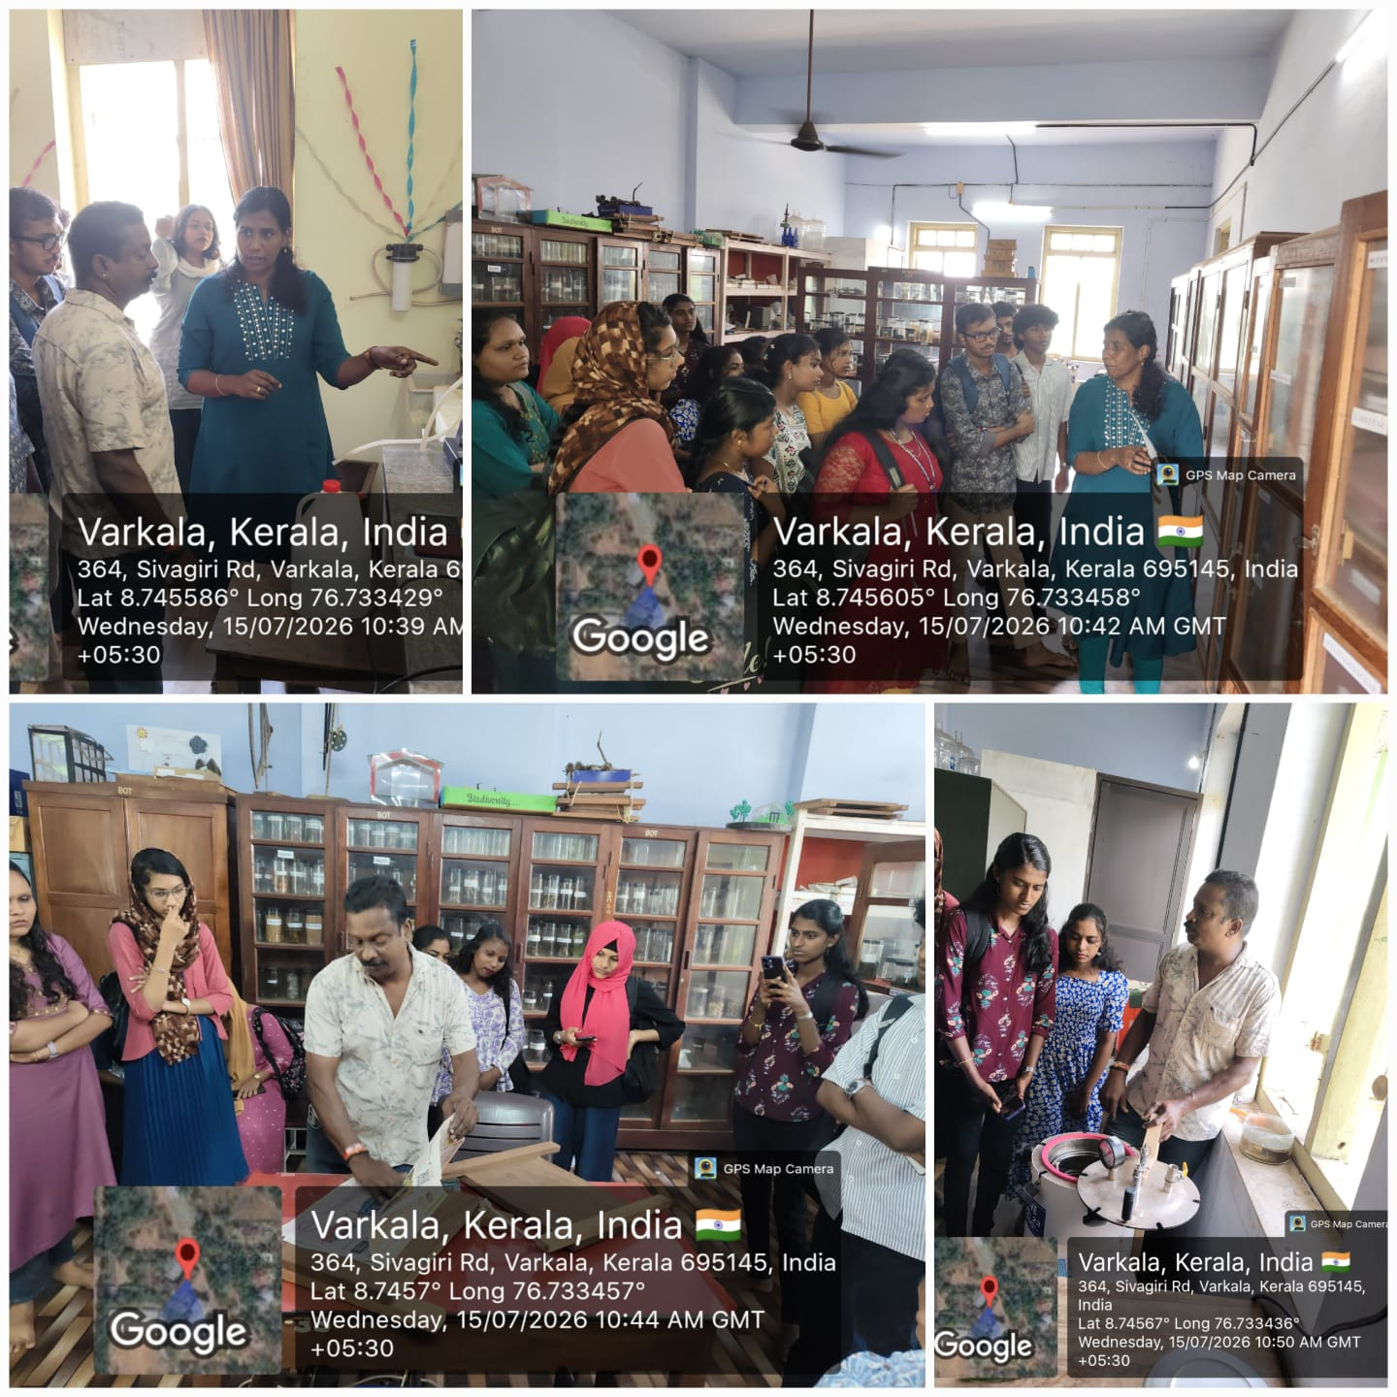
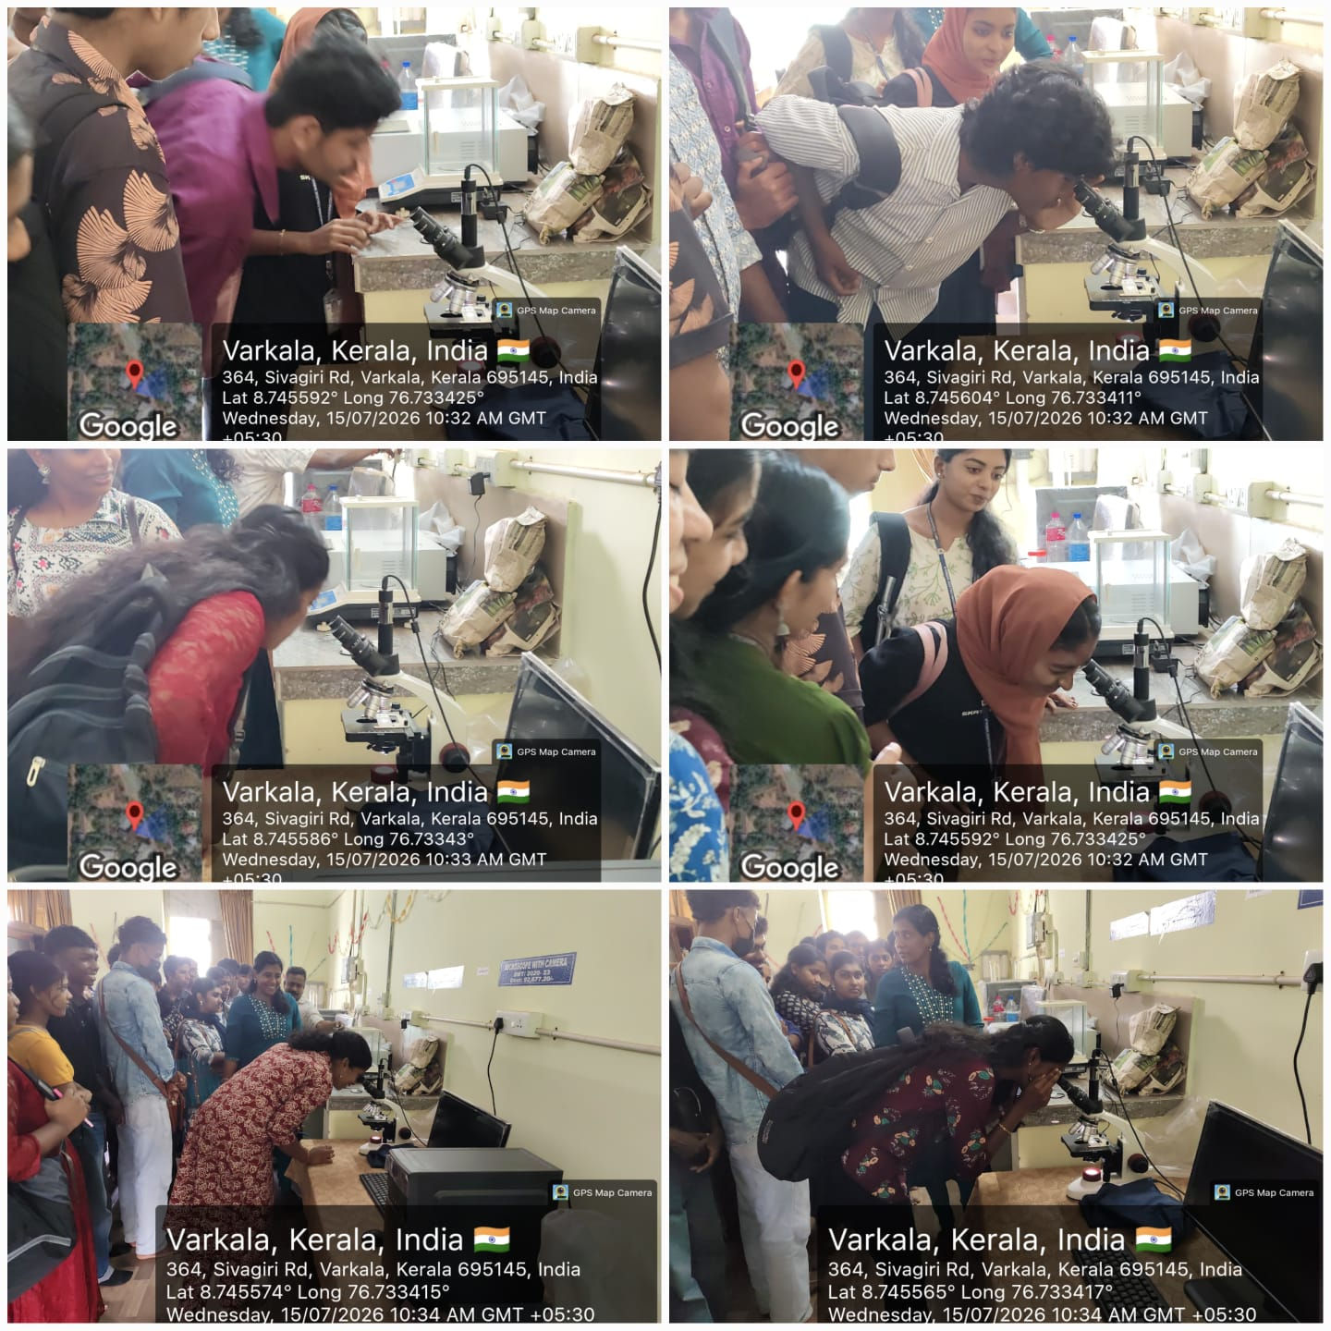
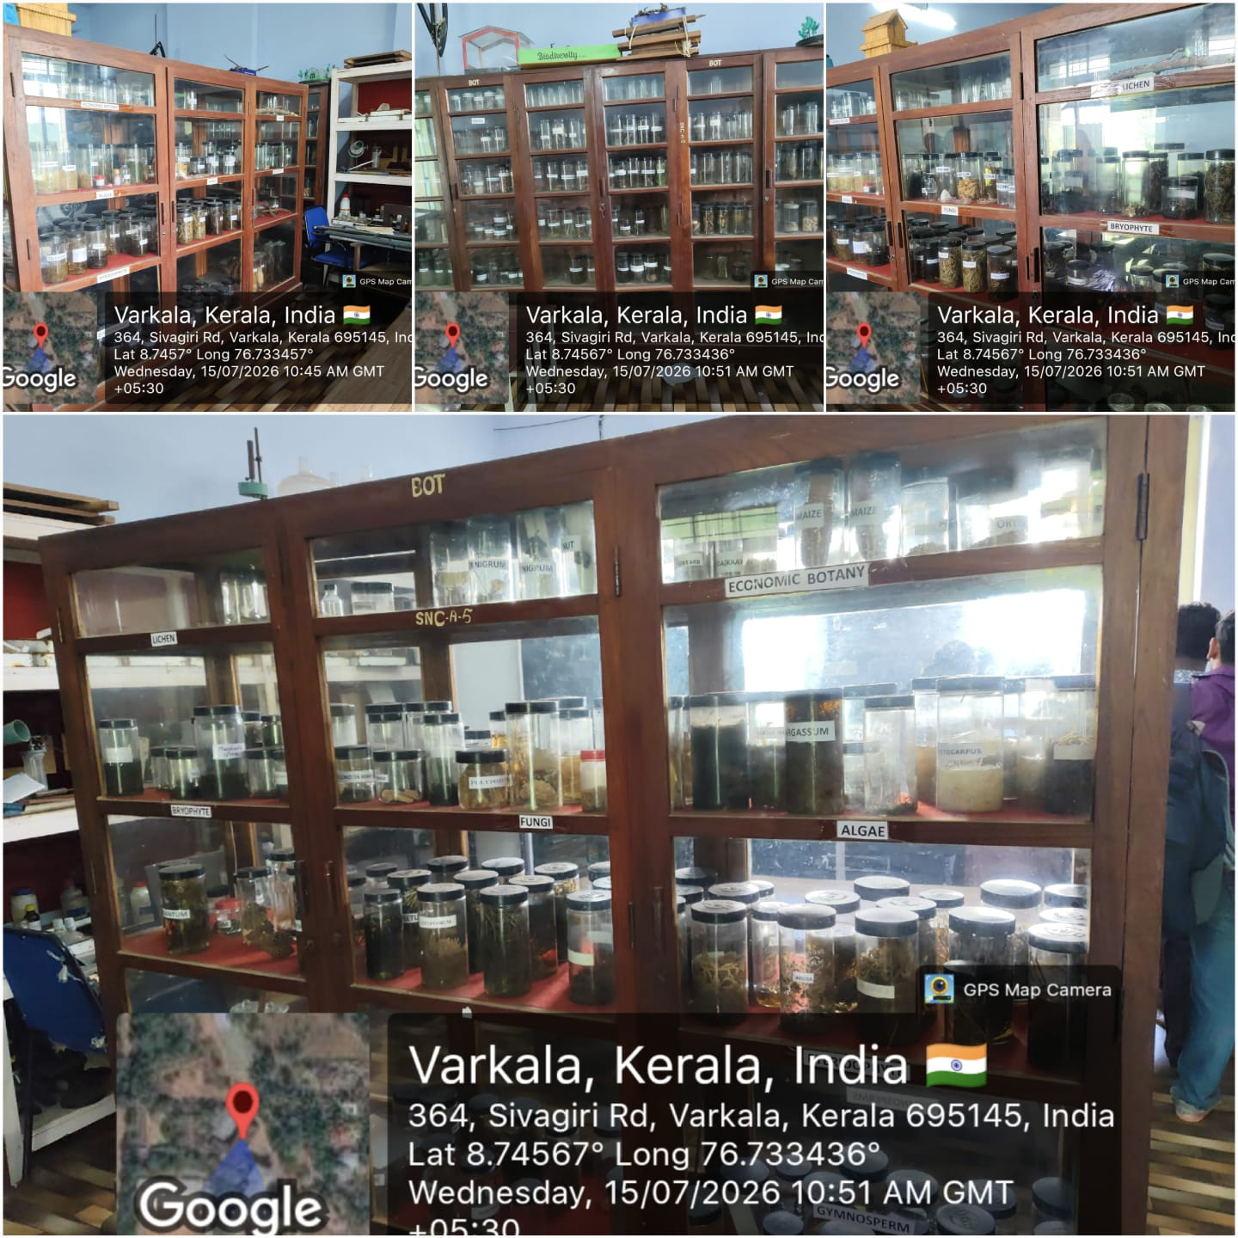
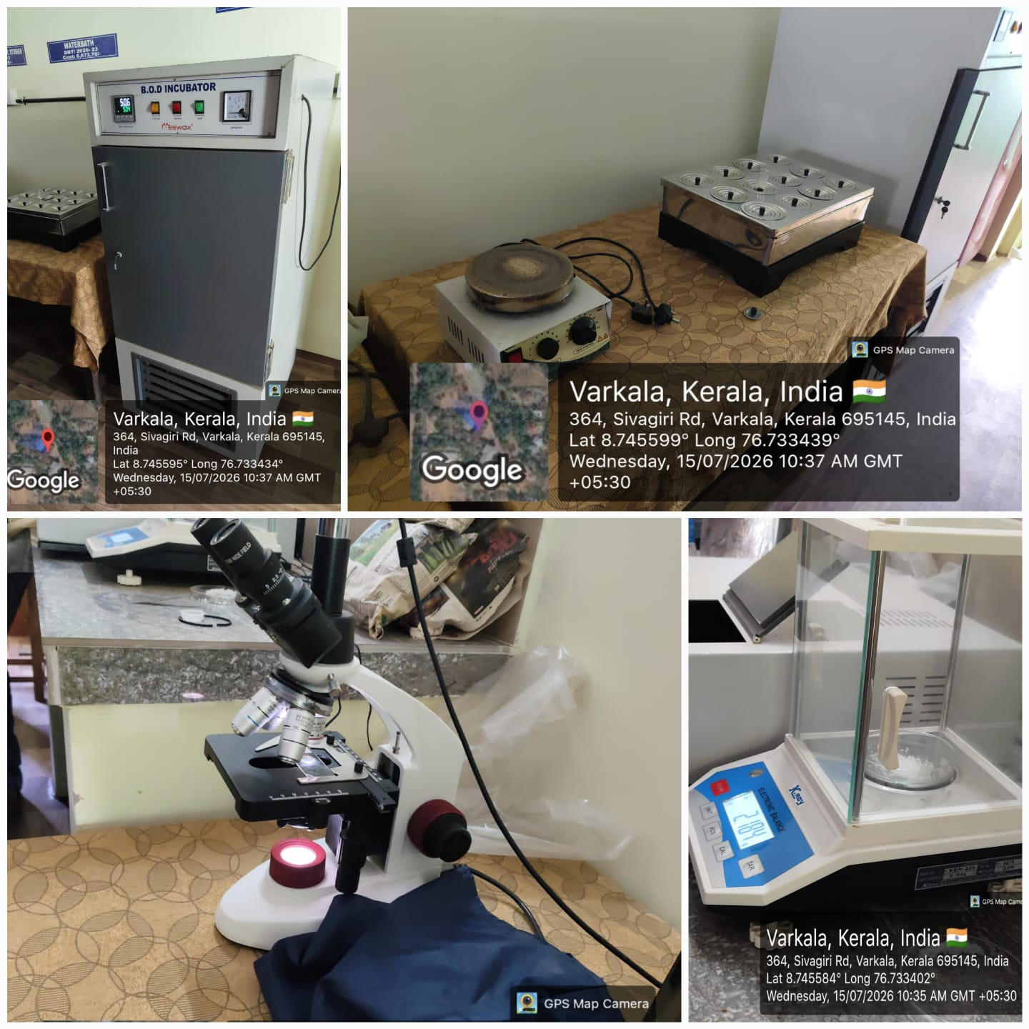

REPORT

Hands-on Botany: Laboratory and Museum Experience – An Educational Visit by the Department of History Students
The Department of History, in collaboration with the Department of Botany and in association with the Internal Quality Assurance Cell (IQAC), Sree Narayana College, Sivagiri, Varkala, organized "Hands-on Botany: Laboratory and Museum Experience – An Educational Visit by the Department of History Students" on 15 July 2026 at 10:30 A.M. in the Department of Botany.
The educational visit was organized to provide History students with an opportunity to experience the practical aspects of Botany through laboratory demonstrations and museum exhibits. The programme aimed to promote interdisciplinary learning by introducing students to plant diversity, botanical research methods, specimen preservation, and the scientific importance of botanical collections.
During the visit, students explored the Botany Laboratory and Museum, where they observed preserved plant specimens, herbarium sheets, laboratory instruments, and botanical models. Faculty members explained the techniques used in plant identification, classification, specimen preservation, and biodiversity documentation. The students also gained an understanding of the role of botanical museums in research, conservation, and environmental education.
The interactive session enabled participants to appreciate the close relationship between history, ecology, biodiversity, and environmental conservation. Students actively interacted with the faculty members, clarified their doubts, and developed a broader understanding of the significance of plant sciences in addressing contemporary environmental challenges.
The programme was organized under the guidance of Prof. (Dr.) Sekaran S., Principal, with the support of Dr. Archana S. R., IQAC Coordinator. The programme was coordinated by Dr. Aranya K. Sasi, Programme Coordinator and Assistant Professor, Department of History. The organizing committee also included Dr. Simi S., Head & Assistant Professor, Department of History, Smt. Biji K. K., Assistant Professor, Department of History, Dr. Smitha P. D., Assistant Professor, Department of Botany, Dr. Biju C., Assistant Professor, Department of Botany, and Dr. Raji R., Assistant Professor (on Contract), Department of Botany.
The programme concluded successfully with enthusiastic participation from the students. The educational visit strengthened interdisciplinary learning and enhanced students' awareness of biodiversity conservation, botanical research, and the importance of museums and laboratories as centres of knowledge and scientific inquiry.

