SREE NARAYANA COLLEGE, SIVAGIRI, VARKALA,
THE DEPARTMENT OF HISTORY

BROCHURE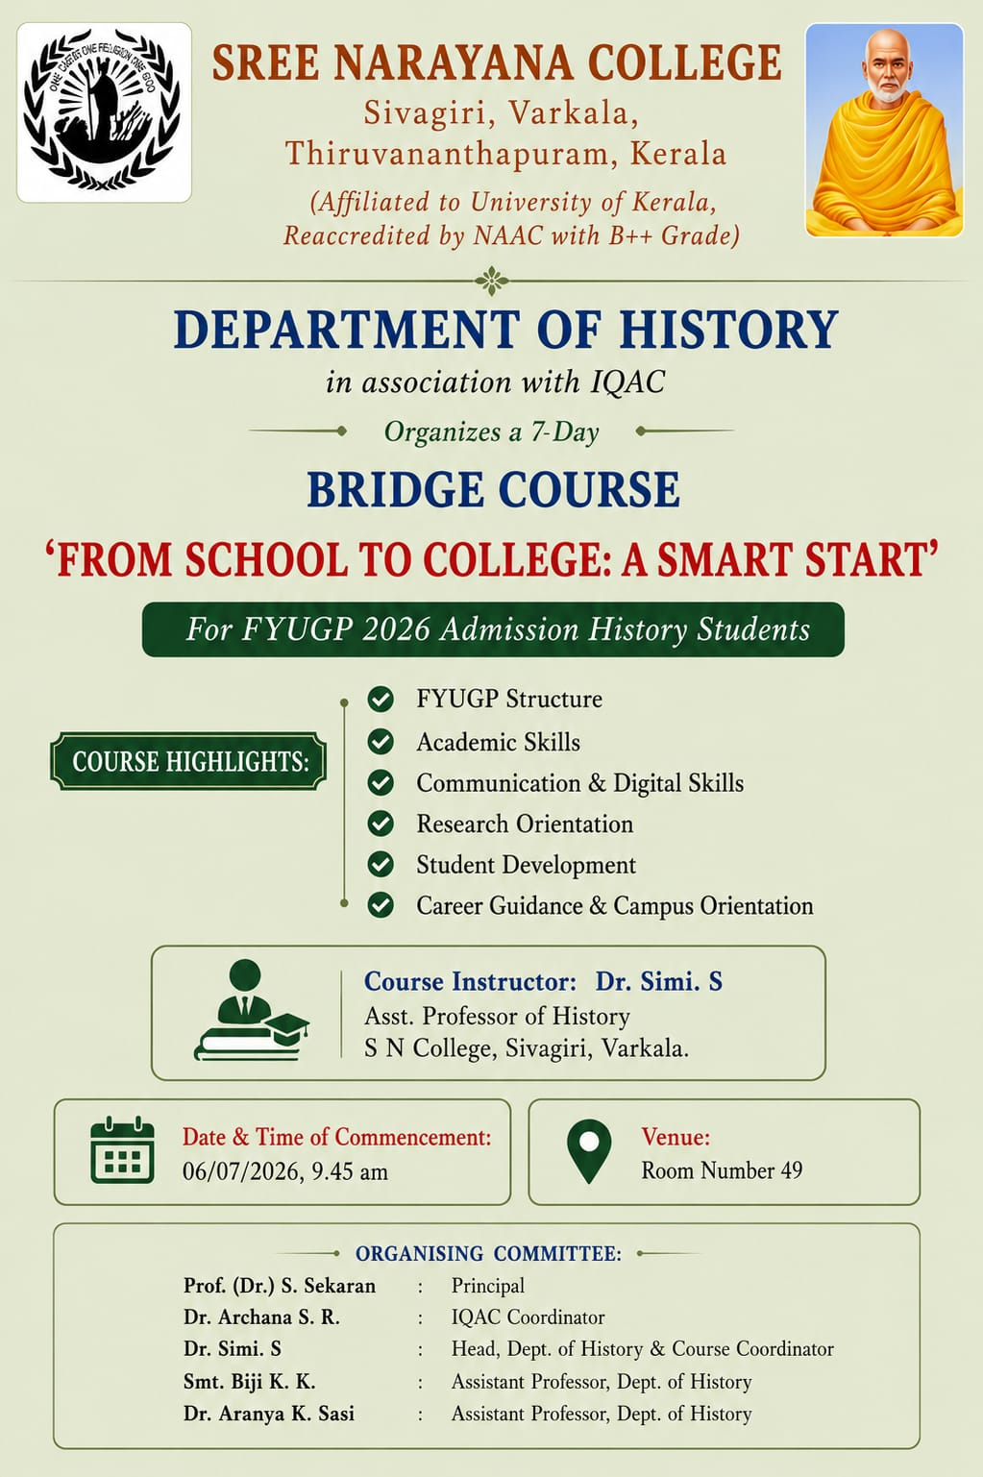
Photos
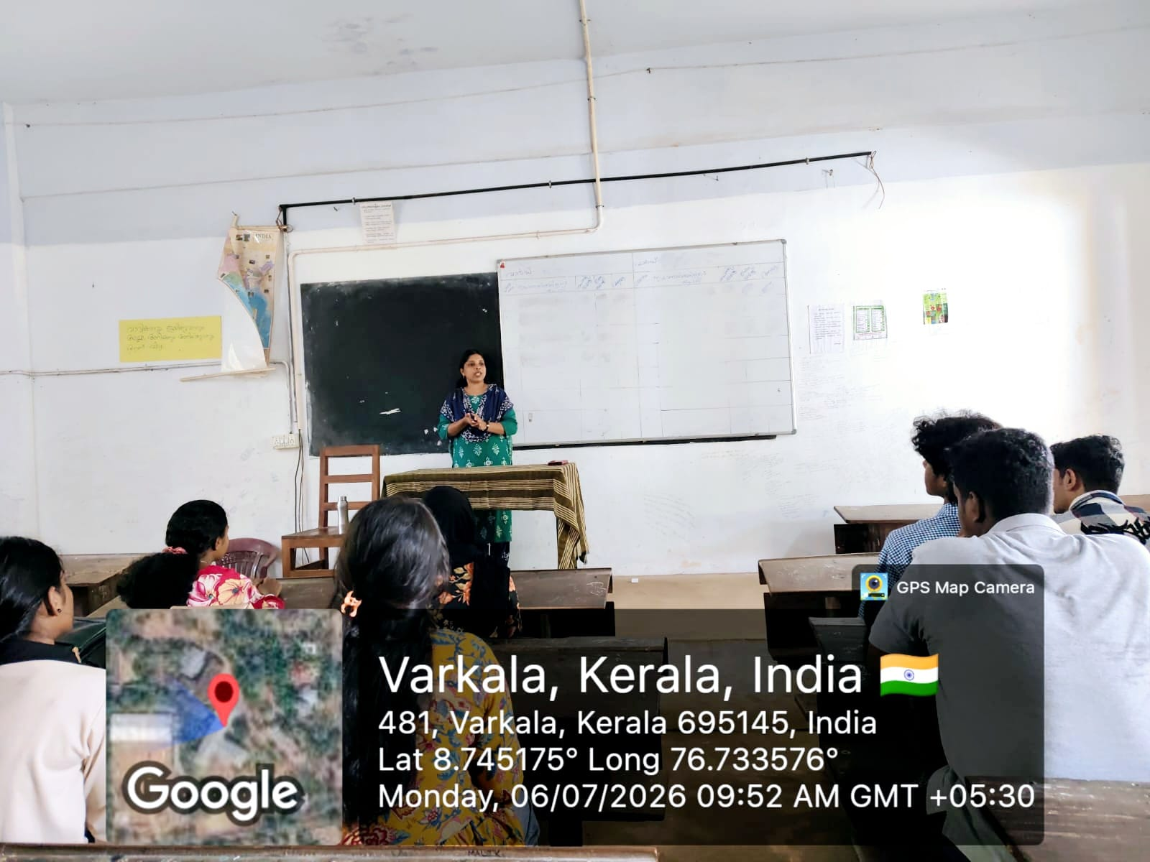
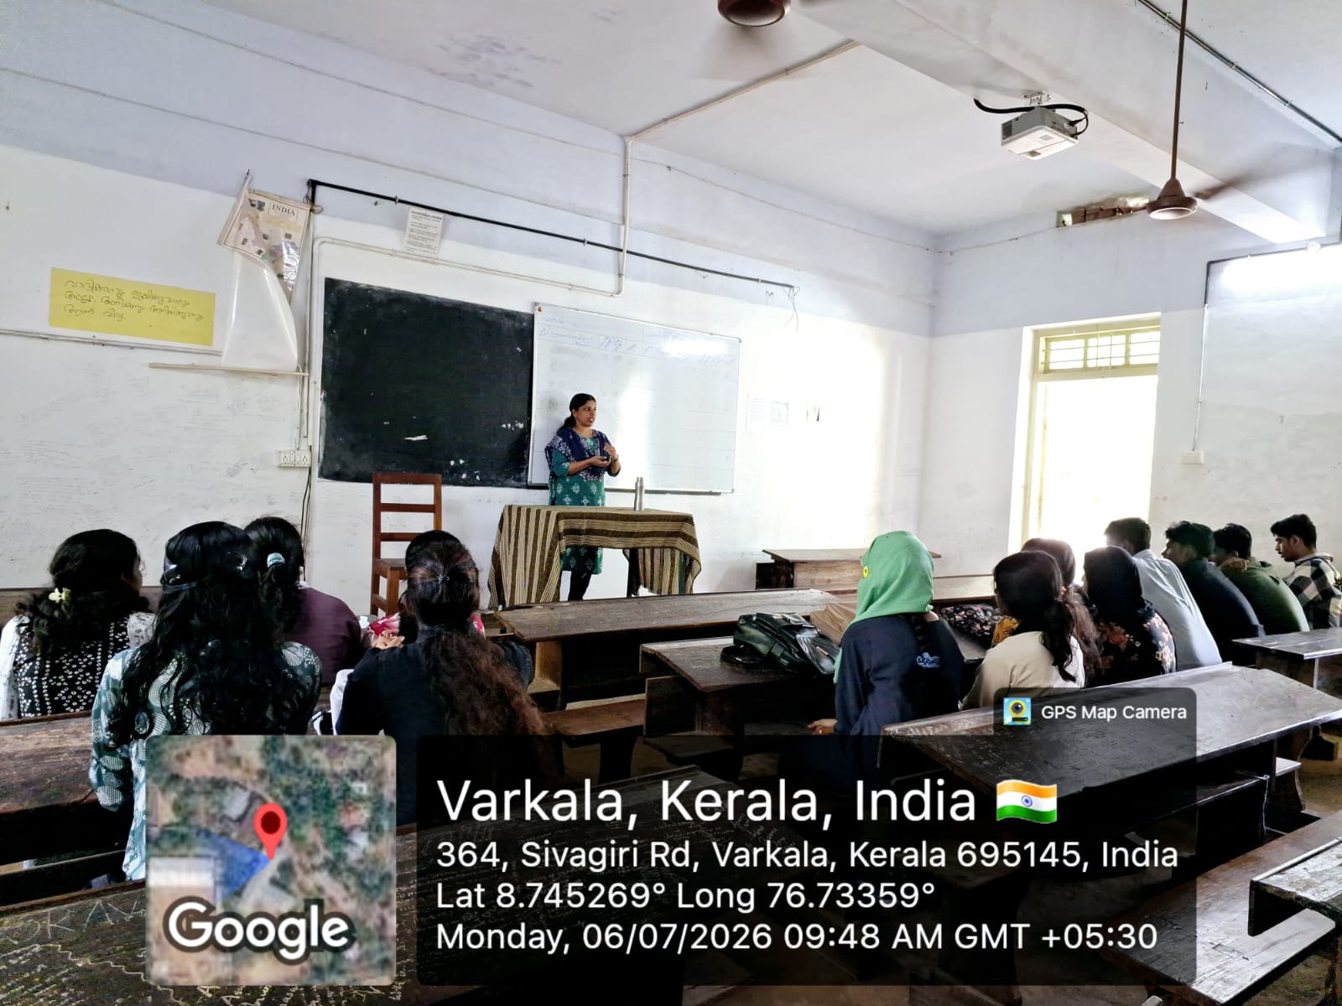

Report

Bridge Course: "From School to College – A Smart Start"

The Department of History, in association with the Internal Quality Assurance Cell (IQAC), Sree Narayana College, Sivagiri, Varkala, launched the 7-Day Bridge Course titled "From School to College – A Smart Start" for FYUGP 2026 Admission History Students. The programme commenced on 6 July 2026 at 9:45 A.M. in Room No. 49 with the objective of helping newly admitted students make a smooth transition from school education to the academic environment of higher education.
The bridge course was designed to familiarize students with the FYUGP curriculum, academic expectations, and essential learning strategies required for success in college. The programme focused on developing students' academic confidence, communication skills, digital literacy, research orientation, personality development, and career awareness.
The course was conducted by Dr. Simi S., Assistant Professor, Department of History, who served as the Course Instructor. Through interactive sessions, discussions, and practical activities, students were introduced to the structure of the FYUGP programme, effective study techniques, communication and digital skills, research fundamentals, student development initiatives, and campus orientation. The sessions encouraged active participation and helped students develop the confidence required to adapt to higher education.
The programme was organized under the guidance of Prof. (Dr.) S. Sekaran, Principal, with the support of Dr. Archana S. R., IQAC Coordinator. The organizing committee comprised Dr. Simi S. (Head, Department of History & Course Coordinator), Smt. Biji K. K. (Assistant Professor, Department of History), and Dr. Aranya K. Sasi (Assistant Professor, Department of History).
The bridge course witnessed enthusiastic participation from first-year History students and successfully fulfilled its objective of preparing them for college life by strengthening their academic foundation, enhancing essential life skills, and creating awareness about the opportunities available under the FYUGP framework. The programme concluded with positive feedback from participants, marking a successful beginning to their undergraduate academic journey.

