SREE NARAYANA COLLEGE, SIVAGIRI, VARKALA,
THE DEPARTMENT OF HISTORY
Bridge courses in different sessions

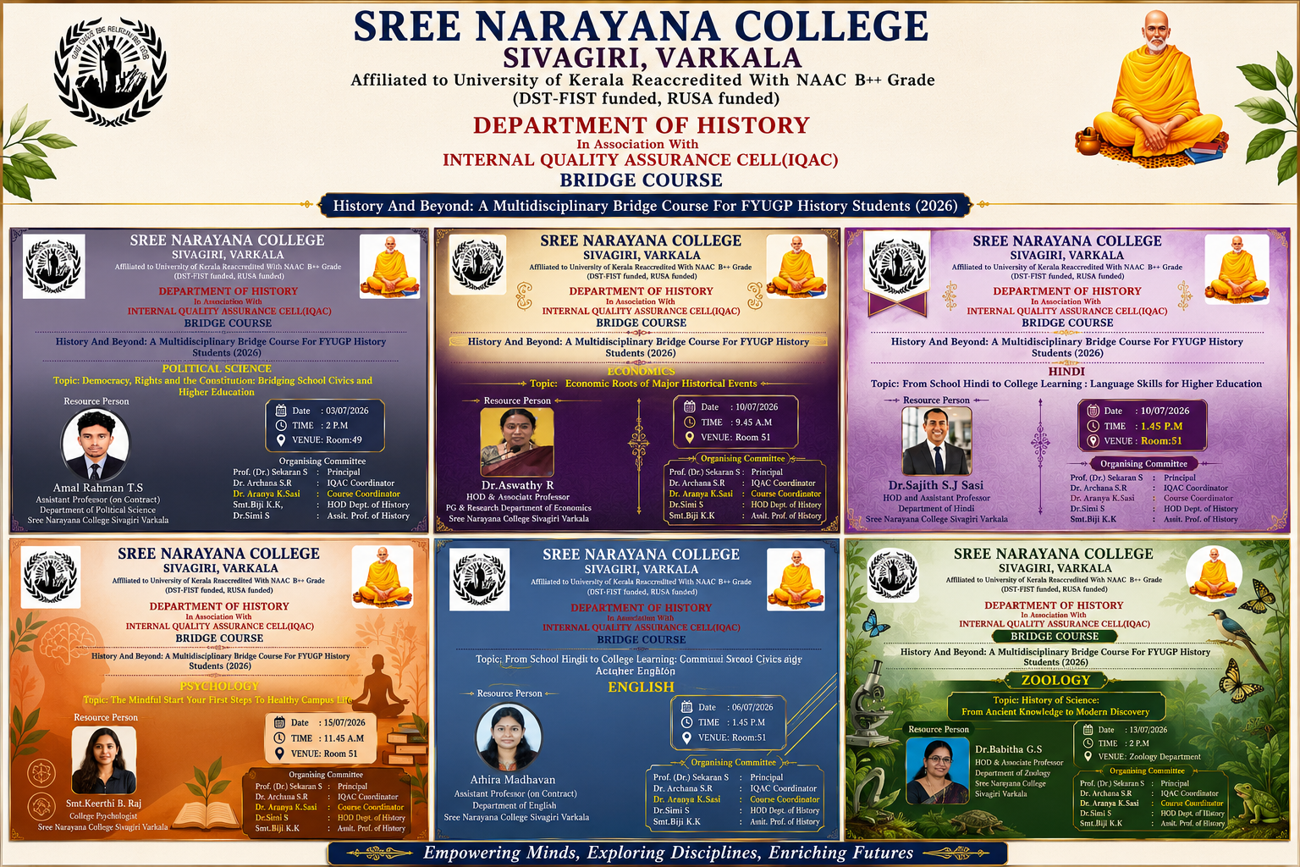

Bridge courses in different sessions

Report

Bridge Course – Different Academic Sessions
The Department of History, in association with the Internal Quality Assurance Cell (IQAC), Sree Narayana College, Sivagiri, Varkala, successfully conducted a series of Bridge Course sessions under the title "History and Beyond: A Multidisciplinary Bridge Course for FYUGP History Students (2026)". The programme was designed to facilitate the smooth transition of first-year students from school to higher education by introducing them to interdisciplinary perspectives and essential academic skills.
The Bridge Course comprised sessions delivered by experts from various departments, enabling students to appreciate the interconnectedness of History with other disciplines. Each session focused on strengthening students' foundational knowledge while enhancing their critical thinking, communication, and analytical abilities.
The sessions included:
- Political Science: Democracy, Rights and the Constitution: Bridging School Civics and Higher Education, delivered by Mr. Amal Rahman T. S., Assistant Professor (on Contract), Department of Political Science.
- English: From School English to College Learning: Communication Skills and Academic English, handled by Ms. Athira Madhavan, Assistant Professor (on Contract), Department of English.
- Sanskrit: From School Sanskrit to College Learning: Language, Literature and Cultural Heritage, presented by Dr. Sunitha S., Assistant Professor (on Contract), Department of Sanskrit.
- Economics: Economic Roots of Major Historical Events, delivered by Dr. Aswathy R., Head and Associate Professor, PG & Research Department of Economics.
- Hindi: From School Hindi to College Learning: Language Skills for Higher Education, handled by Dr. Sajith S. J. Sasi, Head and Assistant Professor, Department of Hindi.
- Zoology: History of Science: From Ancient Knowledge to Modern Discovery, presented by Dr. Babitha G. S., Head and Associate Professor, Department of Zoology.
- Botany: Biology and History: The Story of Life and Civilization, delivered by Dr. Smitha P. D., Head and Assistant Professor, Department of Botany.
- Psychology: The Mindful Start: Your First Steps to Healthy Campus Life, presented by Smt. Keerthi B. Raj, College Psychologist.
The programme was organized under the guidance of Prof. (Dr.) Sekaran S., Principal, with the support of Dr. Archana S. R., IQAC Coordinator. The organizing committee comprised Dr. Aranya K. Sasi (Course Coordinator), Smt. Biji K. K. (Head, Department of History), and Dr. Simi S. (Assistant Professor, Department of History).
The Bridge Course sessions witnessed active participation from FYUGP History students and provided them with valuable insights into multidisciplinary learning, academic expectations, communication skills, constitutional values, scientific perspectives, cultural heritage, environmental awareness, and mental well-being. The programme successfully fulfilled its objective of preparing students for higher education by fostering confidence, curiosity, and a holistic understanding of the diverse disciplines that enrich the study of History.

