SREE NARAYANA COLLEGE, SIVAGIRI, VARKALA,
THE DEPARTMENT OF HISTORY

Inauguration of Bridge Courses for FYUGP History Students (2026) & Short-Term Courses
Brochure
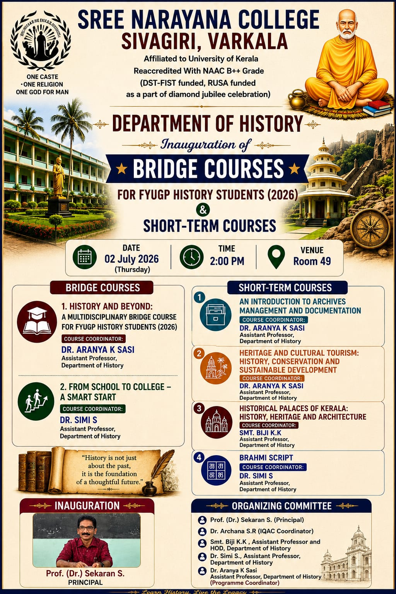

Photos
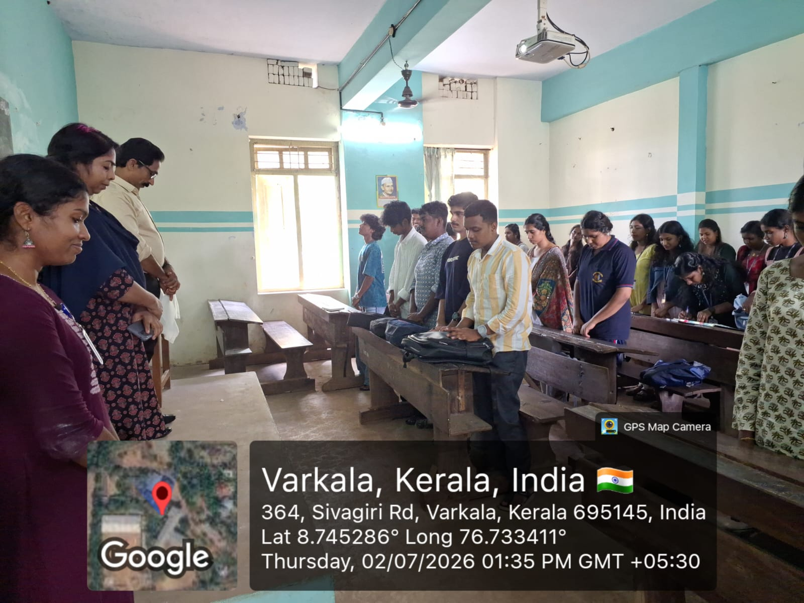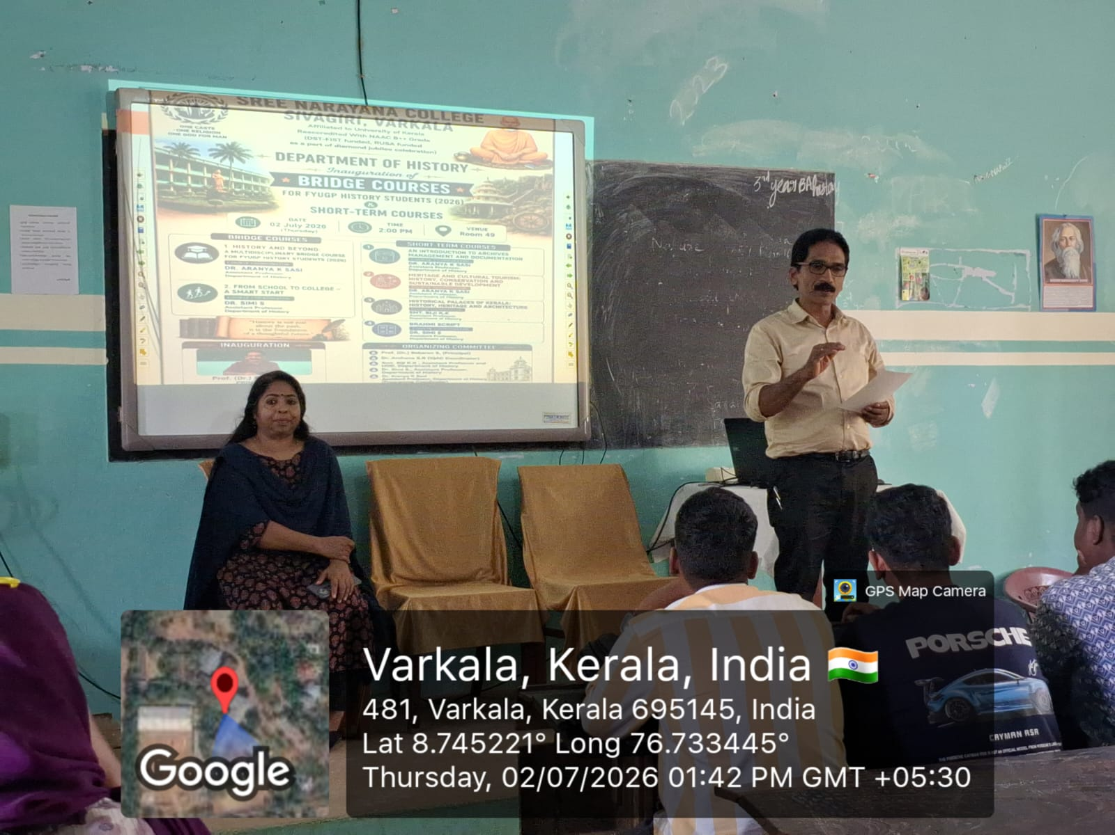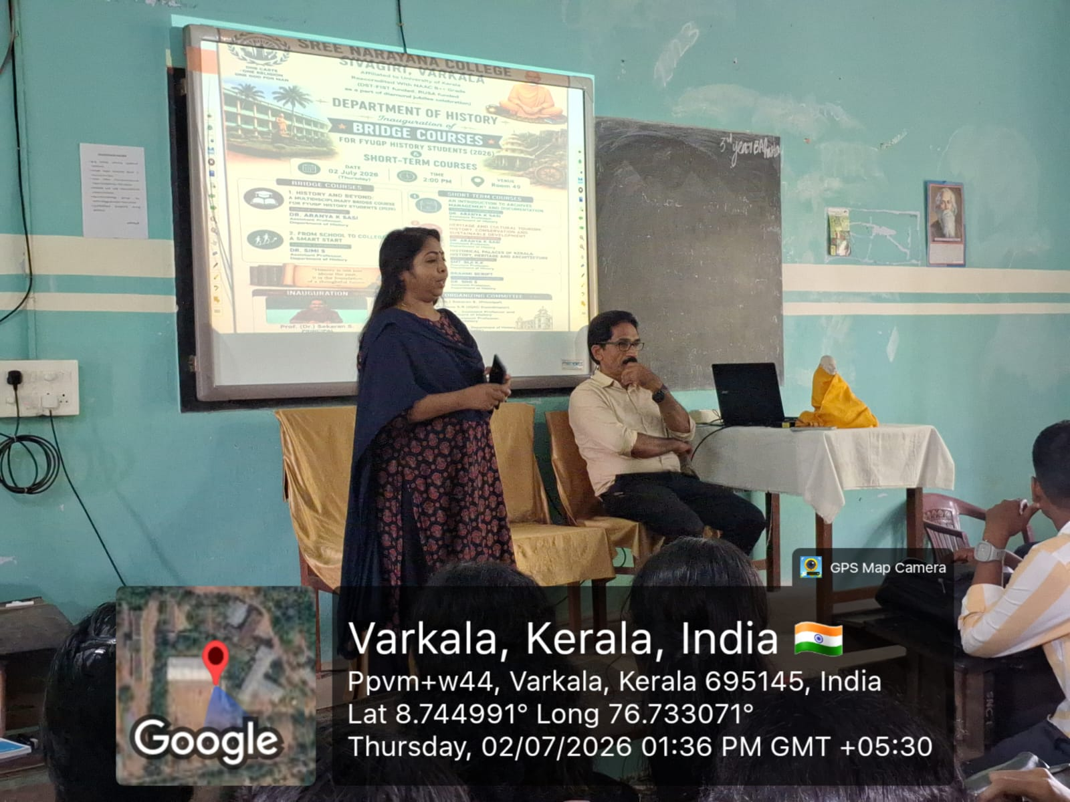

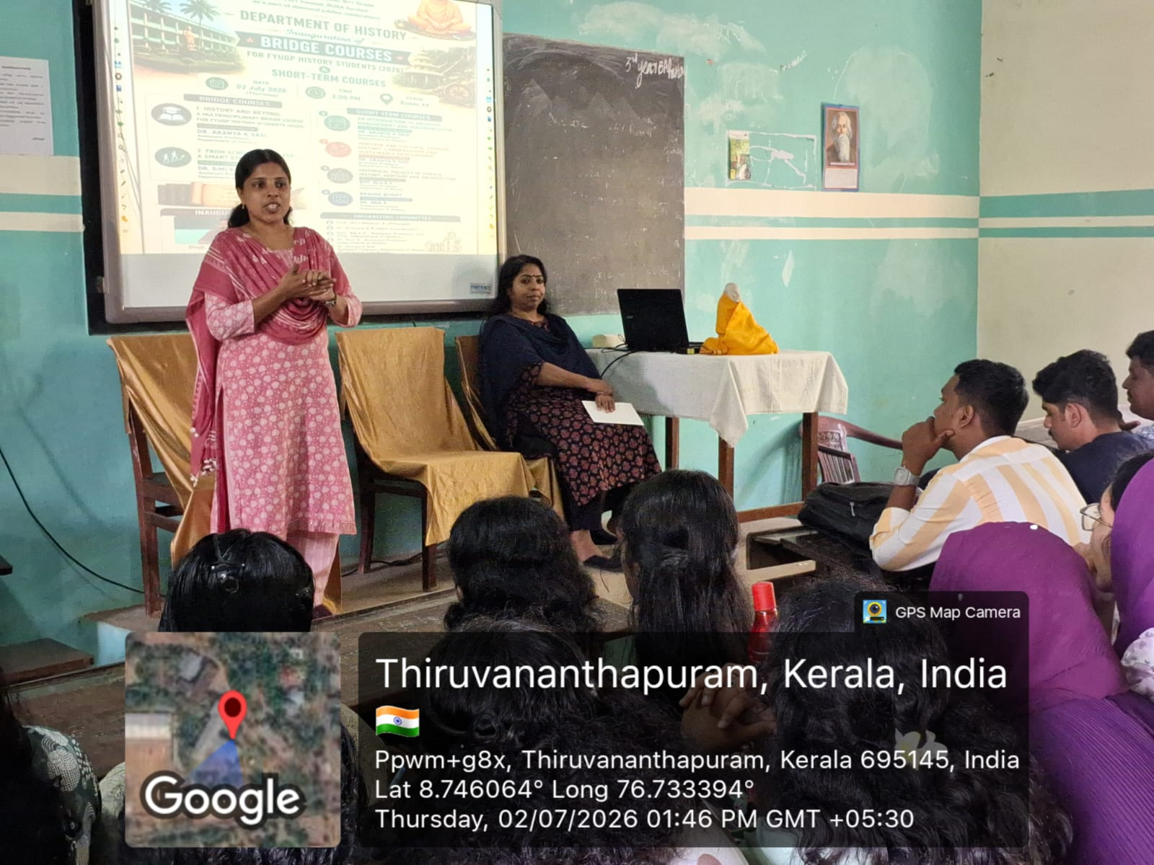
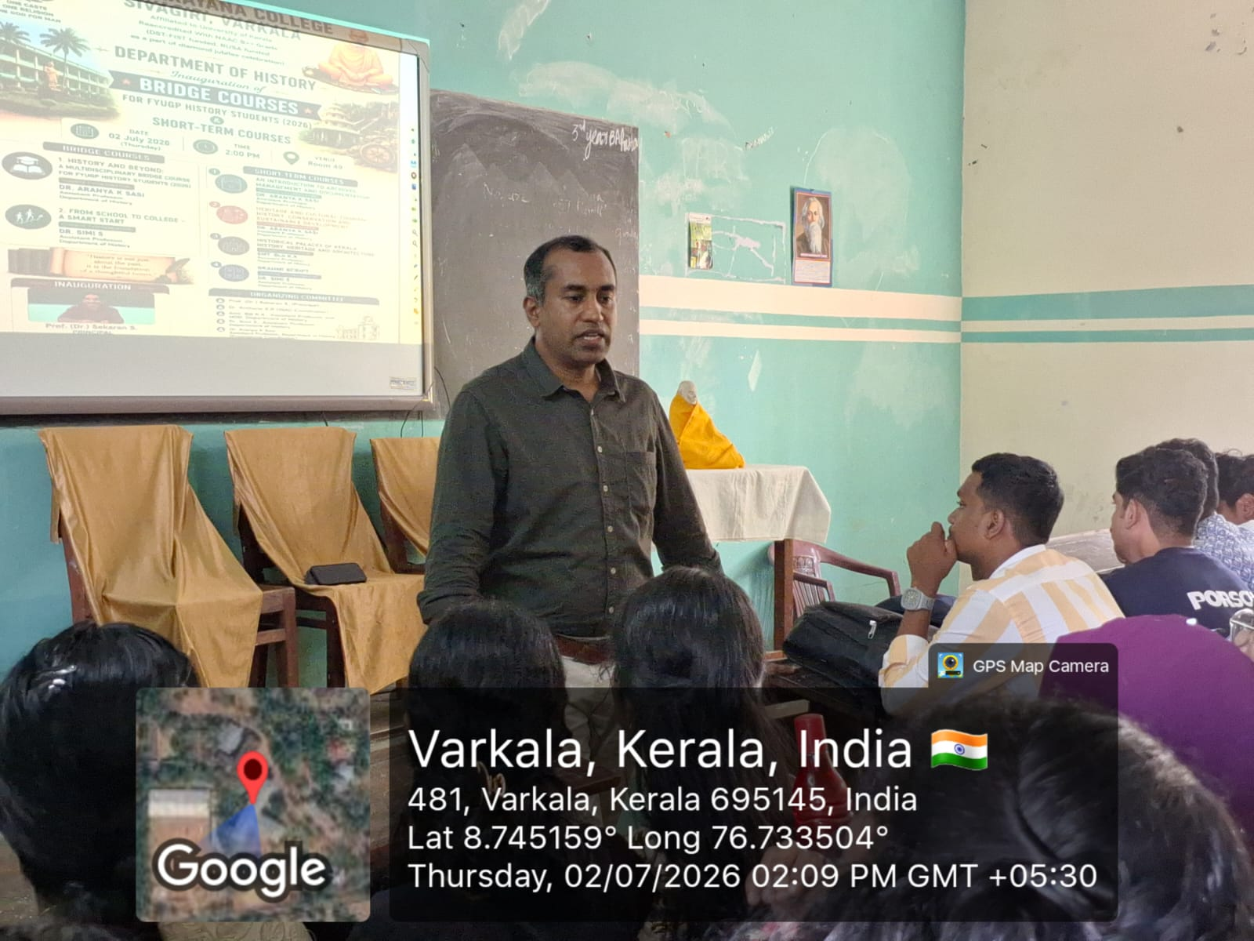
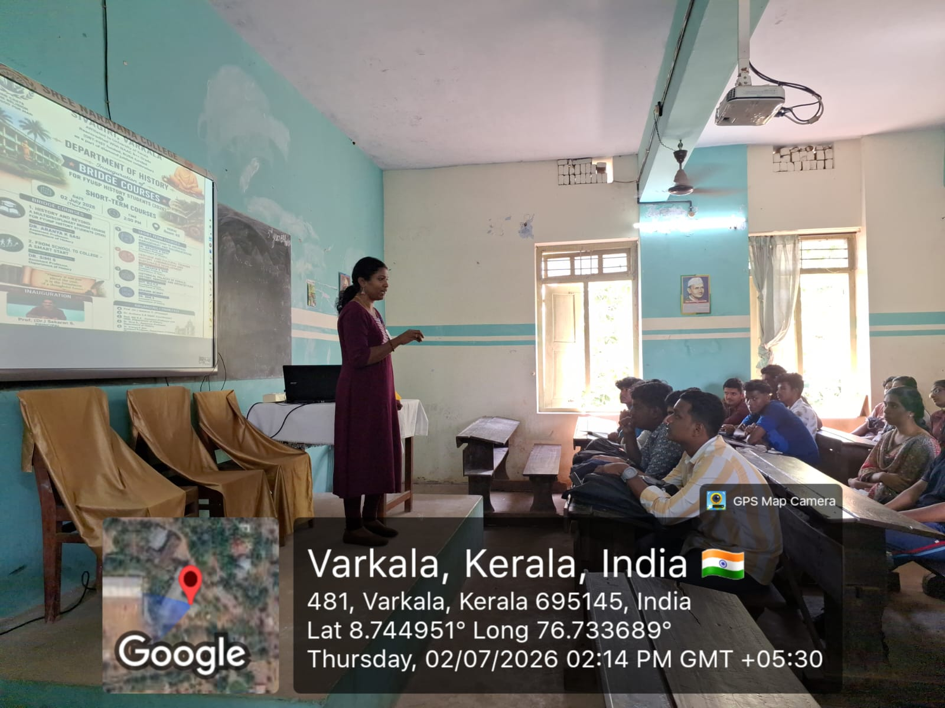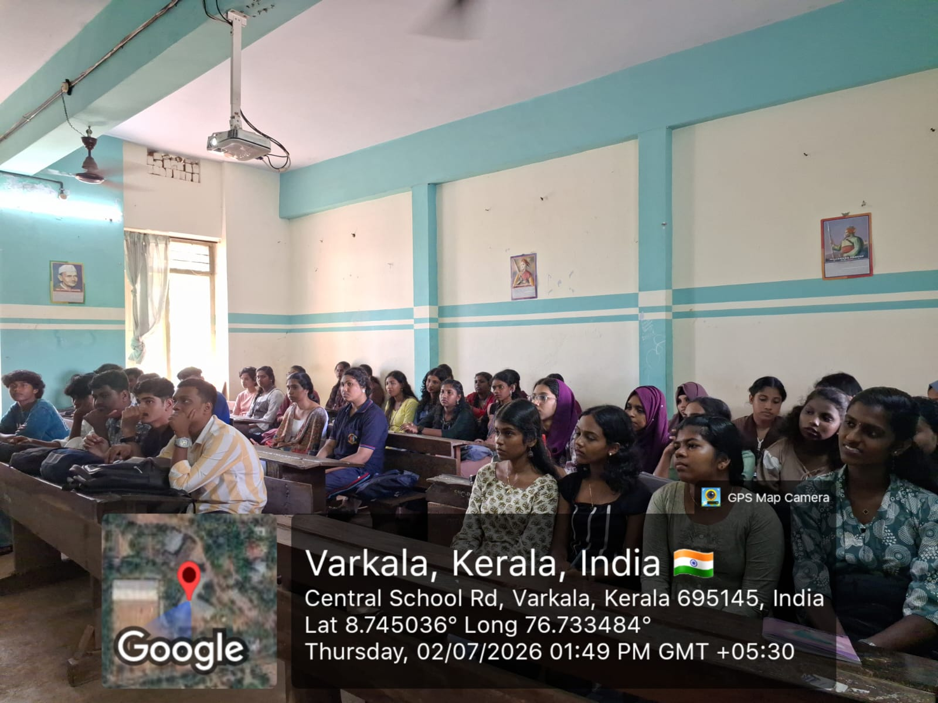

Report

Inauguration of Bridge Courses for FYUGP History Students (2026) & Short-Term Courses
The Department of History, Sree Narayana College, Sivagiri, Varkala, organized the Inauguration of Bridge Courses for FYUGP History Students (2026) and Short-Term Courses on 2 July 2026 at 2:00 P.M. in Room No. 49. The programme was conducted as part of the Diamond Jubilee Celebrations of the college with the objective of equipping newly admitted FYUGP History students with the academic skills and interdisciplinary knowledge required for a smooth transition to higher education.
The inaugural session was presided over by Prof. (Dr.) Sekaran S., Principal, who formally inaugurated the programme. In his inaugural address, he emphasized the significance of bridge courses in helping students adapt to the academic environment of higher education. He encouraged students to actively participate in the courses to strengthen their subject knowledge, improve their learning skills, and explore interdisciplinary perspectives in History.
The Bridge Course programme introduced two specially designed courses for first-year History students:
- History and Beyond: A Multidisciplinary Bridge Course for FYUGP History Students (2026), coordinated by Dr. Aranya K. Sasi, Assistant Professor, Department of History.
- From School to College – A Smart Start, coordinated by Dr. Simi S., Assistant Professor, Department of History.
In addition to the bridge courses, the Department launched four Short-Term Courses aimed at enhancing students' practical knowledge and employability:
- An Introduction to Archives Management and Documentation – Course Coordinator: Dr. Aranya K. Sasi
- Heritage and Cultural Tourism: History, Conservation and Sustainable Development – Course Coordinator: Dr. Aranya K. Sasi
- Historical Palaces of Kerala: History, Heritage and Architecture – Course Coordinator: Smt. Biji K. K.
- Brahmi Script – Course Coordinator: Dr. Simi S.
The programme highlighted the Department's commitment to providing quality academic enrichment through multidisciplinary learning, skill development, and heritage education. Students were introduced to the objectives, structure, and outcomes of each course, encouraging them to actively participate and make the best use of these academic opportunities.
The programme was organized under the guidance of Prof. (Dr.) Sekaran S., Principal, with the support of Dr. Archana S. R., IQAC Coordinator. The organizing committee included Smt. Biji K. K., Assistant Professor and Head, Department of History, Dr. Simi S., Assistant Professor, Department of History, and Dr. Aranya K. Sasi, Assistant Professor, Department of History (Programme Coordinator), whose coordinated efforts ensured the successful conduct of the inauguration.
The event concluded with a vote of thanks, expressing gratitude to the Principal, faculty members, and students for their active participation. The inauguration marked the beginning of a series of innovative academic initiatives designed to enhance students' knowledge, research aptitude, and appreciation of history, heritage, and culture.

