SREE NARAYANA COLLEGE, SIVAGIRI, VARKALA,
THE DEPARTMENT OF HISTORY

Read to Lead: Reading Day Written Quiz Competition

Brochure

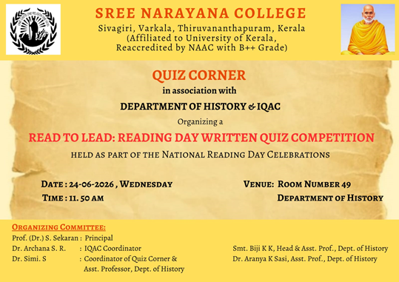

Photos
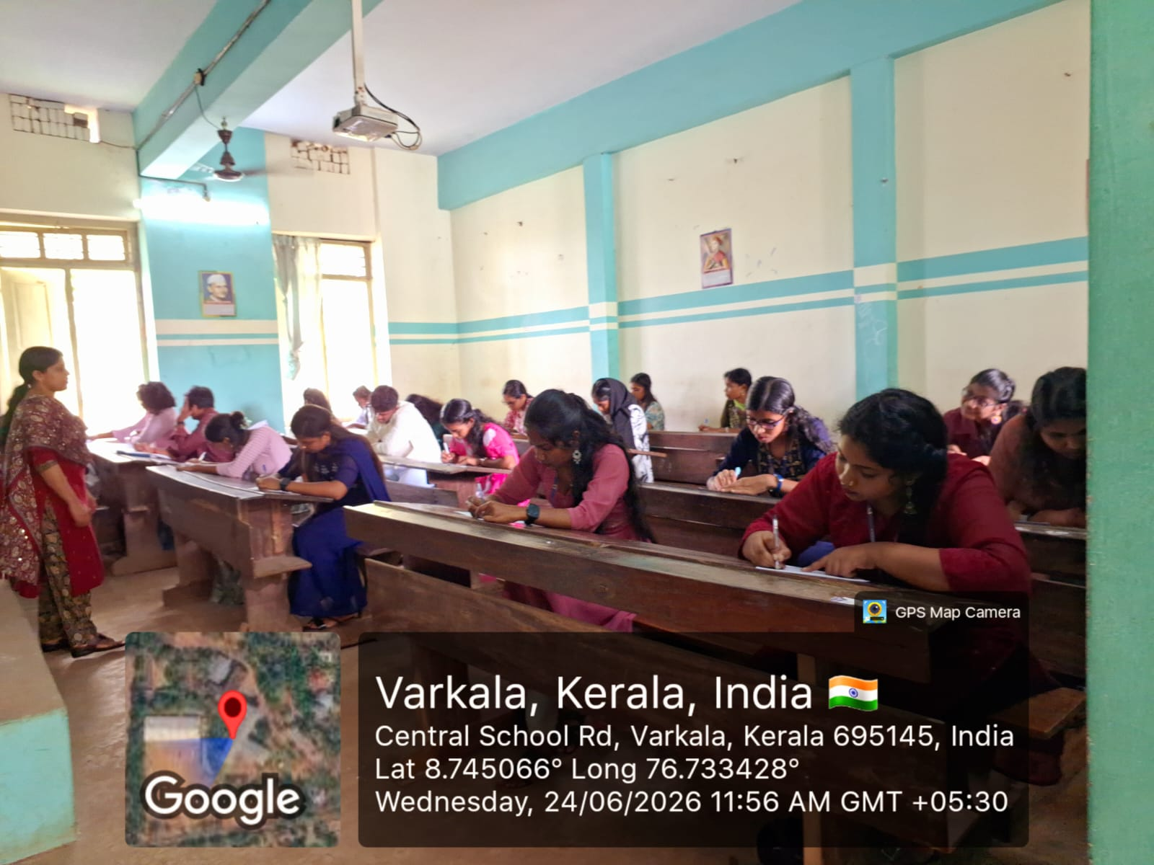
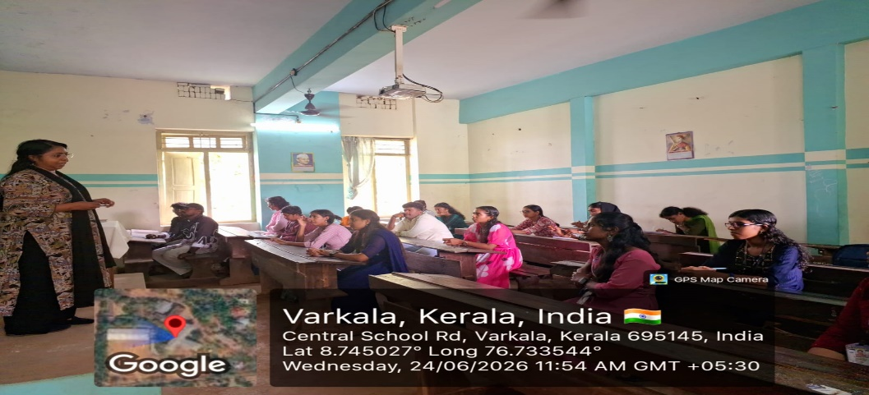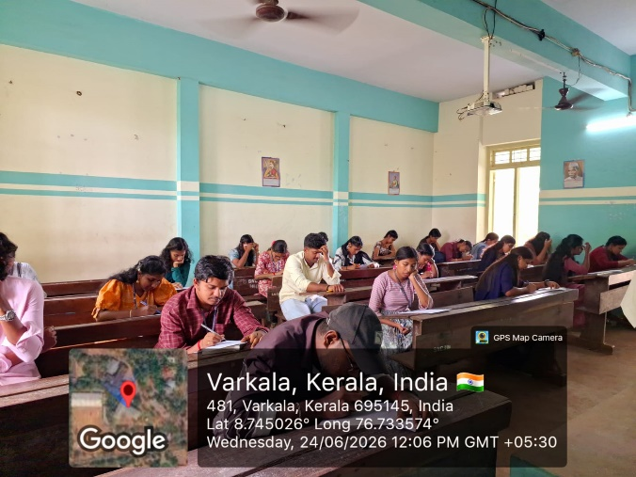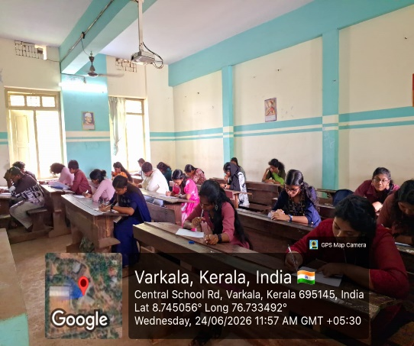

REPORT

Read to Lead: Reading Day Written Quiz Competition
The Quiz Corner, in association with the Department of History and the Internal Quality Assurance Cell (IQAC), Sree Narayana College, Sivagiri, Varkala, successfully organized the "Read to Lead: Reading Day Written Quiz Competition" as part of the National Reading Day Celebrations on 24 June 2026 (Wednesday) at 11.50 A.M. in Room No. 49, Department of History.
The programme was organized under the guidance of Prof. (Dr.) S. Sekaran, Principal, with the support of Dr. Archana S. R., IQAC Coordinator. The organizing committee included Dr. Simi S., Coordinator of Quiz Corner & Assistant Professor, Department of History, Smt. Biji K. K., Head & Assistant Professor, Department of History, and Dr. Aranya K. Sasi, Assistant Professor, Department of History.
The objective of the competition was to cultivate reading habits, enhance knowledge acquisition, and encourage students to develop critical thinking and analytical skills through a written quiz. The event served as a meaningful tribute to National Reading Day, highlighting the importance of reading as a foundation for academic excellence and lifelong learning.
The competition witnessed enthusiastic participation from students across various departments of the college. A total of 24 students participated in the written quiz, demonstrating their enthusiasm for reading and their broad knowledge of literature, current affairs, and general awareness.
The written quiz was conducted in a fair and systematic manner, with questions designed to evaluate participants' comprehension, reasoning ability, and reading aptitude. The event provided an excellent platform for students to challenge themselves academically while fostering a spirit of healthy competition.
Based on their performance, the following students emerged as winners:
- First Prize: Akhilesh A., Department of Economics
- Second Prize: Sreevinayak R. S., Department of Zoology
- Third Prize: R. Gouri Nandana, Department of Geology
- Third Prize: Sreelekshmi J., Department of History
- Third Prize: Rasna S. R., Department of Zoology
The Department congratulated the winners for their outstanding performance and appreciated all participants for their enthusiastic involvement. The programme concluded successfully, reinforcing the importance of reading in intellectual growth, personal development, and academic achievement while inspiring students to cultivate a lifelong love for books and learning.

