SREE NARAYANA COLLEGE, SIVAGIRI, VARKALA,
THE DEPARTMENT OF HISTORY

Eco Talk & Student Reflections
World Environment Day Celebrations 2026

Brochure
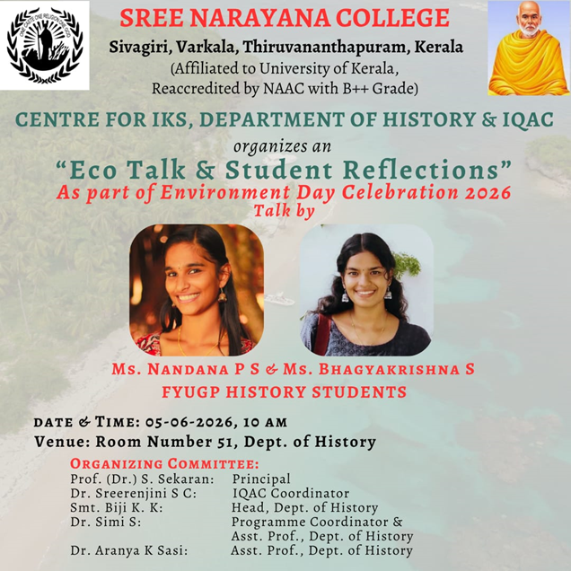

Photos

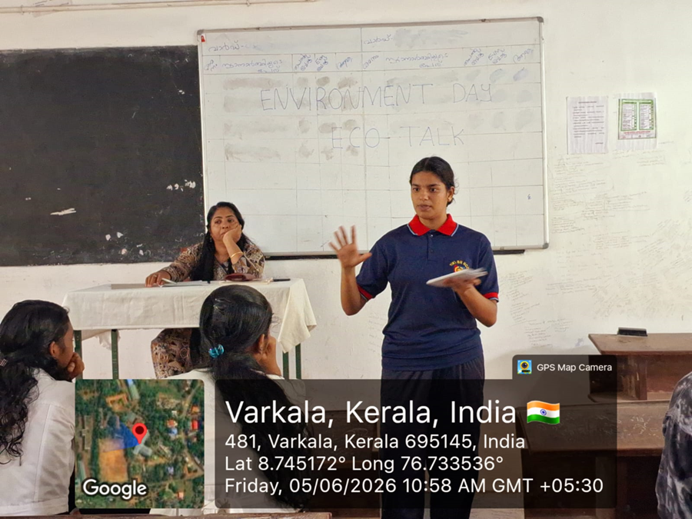

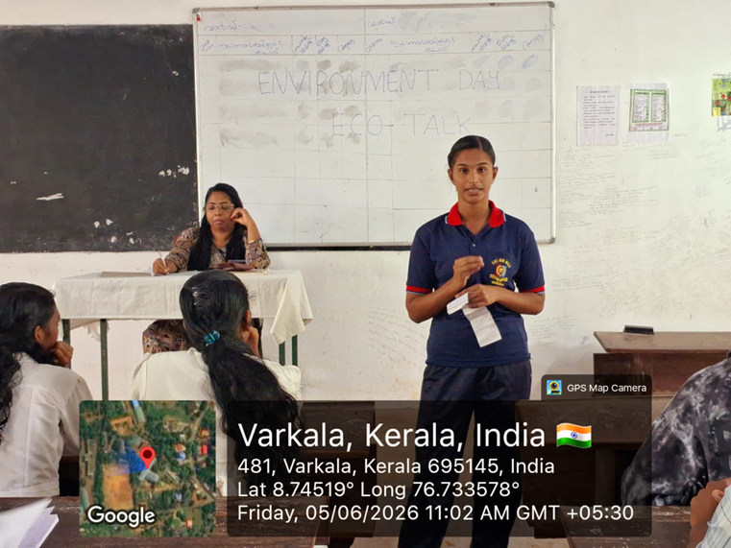
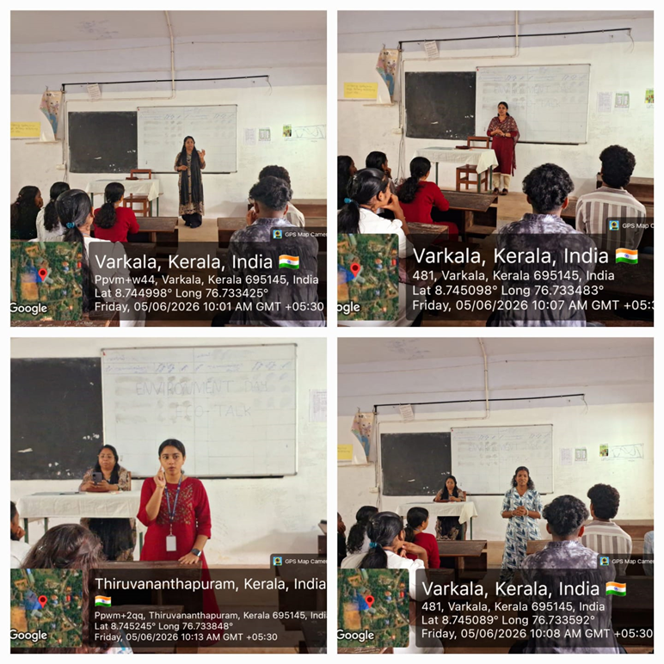
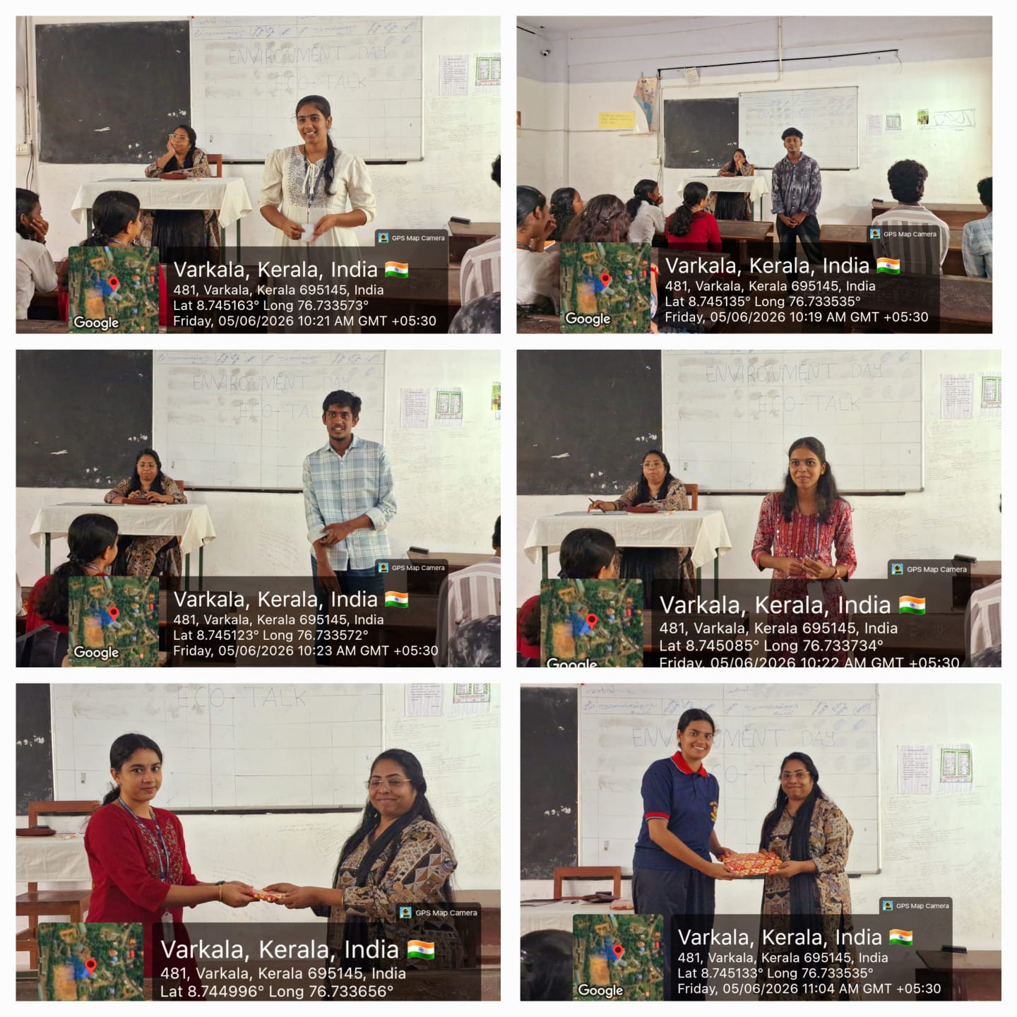

REPORT
Eco Talk & Student Reflections
World Environment Day Celebrations 2026
As part of the World Environment Day Celebrations 2026, the Centre for Indian Knowledge Systems (IKS), Department of History, and Internal Quality Assurance Cell (IQAC), Sree Narayana College, Sivagiri, Varkala, jointly organized "Eco Talk & Student Reflections" on 5 June 2026 at 10:00 A.M. in Room No. 51, Department of History. The programme aimed to promote environmental awareness, encourage sustainable thinking, and provide students with a platform to reflect on contemporary environmental challenges and their role in protecting nature.
The programme commenced with a welcome address, followed by an introduction to the significance of World Environment Day, emphasizing the importance of environmental conservation, sustainable development, and responsible citizenship. The event highlighted the need for collective efforts in addressing pressing environmental issues such as climate change, biodiversity loss, pollution, and resource conservation.
The highlight of the programme was the Eco Talk and Student Reflection Session, delivered by Ms. Nandana P. S. and Ms. Bhagyakrishna S., FYUGP History students. Through their insightful presentations, the speakers discussed various environmental concerns and stressed the importance of adopting eco-friendly lifestyles. They reflected on the role of youth in environmental protection, sustainable resource management, waste reduction, and community participation in conserving nature. Their presentations encouraged fellow students to become environmentally conscious and to contribute actively towards building a sustainable future.
An interactive discussion followed the presentations, during which students shared their thoughts, ideas, and personal experiences related to environmental conservation. The session fostered meaningful dialogue and inspired participants to adopt environmentally responsible practices in their daily lives.
The programme was conducted under the guidance of Prof. (Dr.) S. Sekaran, Principal. The event was organized with the support of Dr. Sreerenjini S. C., IQAC Coordinator. The organizing committee comprised Dr. Biji K. K., Head, Department of History, Dr. Simi S., Programme Coordinator & Assistant Professor, Department of History, and Dr. Aranya K. Sasi, Assistant Professor, Department of History, whose coordinated efforts ensured the smooth and successful conduct of the programme.
The event witnessed active participation from students and faculty members, making it an engaging and thought-provoking celebration of World Environment Day 2026. The programme concluded with a vote of thanks, expressing gratitude to the speakers, participants, faculty members, and organizers for their valuable contributions. The event successfully reinforced the importance of environmental stewardship and inspired students to embrace sustainable practices for a greener and healthier future.

