SREE NARAYANA COLLEGE, SIVAGIRI, VARKALA,
THE DEPARTMENT OF HISTORY

World Environment Day Colouring Competition,
Brochure
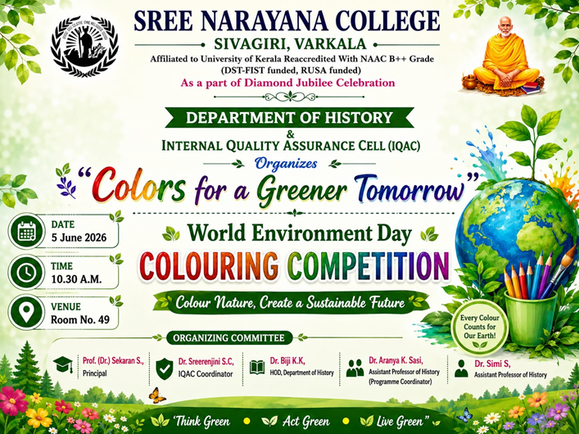

Photos

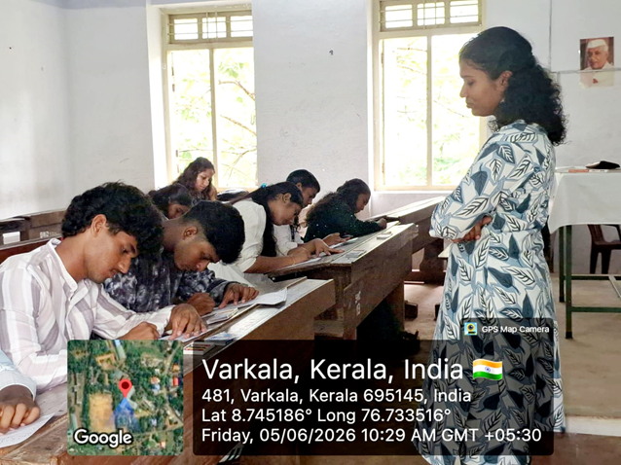
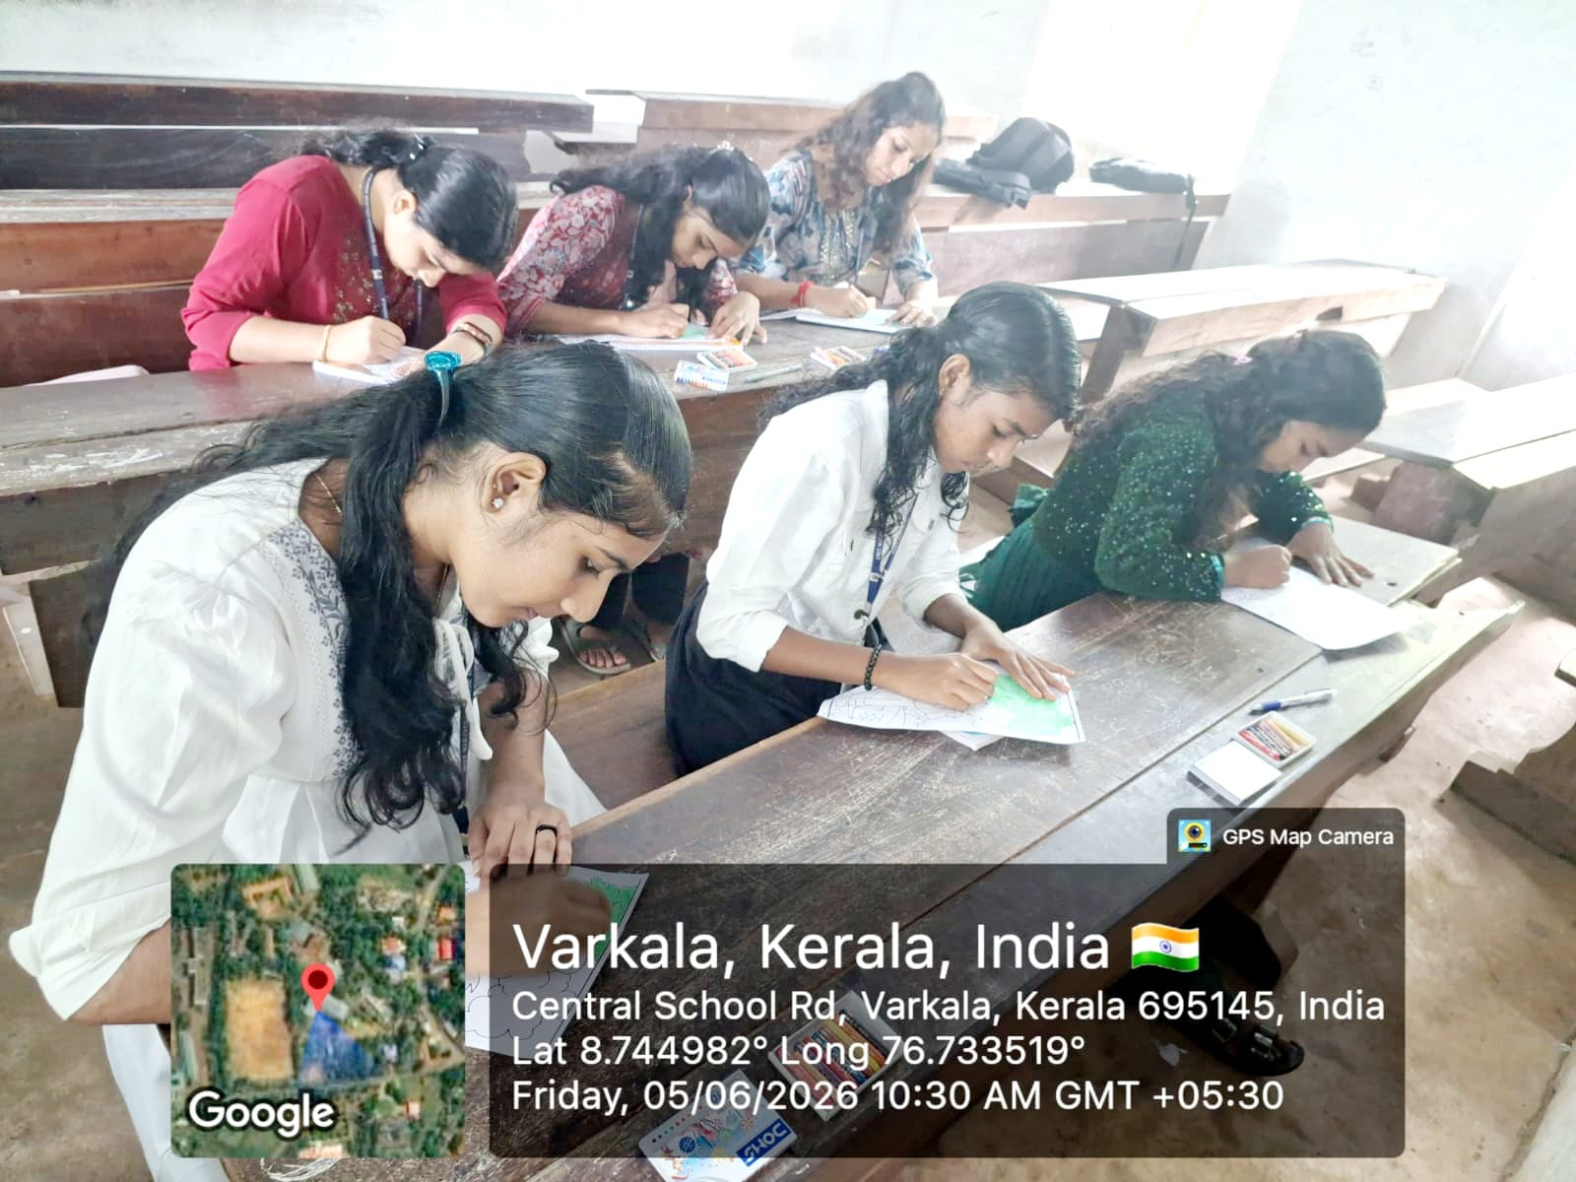

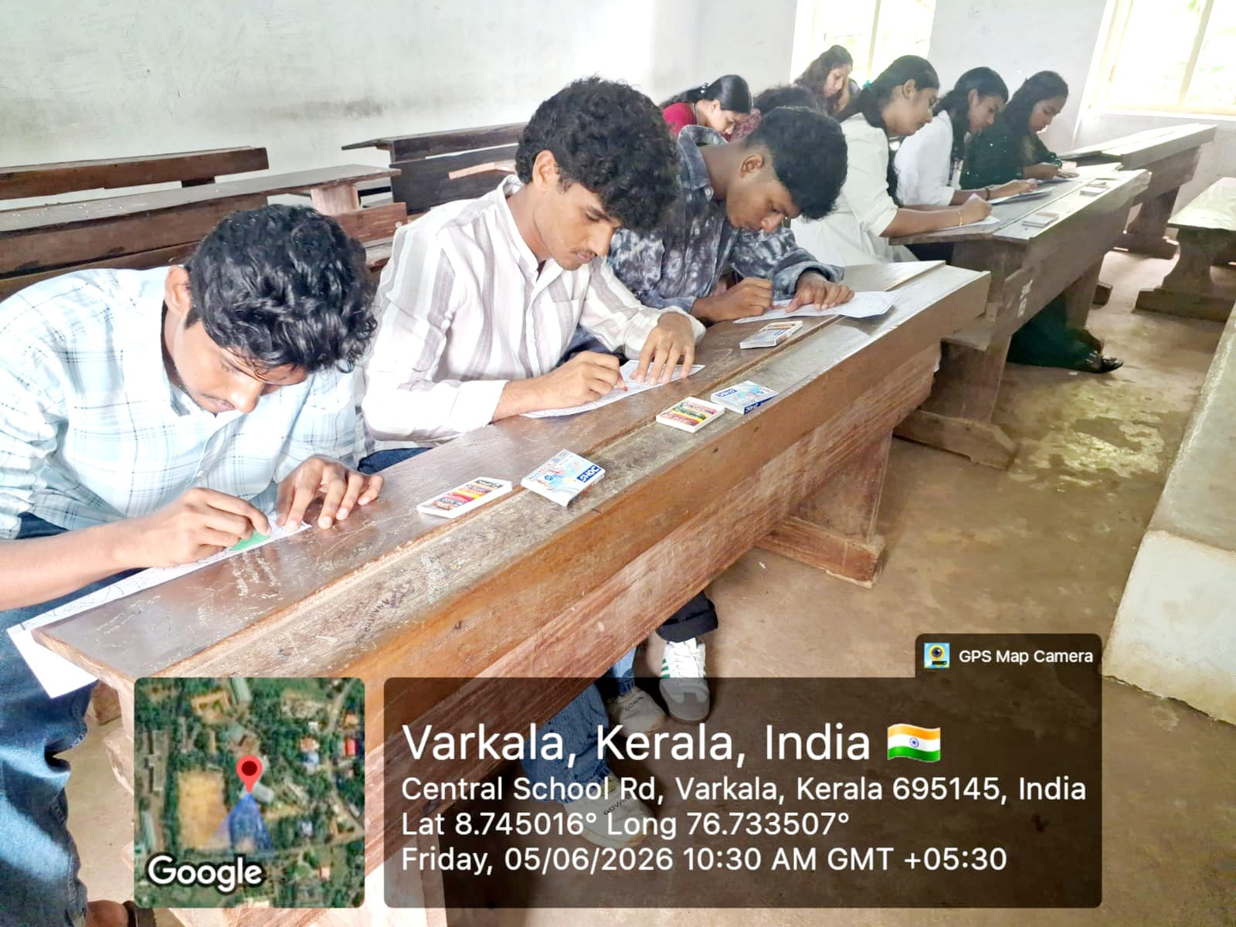

Report

World Environment Day Colouring Competition – “Colors for a Greener Tomorrow”

As part of the Diamond Jubilee Celebrations, the Department of History, in association with the Internal Quality Assurance Cell (IQAC), Sree Narayana College, Sivagiri, Varkala, organized the World Environment Day Colouring Competition titled “Colors for a Greener Tomorrow.” The programme was held on 5 June 2026 at 10.30 A.M. in Room No. 49 with the objective of fostering environmental awareness, creativity, and sustainable values among students through artistic expression.

The event was organized under the guidance of Prof. (Dr.) Sekaran S., Principal, with the support of Dr. Sreerenjini S. C., IQAC Coordinator. The programme was coordinated by Dr. Biji K. K., Head, Department of History, along with Dr. Aranya K. Sasi, Assistant Professor of History (Programme Coordinator) and Dr. Simi S., Assistant Professor of History, who served as the organizing committee members.

The competition witnessed enthusiastic participation from students, who presented vibrant and creative artworks highlighting themes such as environmental conservation, biodiversity, climate action, and sustainable living. The event provided an excellent platform for students to express their concern for nature while showcasing their artistic talents.

The entries were evaluated on the basis of creativity, originality, relevance to the theme, and artistic presentation. The winners of the competition were:
- First Prize: Sonu A. Sabu (I B.A. History)
- Second Prize: Resmi R. (I B.A. History)
- Third Prize: Vineeth B. (I B.A. History)

The Department of History congratulated the winners and appreciated all the participants for their enthusiastic involvement and meaningful artistic contributions. The programme concluded successfully, reinforcing the institution's commitment to environmental sustainability and inspiring students to become responsible stewards of nature.

