SREE NARAYANA COLLEGE, SIVAGIRI, VARKALA
PG DEPARTMENT OF CHEMISTRY

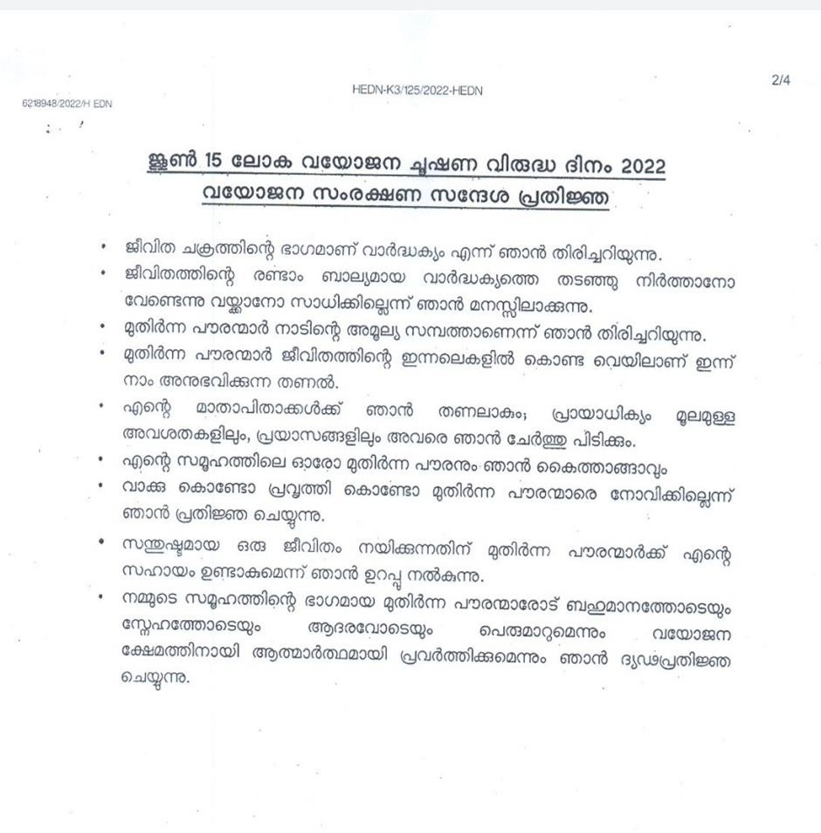
‘World Elder Abuse Awareness Day’ Pledge

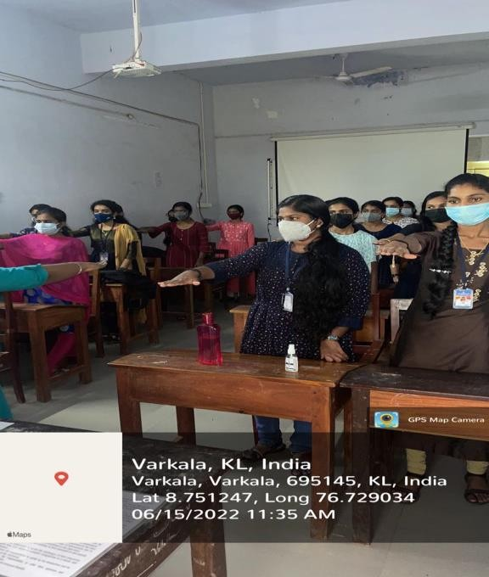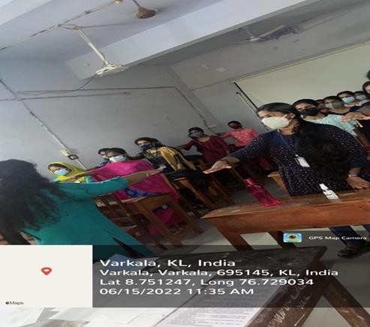
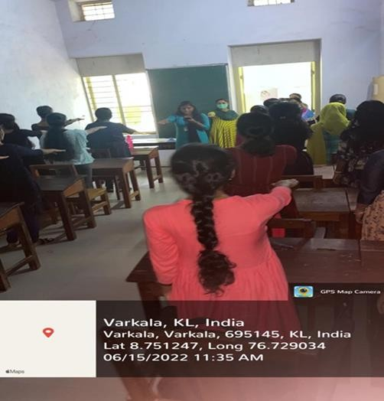
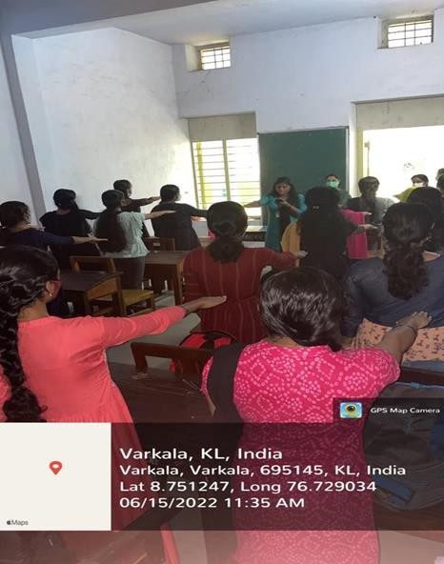

‘World Elder Abuse Awareness Day’ Pledge by Students of PG Department of Chemistry

