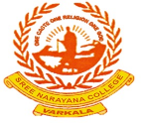 SREE NARAYANA COLLEGE, SIVAGIRI, VARKALA 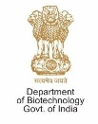
POST GRADUATE DEPARTMENT OF CHEMISTRY
REPORT OF DBT-STAR SPONSORED WEBINAR ON “ULTRAFAST PROCESSES IN CHEMICAL AND BIOLOGICAL SYSTEMS”
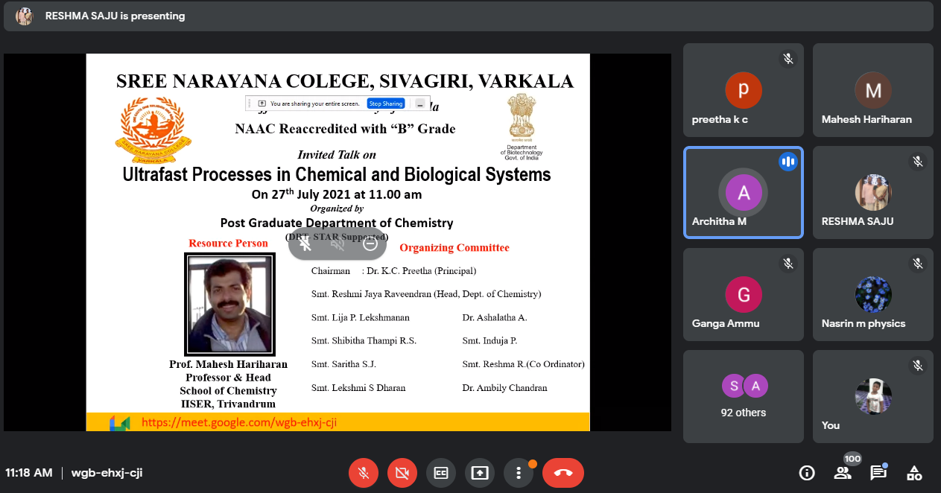
A one-day Seminar on “Ultrafast Processes in Chemical and Biological Systems” was organized by Post Graduate Department of Chemistry, Sree Narayana College, Sivagiri, Varkala on 27th July 2021 through google meet. The inaugural session began with a prayer followed by the welcome speech delivered by our respected Head of the Department of Chemistry Smt. Reshmi Jaya Raveendran. She began her speech giving tribute to the memories of Dr. A.P.J. Abdul Kalam, “The Missile Man of India”, as 27th July was the sixth death anniversary of Dr. Kalam. In her address she highlighted the undisputed value of ensuring quality education to the undergraduate and post graduate students through conducting workshops and seminars in the emerging interdisciplinary fields of science. She expressed her gratitude towards the management and Principal for giving an opportunity to organize this webinar.
Prayer by Architha M., Fifth semester B.Sc. Chemistry
The keynote address was delivered by our respected principal Dr. K.C. Preetha. In her address, she touched upon the current quality concerns of higher education system and said that interdisciplinary approach is one of the new solutions of theoretical and practical problems of education. She highlighted the vital role of ultrafast processes in different biological and chemical processes.
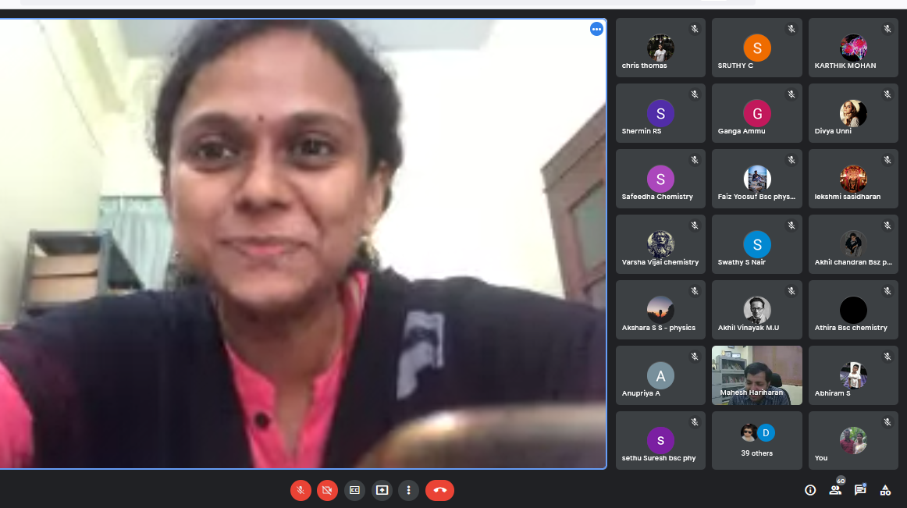
Smt. Reshmi Jaya Raveendran, Head, Dept. of Chemistry delivering welcome address
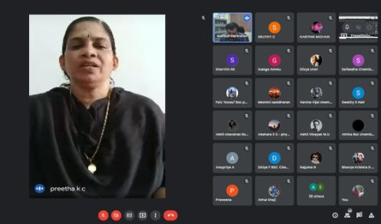
Dr. K.C. Preetha, Principal delivering presidential address

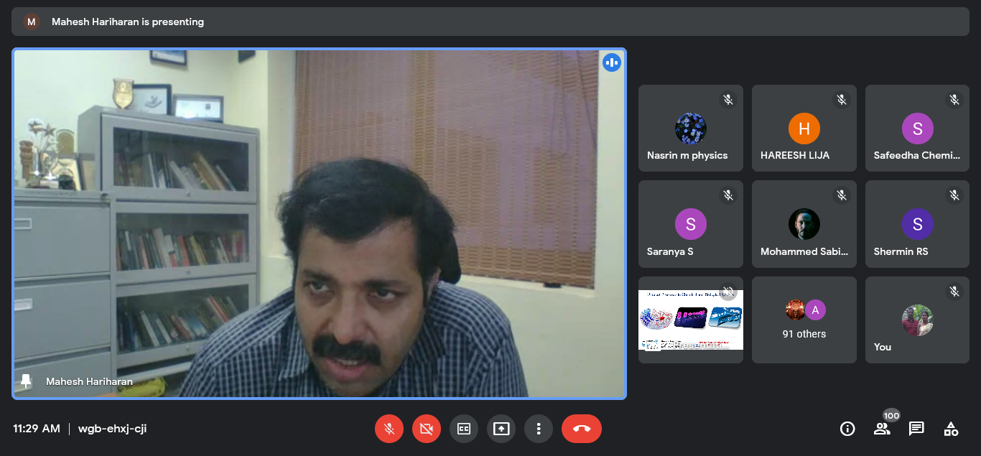
Prof. Mahesh Hariharan delivering the lecture on Ultrafast Processes in Chemical and Biological Systems.
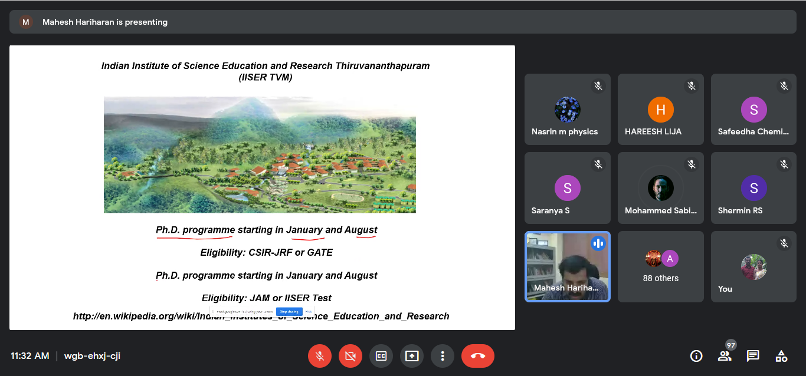
Our eminent resource person for handling the technical session was Prof. Mahesh Hariharan, Professor and Head, School of Chemistry, IISER, Trivandrum, who gave a wonderful lecture on Ultrafast Processes in Chemical and Biological Systems. In beginning of the session, he shared his knowledge about the future opportunities for our UG and PG students in the research areas of basic science and inspired our students with his insight.
The campus of IISER, Trivandrum

He delivered a thought-provoking talk on the topic “Ultrafast Processes in Chemical and Biological Systems”. He explained the applications of ultrafast processes in various fields such as femtosecond spectroscopy to understand the mechanism of chemical reactions. He also gave a brief idea on basic principles of visual spectroscopy and time resolved spectroscopy. He concluded the session by encouraging our students to come forward to the modern research field of photochemistry.
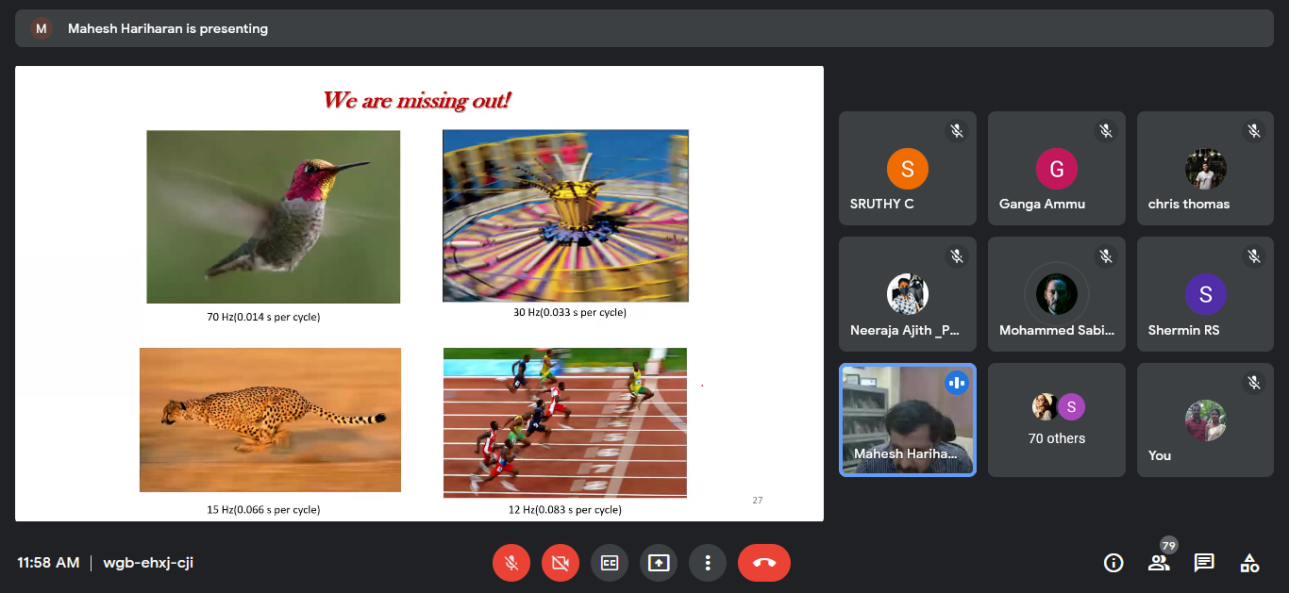
Prof. Hariharan explaining about visual spectroscopy
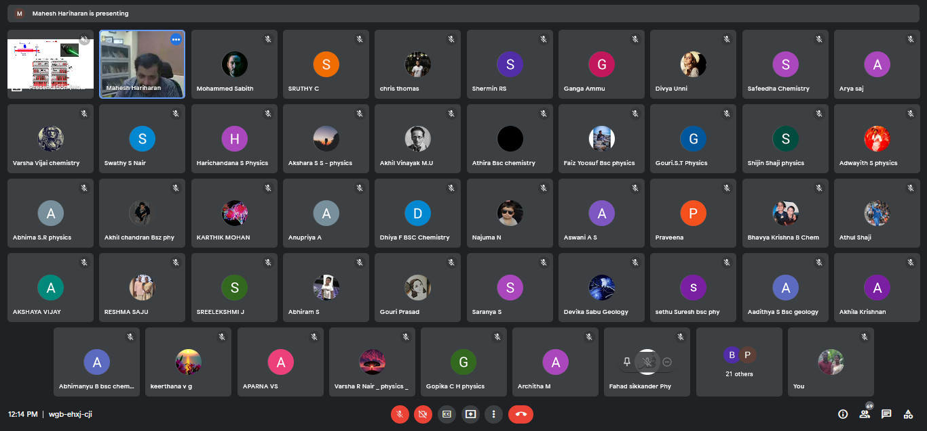
There was an interacting session after his lecture when students interacted with him to clear their doubts. Towards the end of the session, Ms. Farzana Nishad, sixth semester B.Sc. Chemistry delivered the vote of thanks. The anchoring of the inaugural session was done by Ms. Ganga S., second semester M.Sc. Analytical Chemistry.

Participants of the webinar
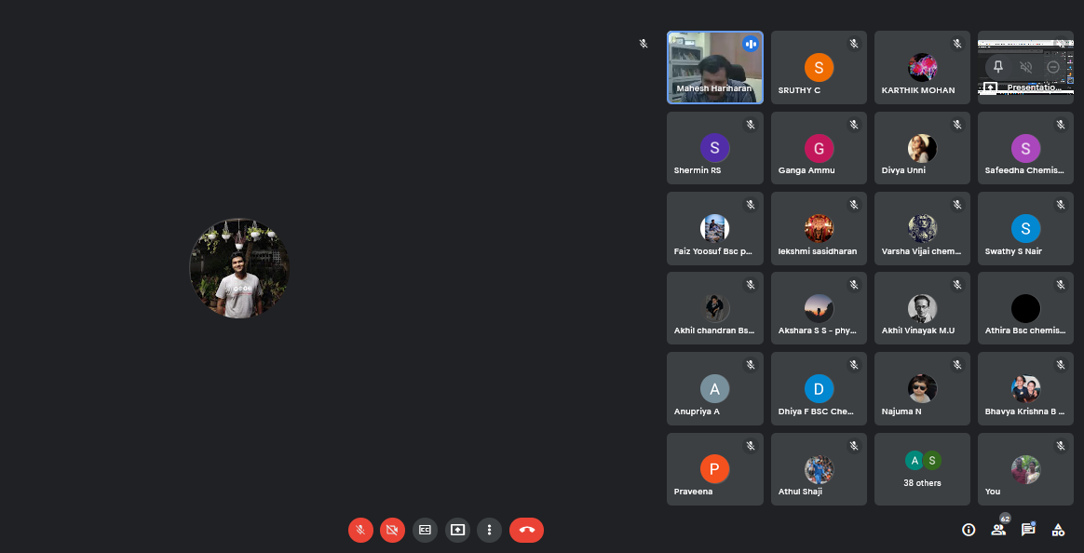
Chris Thomas, 2nd semester B.Sc. Geology interacting with
Prof. Mahesh Hariharan

