Report of Alumni Meeting - 2015
The Alumni Association of Department of Chemistry, SN College, Varkala organized "ALUMNI MEET 2015"- a programme to facilitate, consolidate and coordinate alumni activities of the department at college conference hall on 24-05-2015. The alumni meet is to reconnect with the Alumni and celebrate their success and various achievements. The Alumni Meet started with a welcome address by Dr V.S Thampidas, Head, department of chemistry. The meeting was presided by former head and syndicate member of University of Kerala Dr. Mohan Kumar. The meeting was inaugurated by Dr. C. N. Sarathchandran, former student and faculty of the department of chemistry. In his speech he fondly remembered his days in the college both as a student and as a teacher.
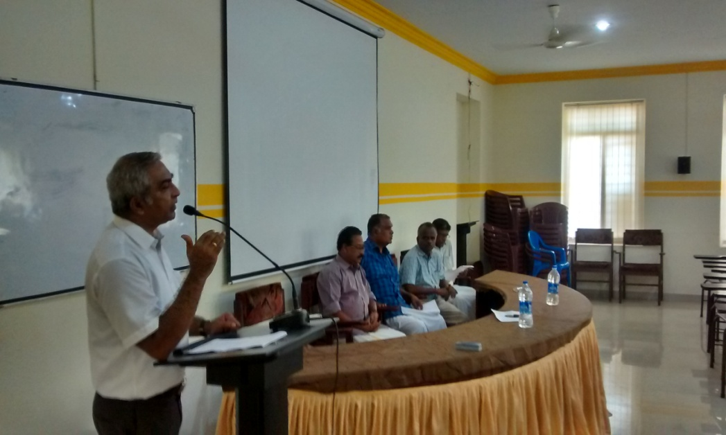
Dr. V.S. Thampidas delivering welcome address
Alumni interacted with the students and gave motivational talk regarding preparing for higher studies and placements. Students asked many questions regarding placements and the alumni shared their views. Felicitation to the meeting was offered by Dr K. Vijayakumar, Sri S. Radhakrishnan, and Smt. Reshma R.
Smt. Saritha S.J proposed the vote of thanks. She thanked the various organizers alumni members of the event. She also thanked the management of SN College Sivagiri, Varkala for the support and guidance which has made Alumni Meet 2015 a grand success.

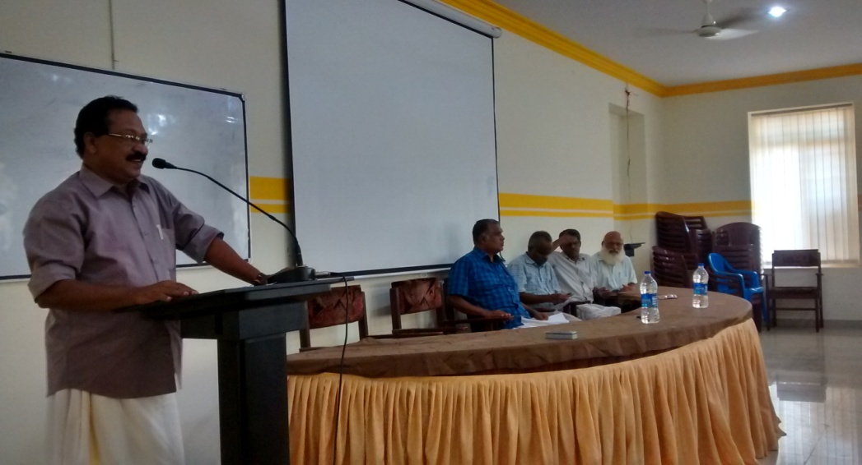
Dr. Mohankumar delivering presidential address
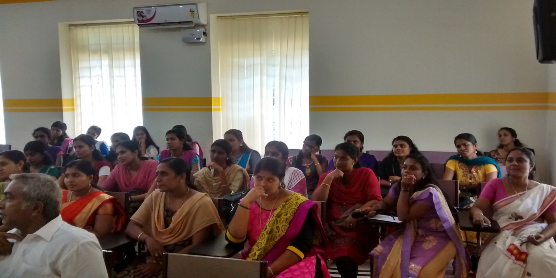Participants of “Alumni Meet – 2015”

