Report of “Alumni Meet – 2019”
Alumni Meeting Report (2005-2008 B.Sc. Batch)
Alumni meeting of (2005-2008) B.Sc Chemistry batch was held on 25/08/2019 at college conference hall. Our Alumni and teachers gathered at conference hall by 10 am on 25/08/2019. Former teacher Dr. Kala Kumari C. R. and Dr. V. Bhagavathy (Head, Department of Chemistry, S.N College, Chempazhanthy) were also participated in the meeting .Both of them worked here during 2005-2008 period.The function was presided by our Head of the Department Smt Joly A. She delivered the welcome speech. Students of B.Sc batch (2005-2008) shared their evergreen memories. They also honoured their teachers in the programme. After lunch and photo session meeting was dispersed.
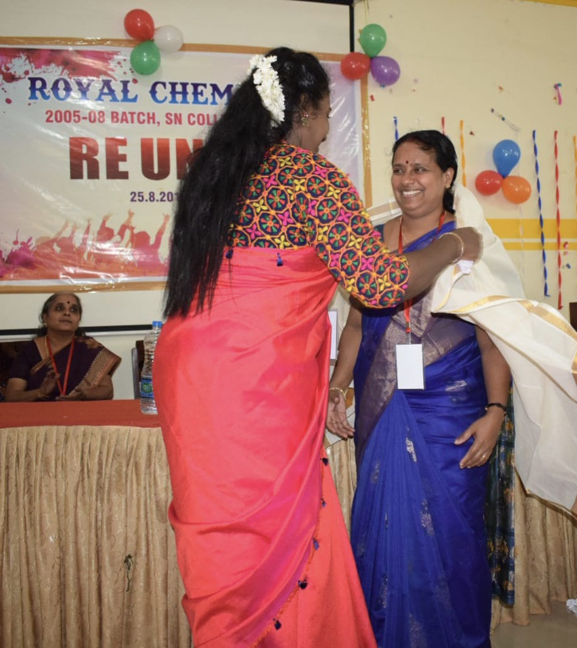
Alumni honoring Dr. A Joly

