Report of “Alumni Meet – 2019”
Alumni Meeting Report (1996-1999 B.Sc. Batch)
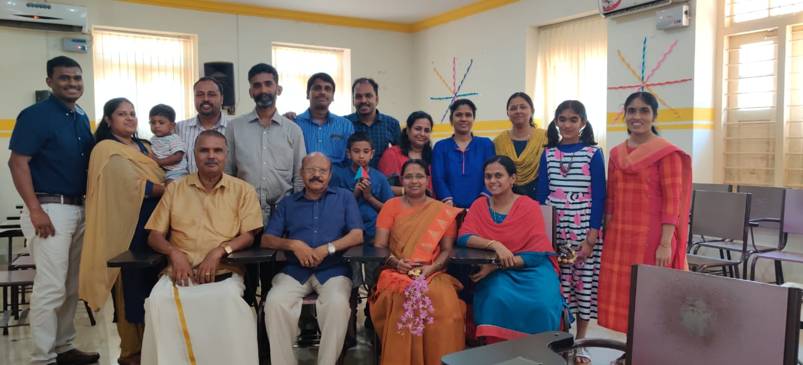
The Alumni meeting of 1996-1999 B.Sc Chemistry batch was held at the conference hall on 1-06-2019 .Alumni gathered at the conference hall at 9 am . Principal Smt Joly A. and teachers of Chemistry Department, former teachers Dr. Saraschandran and Dr. Vasundharan arrived there. The main agenda of the meeting was to digitalize the class room. The meeting was presided by Principal Joly A. Welcome speech was delivered by Head of the Department Smt. Resmi Jaya Raveendran. The function was felicitated by Dr Vasundharan. The alumni promised that they would meet whole expenses to digitalize the class room. Vote of thanks was delivered by Dr.Saraschandran.

Participants of “Alumni Meet – 2019”

