Report of Alumni Meeting - 2018
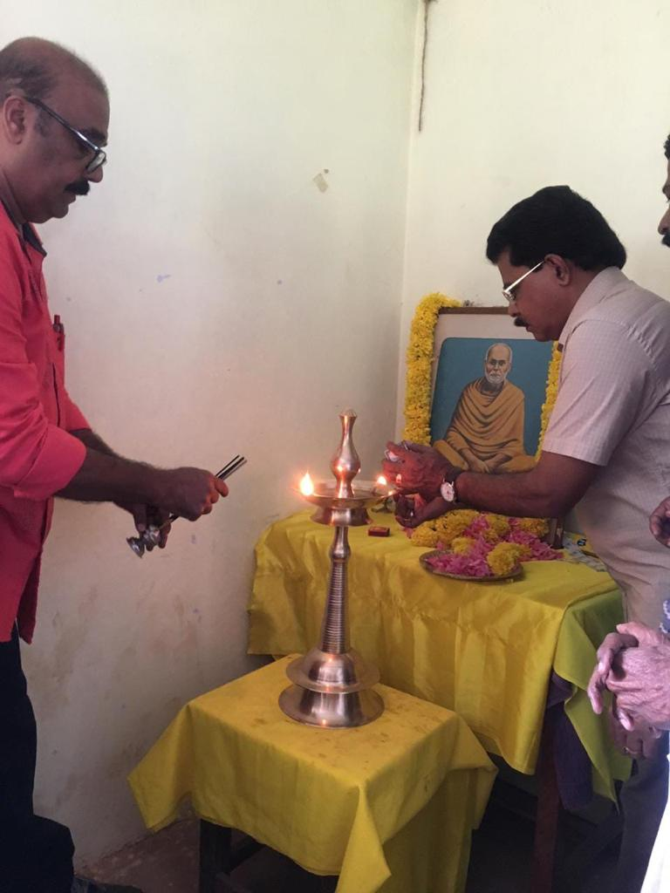
Alumni of 1981-84 batch gathered at seminar hall on 16-03-2018. The meeting started at 10 am. The meeting was presided by respected Principal Dr. L Thulaseedharan. Dr Saraschandran former Head of the Department and Alumnus delivered the welcome speech. He coordinated the function. Head of Chemistry Department Smt Joly A felicitated the function. Most of former students arrived with their family. They cherished memories of their college days. The programme was named “Guruvandanam”. In this program they honoured their teachers. All of them have been contributing for mid-day meal program in the college. The discussed about how would they be able to make much more contributions to the development of the College. They expressed their willingness to be in close contact with the PTA for more developments in the College. Sri Ashok kumar one among the alumni gave vote of thanks. The meeting dispersed after lunch.

Principal Dr. L. Thulaseedharan inaugurating the function
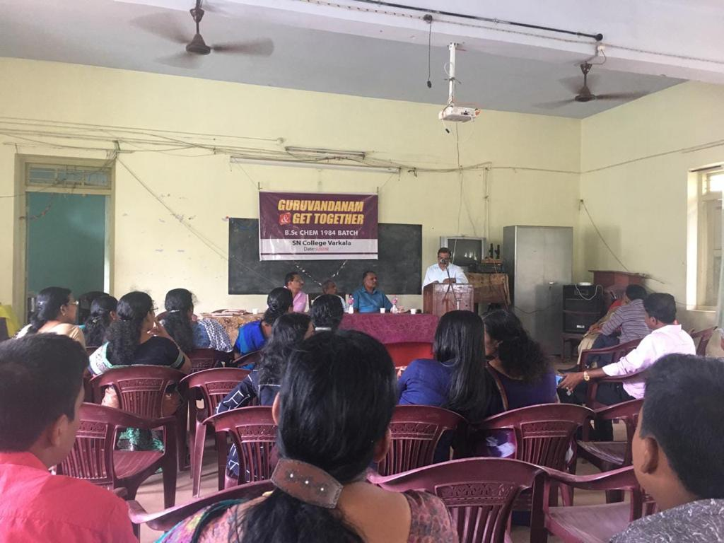
Audience of “Alumni Meet – 2018”

