Report of Alumni meeting (1996-1999)
Alumni meeting of 1996-1999 batch (B.Sc Chemistry) was held at Room no 12 (III DC ) on 30-08-2019 at 9 am. All teachers of Chemistry department and students were gathered at room no 12 Our Principal Smt. Joly A presided the function. Head of the Department Smt. Reshmi Jaya Raveendran delivered the welcome speech. S.N trust executive member Sri Aji S.R.M and PTA Vice President Sri Sivakumar participated in the function. The main objective of the meeting was to inaugurate the digitalized class room. Our Alumni met full expenses of digitalization. The digitalized class room was inaugurated by our principal Smt. Joly A. Sri Aji S.R.M and Sri Sivakumar felicitate the function. Vote of thanks delivered by Lija P Lekshmanan. The meeting was dispersed at 10.30 am.
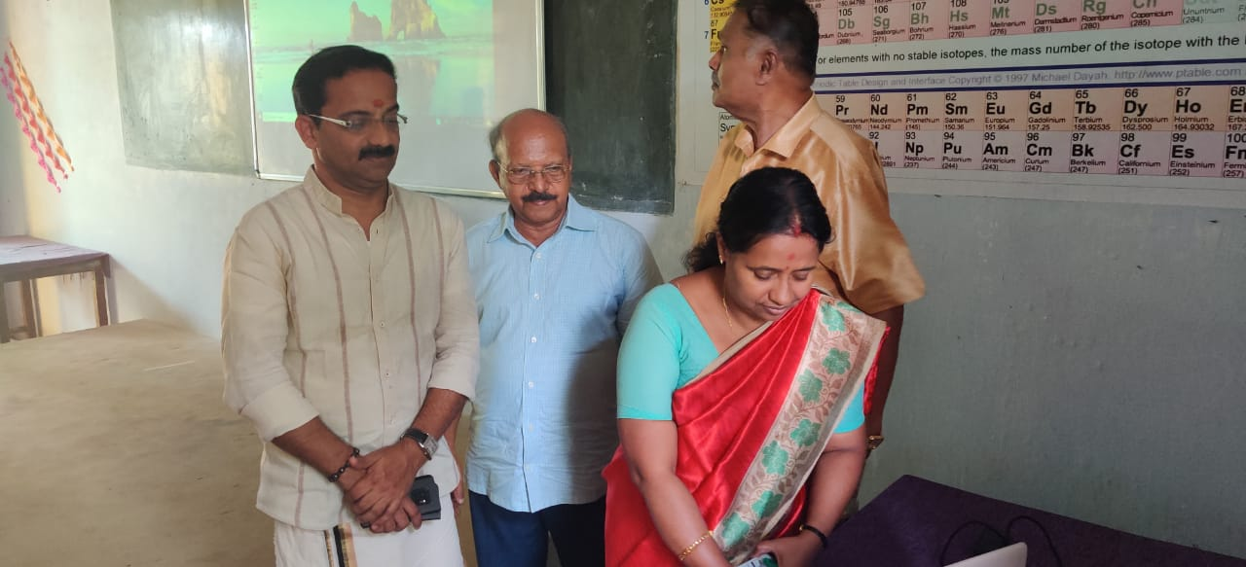
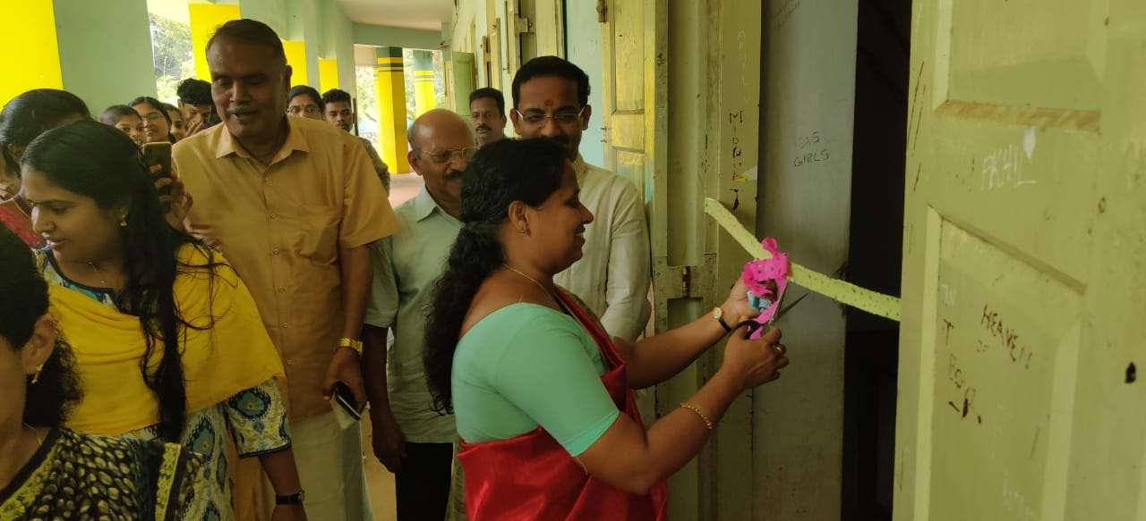

Dr. A. Joly, Head, Dept. of Chemistry inaugurating digital class room

