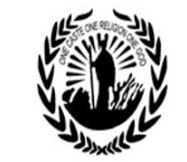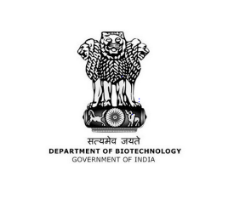
SREE NARAYANA COLLEGE SIVAGIRI, VARKALA
DEPARTMENT OF CHEMISTRY
REPORT ON NATIONAL SCIENCE DAY CELEBRATION-2021
In Association with DBT STAR

The “National Science Day Celebration-2021” was conducted successfully on 04th March, 2021. Dr. V. Sadasivan, Associate Professor and former Head, Department of Chemistry, University College, Trivandrum was invited as the Chief Guest for the program. The event was inaugurated by the Chief Guest with the lighting of the ceremonial lamp. This was followed by welcome address delivered by Ms. Sangeetha First semester BSc Chemistry student.
Dr. A Joly, Head Department of Chemistry presided over the function. In her presidential address she thrown light on the significance of science day and the theme of this year’s science day "Future of STI: Impacts on Education, Skills and Work".
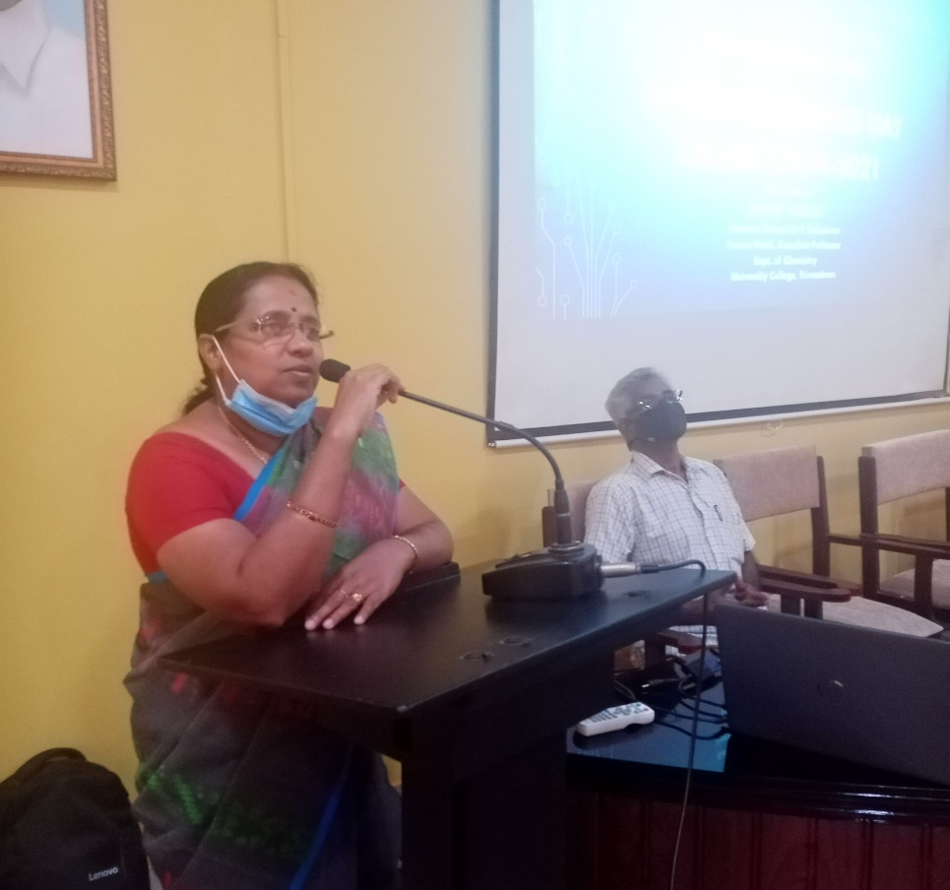

Our chief guest Dr. V Sadasivan in his address highlighted the significance of celebrating the National Science Day in rememberance of Sir Chandrashekhara Venkata Raman for receiving the noble prize for discovery of Raman Effect.
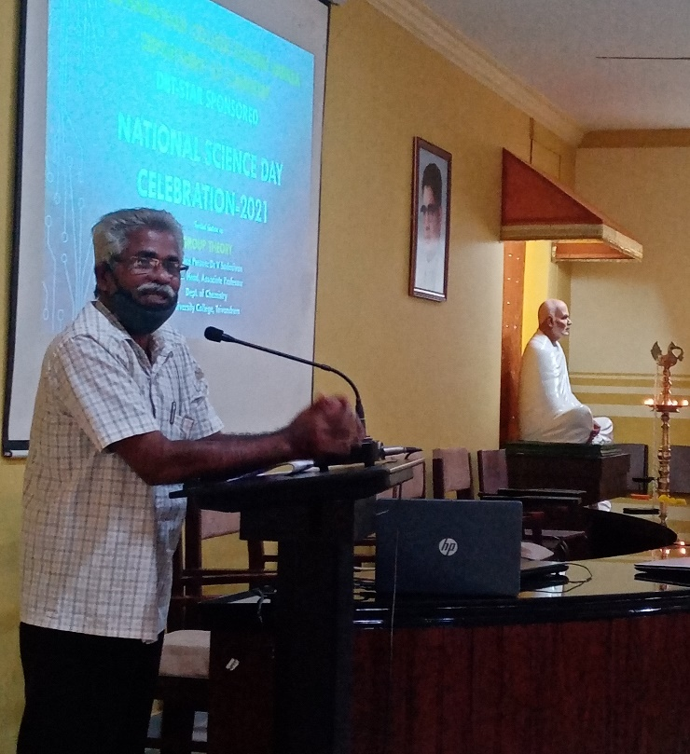

Coordinator of the program Smt. Reshma R, Asst. Professor in Chemistry, had spoken on the emphasis of science and technology for our present generation and motivated our students for better research while applying innovative ideas.
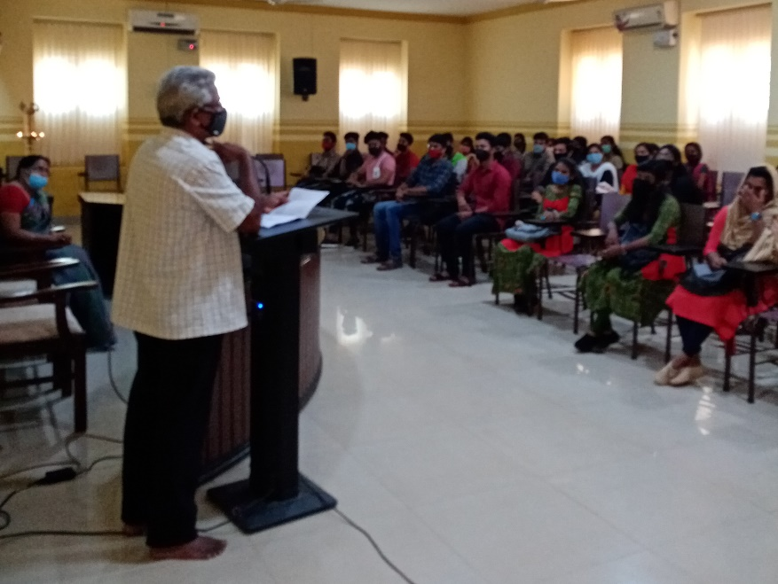
After the inaugural session we had a wonderful lecture from Dr. V. Sadasivan on the topic Group Theory. In the afternoon session we had poster presentation competition for undergraduate and post graduate students on the topic ‘Future of STI: Impacts on Education, Skills and Work’ and group discussion for under graduates on the topic “Prevention of COVID-19 ; Therapeutic Strategies.” The prizes for both the competitions were distributed to students by the dignitaries on the Dias. Ms. Diya first semester BSc Chemistry student proposed the vote of thanks.





